Pipeline Visual Report

This document consolidates the pipeline outputs with key graphs and short interpretations.

# Sampling variation summary

Performance derivative peaks:

* CNN: peak 0.0046 at 20%
* DT: peak 0.0026 at 10%
* LR: peak 0.0058 at 10%
* RF: peak 0.0017 at 30%
* TabNet: peak -0.0029 at 40%

Explainability derivative peaks:

* CNN: peak -0.0023 at 10%
* DT: peak 0.0009 at 10%
* LR: peak 0.0003 at 10%
* RF: peak 0.0001 at 60%
* TabNet: peak -0.0025 at 10%

Threshold variation range: 10 to 100 (step 10) for resources, performance, and explainability.

# Pipeline overview

High-level flow of the MCDA pipeline and where each visualization fits.

09_pipeline_overview.png

Pipeline flow diagram for MCDA steps.

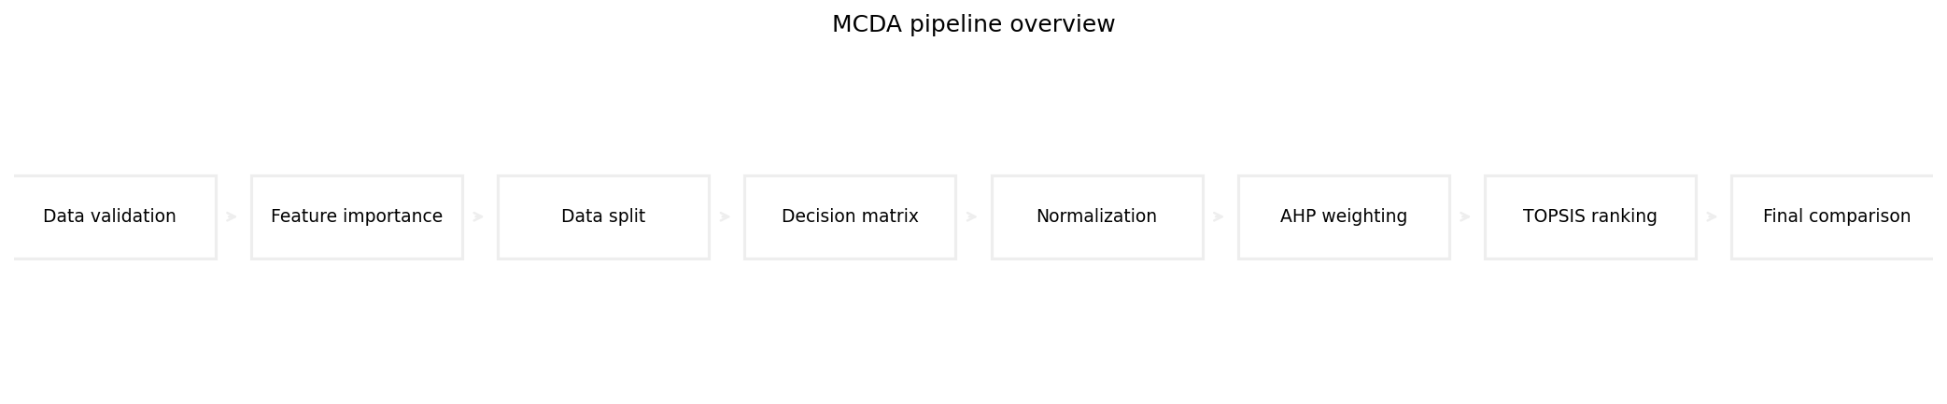

# Stratification checks

Compares label proportions before and after sampling to verify stratification.

cic_stratification.png

Bar chart comparing full vs sampled label proportions.

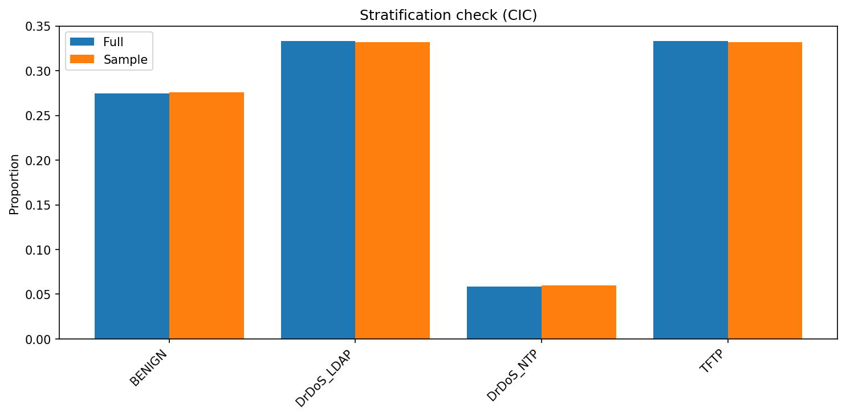

ks_cic.png

Chart generated by the pipeline.

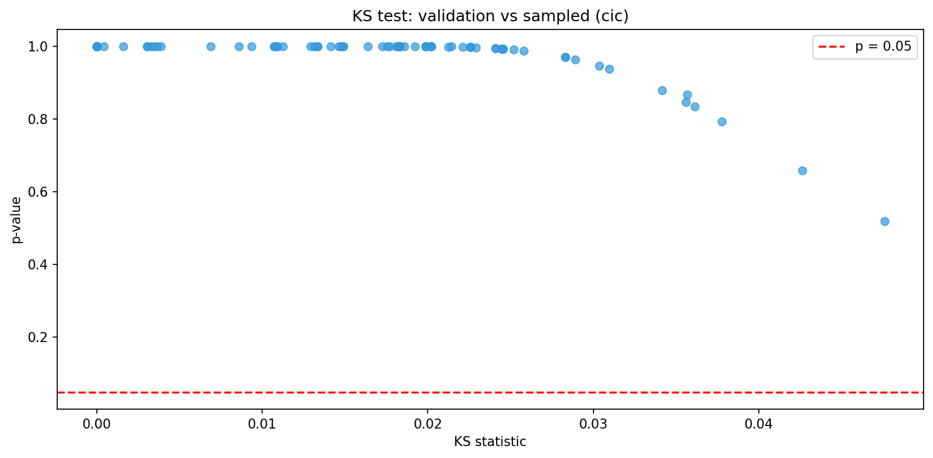

ks_ton.png

Chart generated by the pipeline.

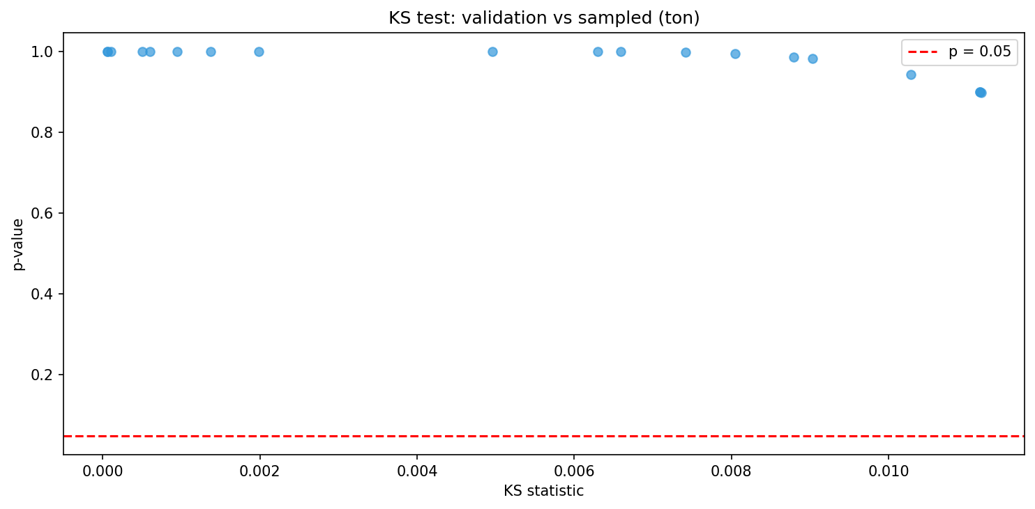

ton_stratification.png

Bar chart comparing full vs sampled label proportions.

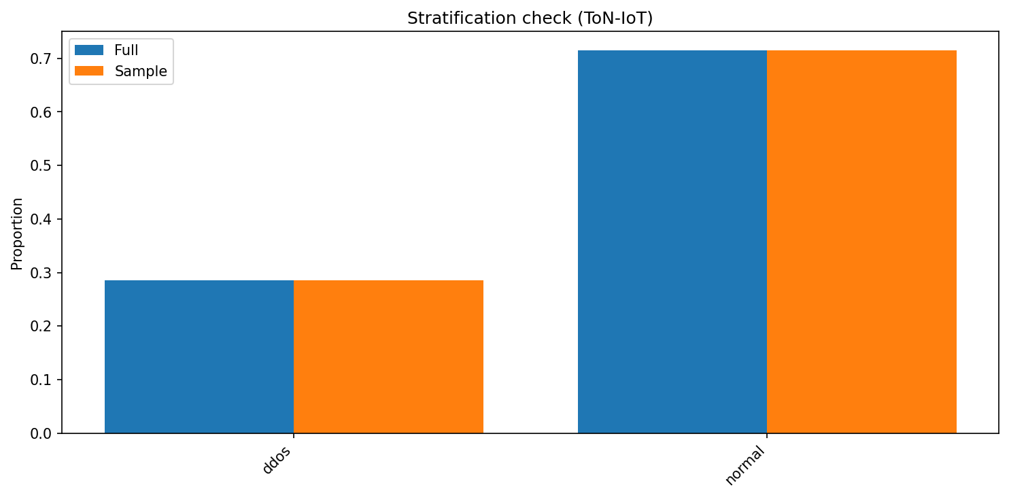

# Feature distributions

Shows post-transformation feature distributions used by the models.

compare_avg_packet_size.png

Chart generated by the pipeline.

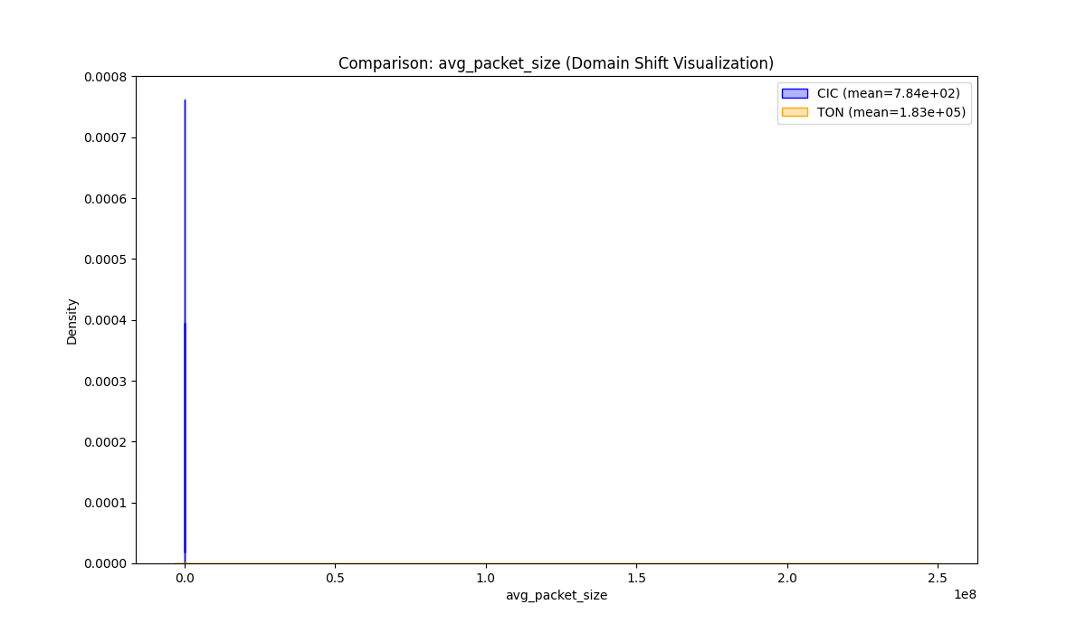

compare_bytes_per_packet.png

Chart generated by the pipeline.

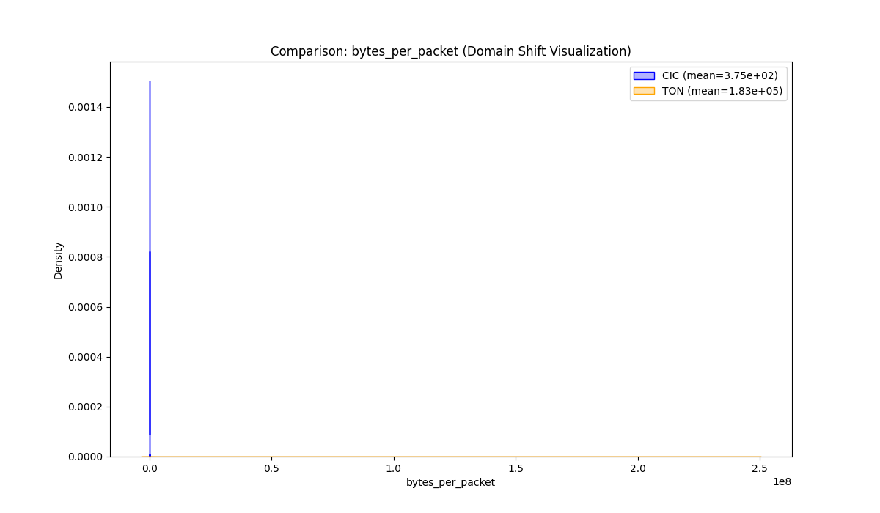

compare_bytes_per_second.png

Chart generated by the pipeline.

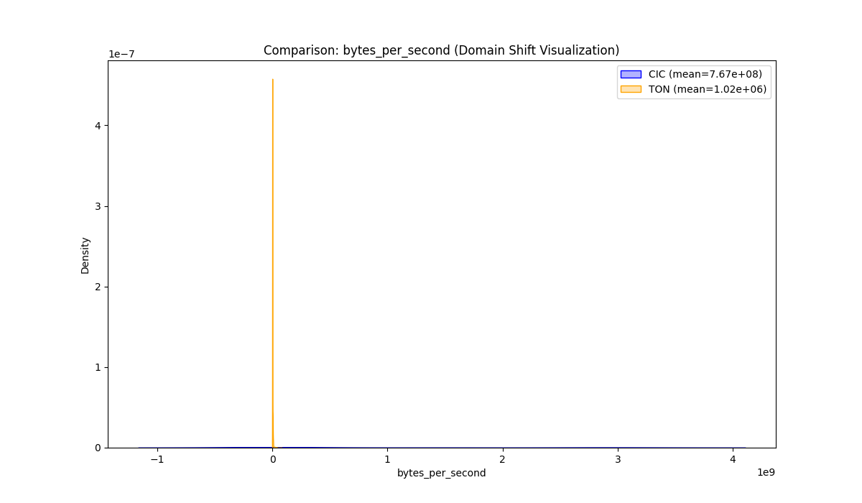

compare_flow_asymmetry.png

Chart generated by the pipeline.

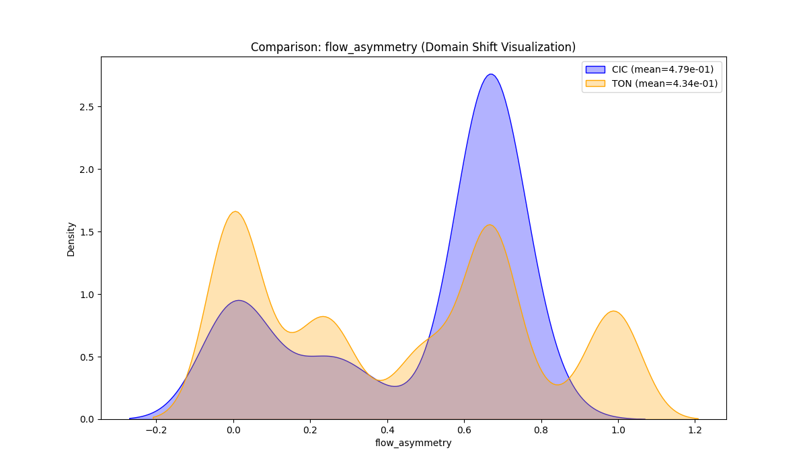

compare_flow_duration.png

Chart generated by the pipeline.

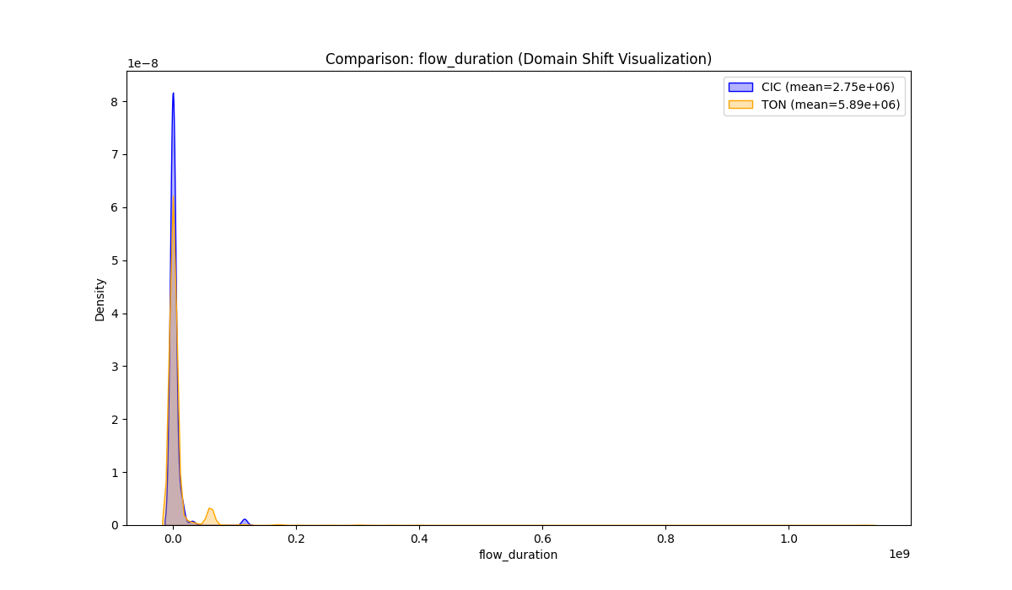

compare_fwd_byte_ratio.png

Chart generated by the pipeline.

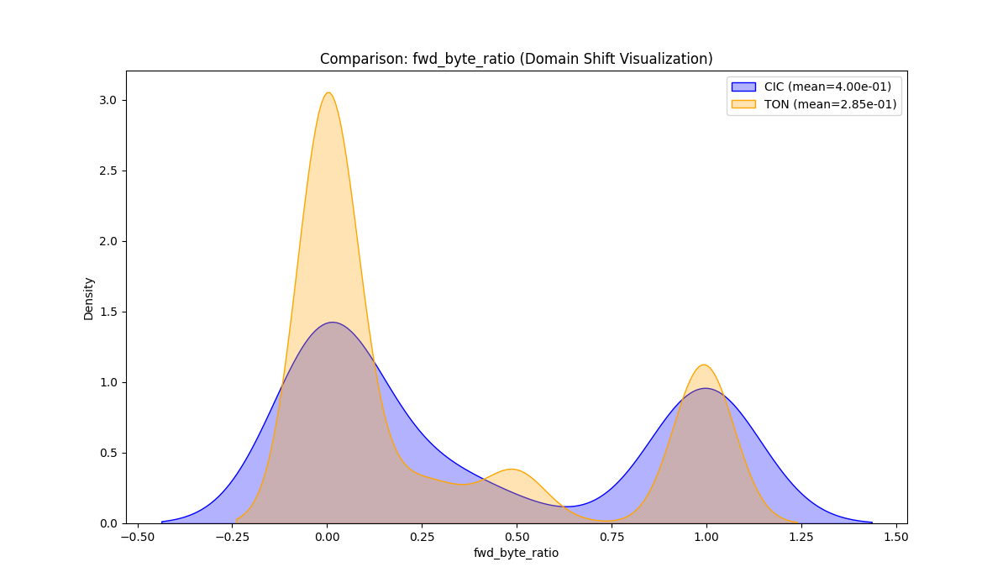

compare_fwd_packet_ratio.png

Chart generated by the pipeline.

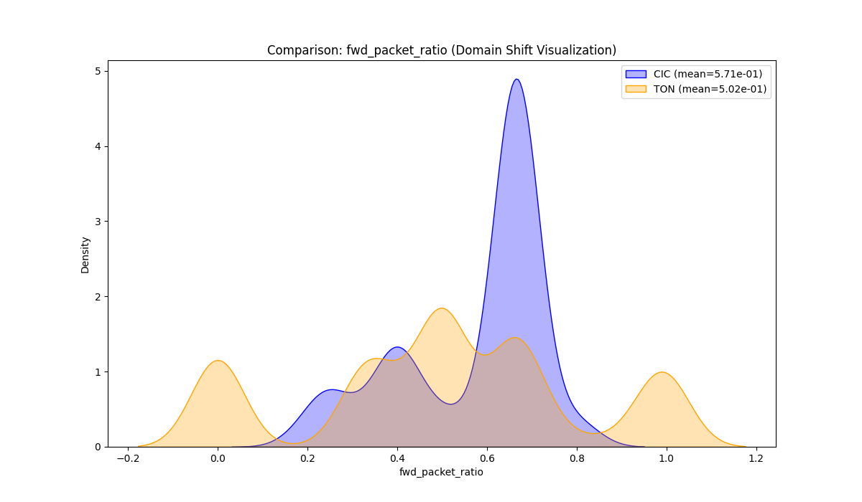

compare_header_ratio.png

Chart generated by the pipeline.

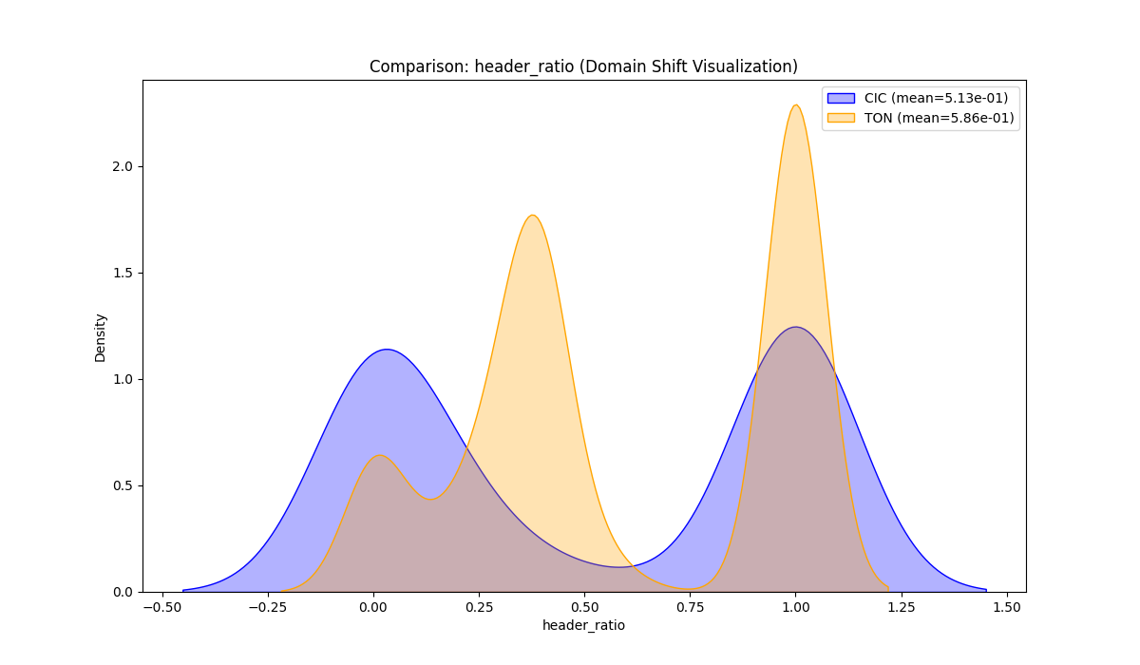

compare_packets_per_second.png

Chart generated by the pipeline.

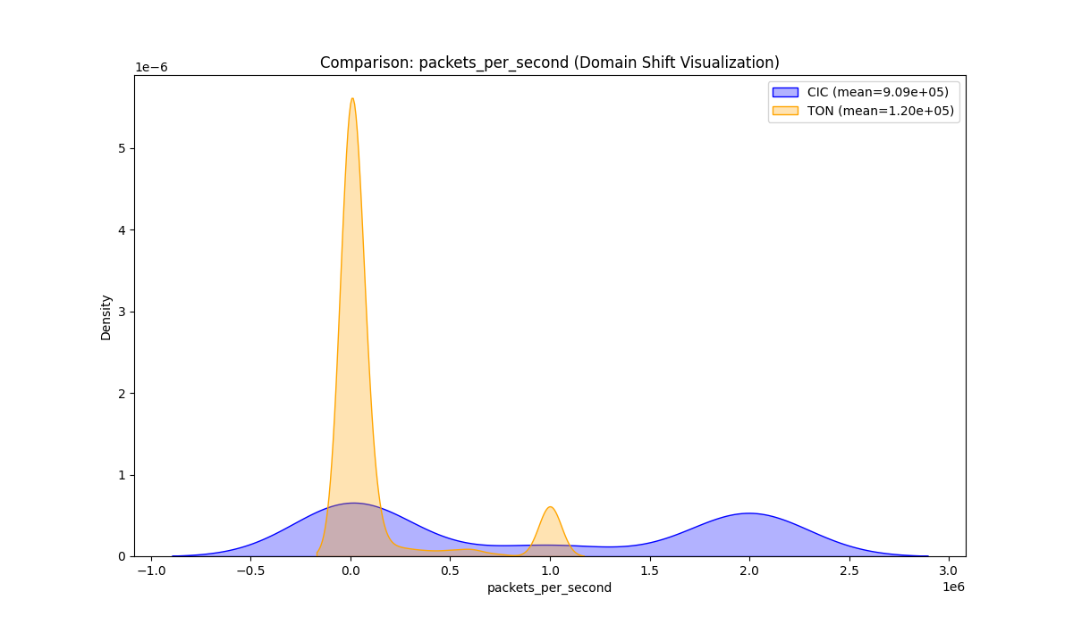

compare_total_bwd_bytes.png

Chart generated by the pipeline.

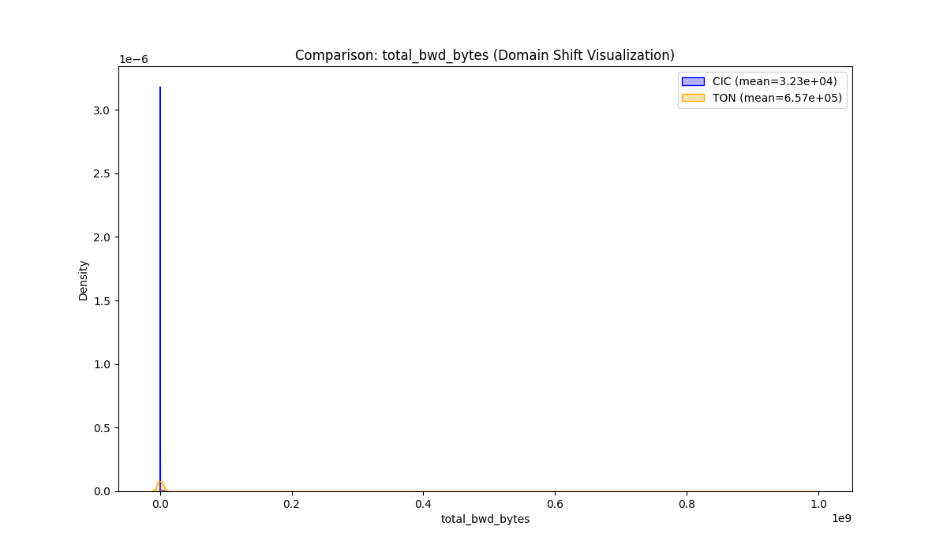

compare_total_bwd_packets.png

Chart generated by the pipeline.

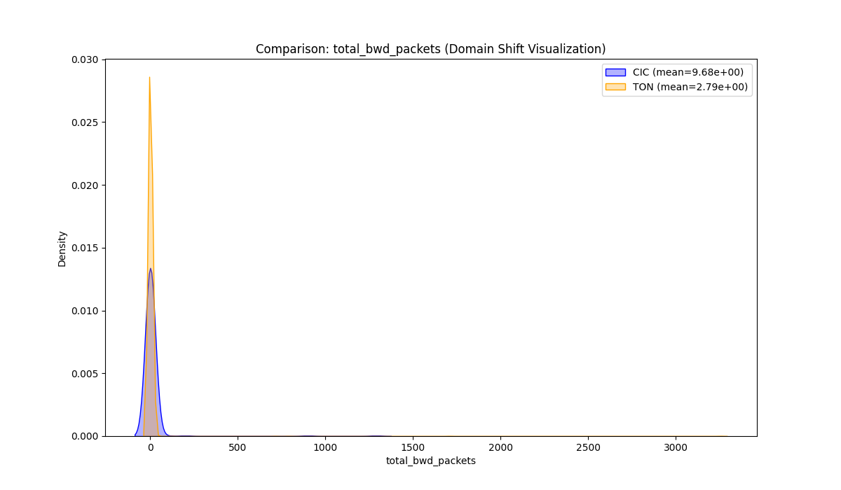

compare_total_bytes.png

Chart generated by the pipeline.

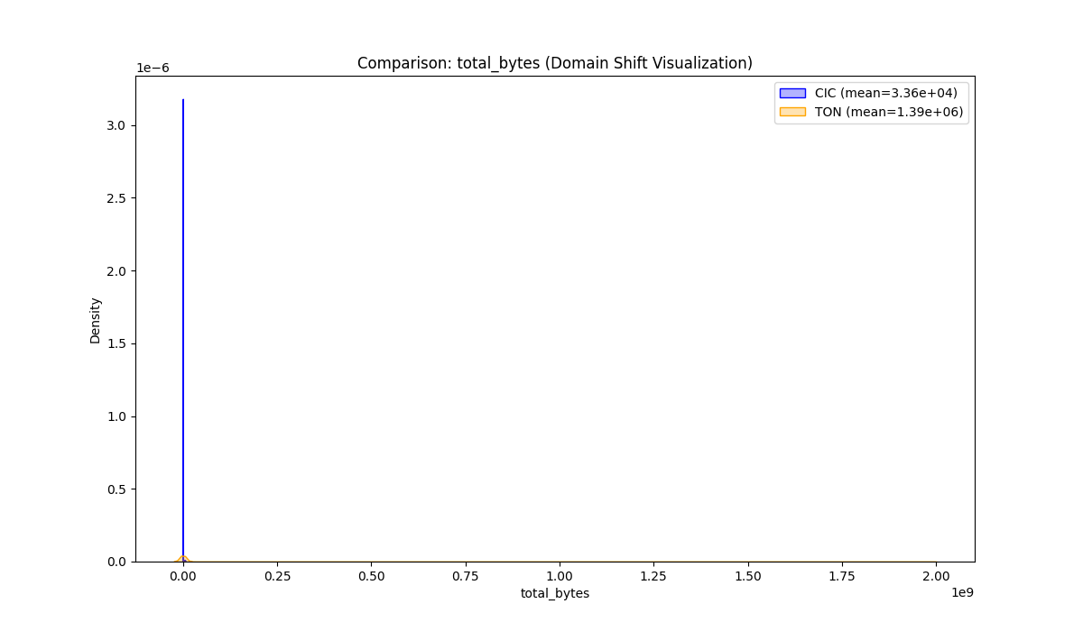

compare_total_fwd_bytes.png

Chart generated by the pipeline.

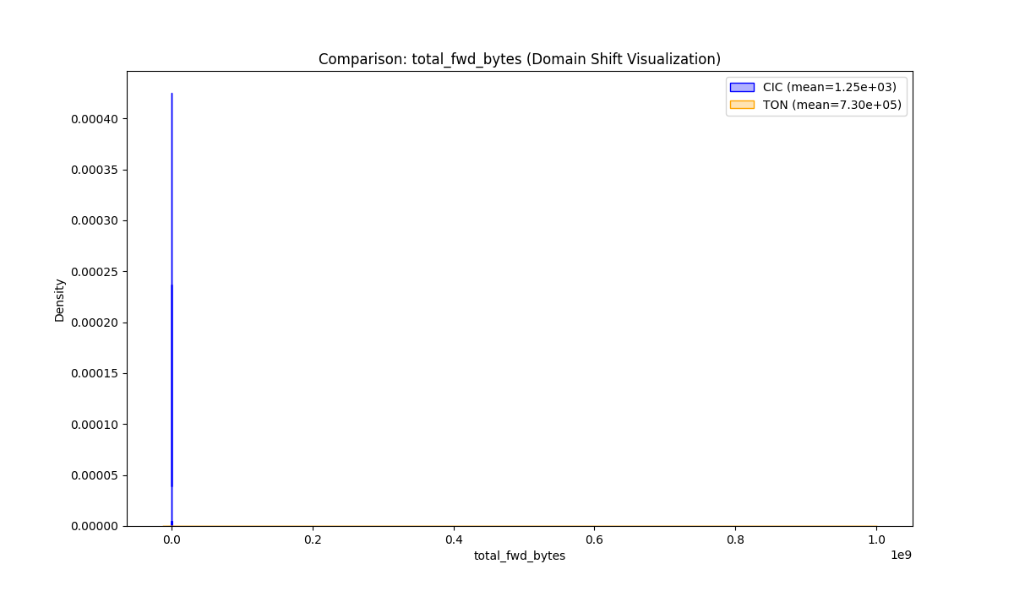

compare_total_fwd_packets.png

Chart generated by the pipeline.

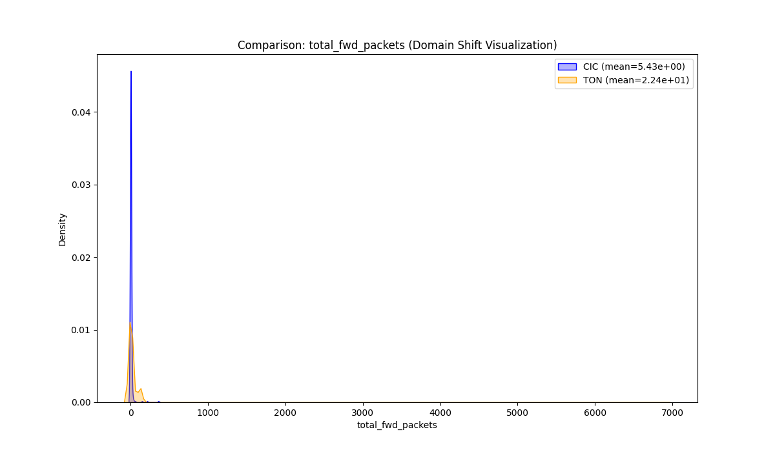

compare_total_packets.png

Chart generated by the pipeline.

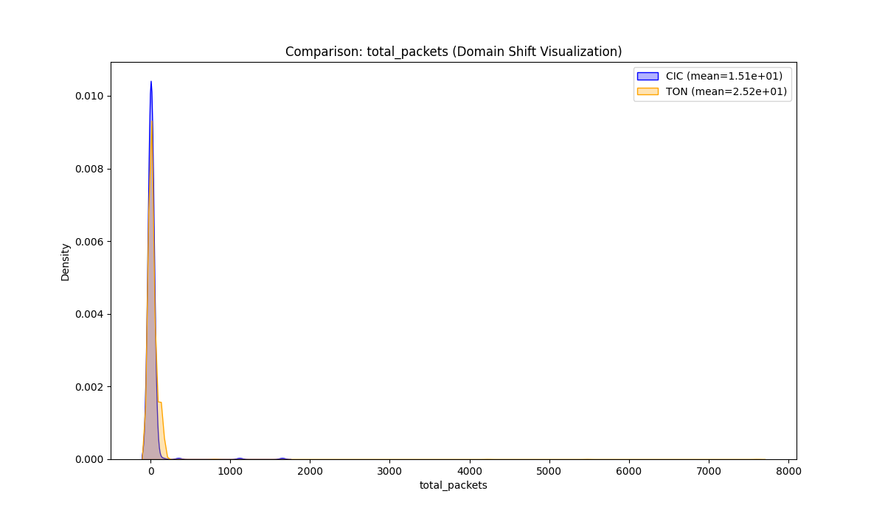

before_after_avg_packet_size.png

Chart generated by the pipeline.

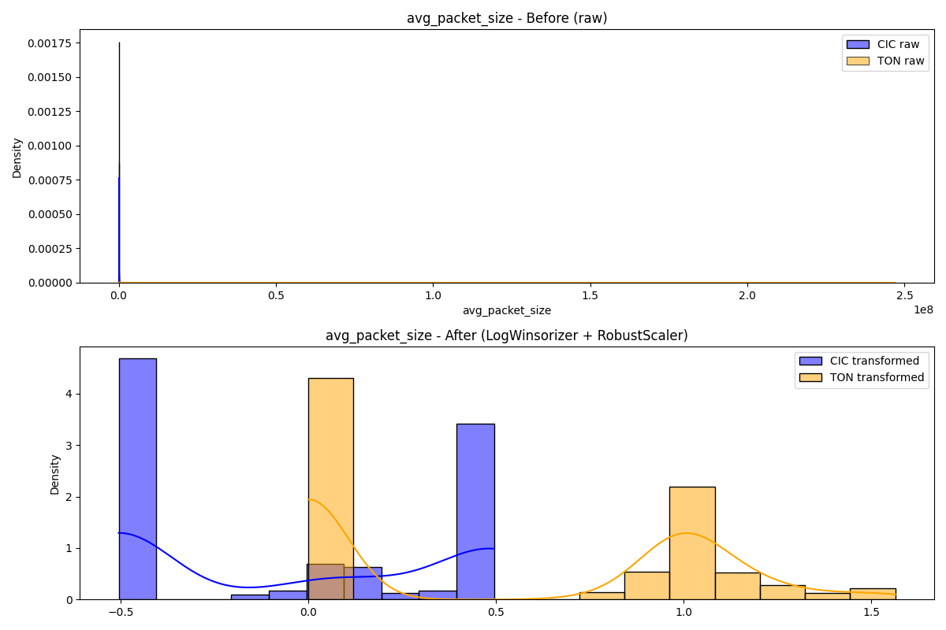

before_after_bytes_per_packet.png

Chart generated by the pipeline.

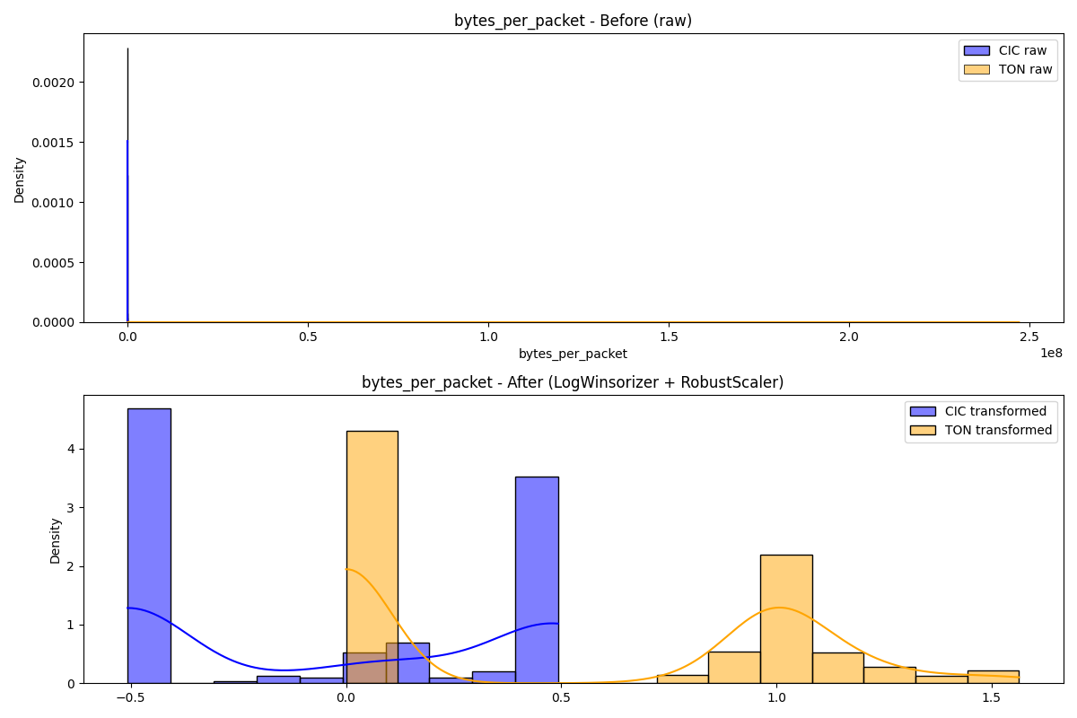

before_after_bytes_per_second.png

Chart generated by the pipeline.

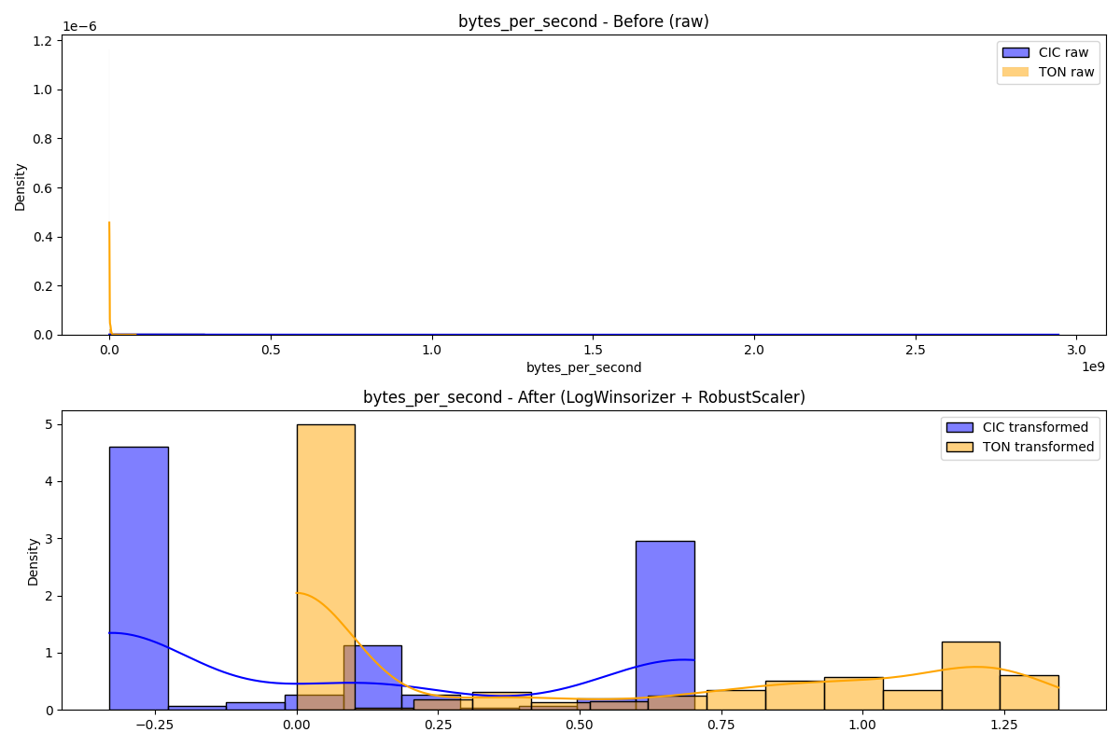

before_after_flow_duration.png

Chart generated by the pipeline.

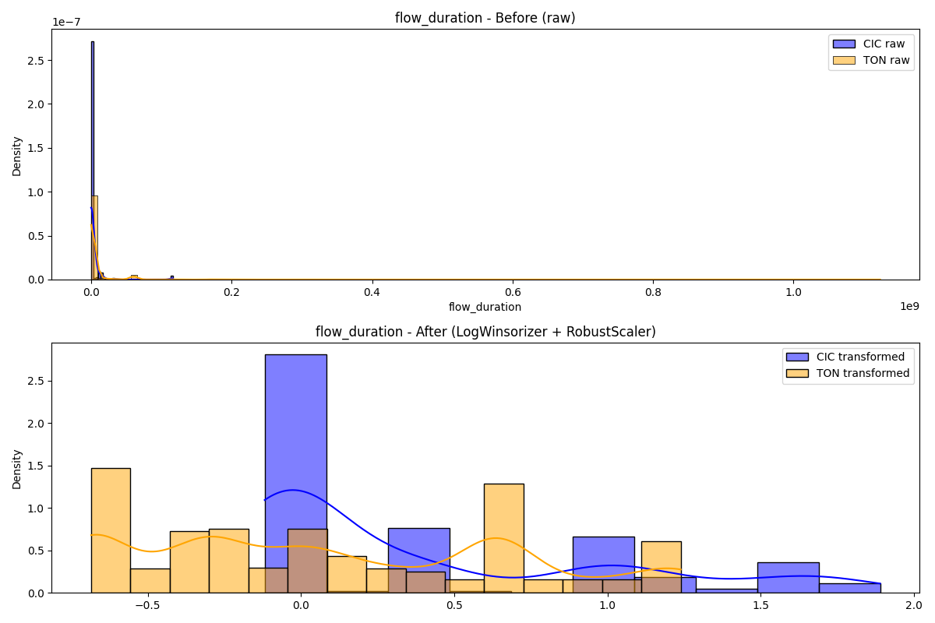

before_after_packets_per_second.png

Chart generated by the pipeline.

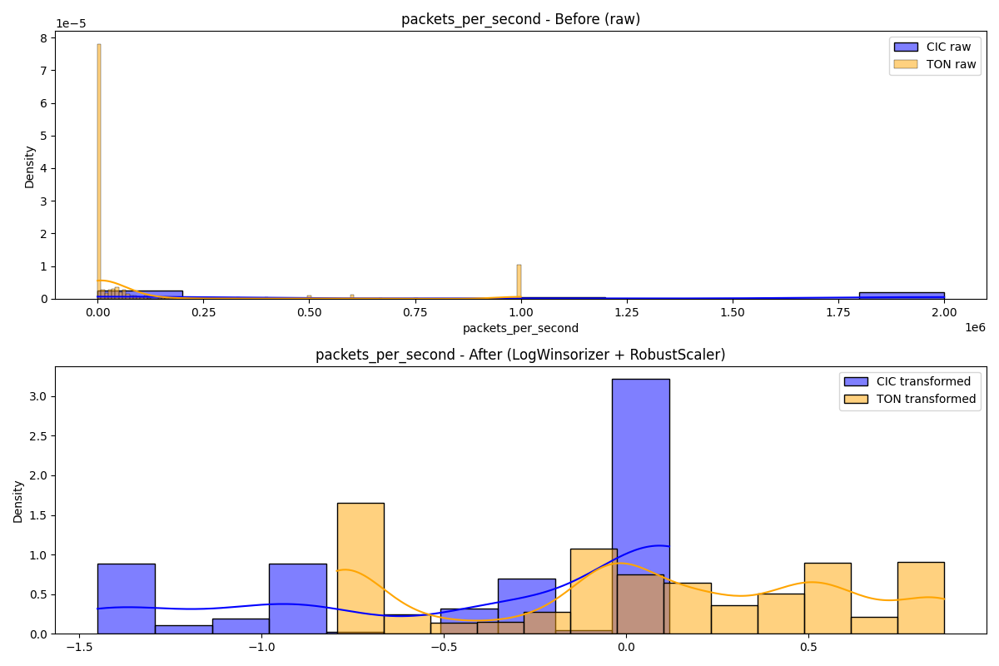

before_after_total_bwd_bytes.png

Chart generated by the pipeline.

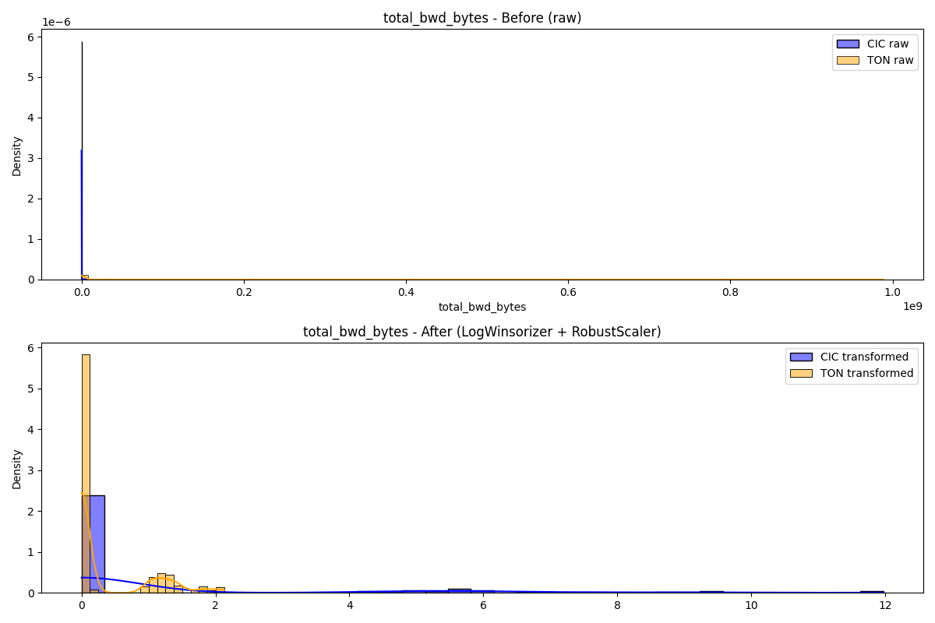

before_after_total_bwd_packets.png

Chart generated by the pipeline.

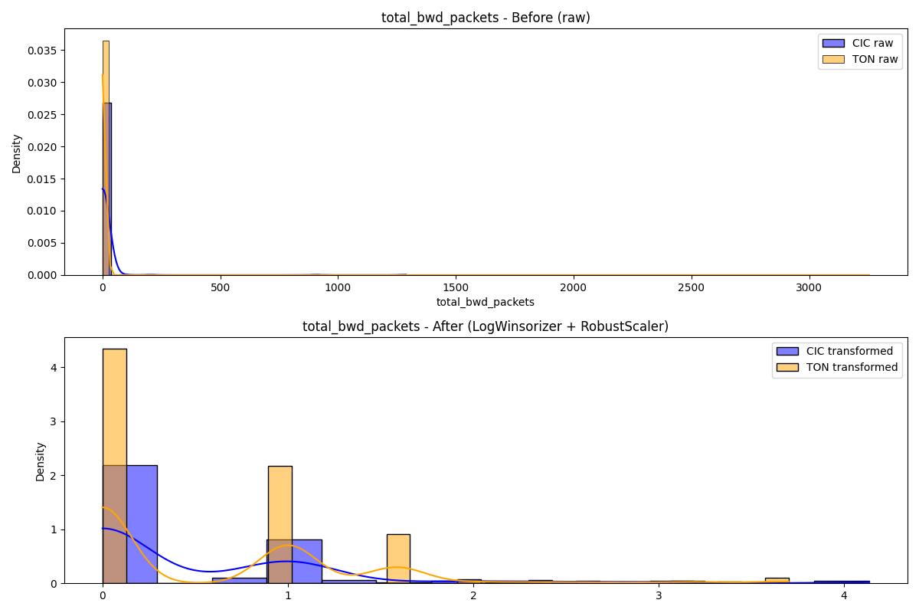

before_after_total_bytes.png

Chart generated by the pipeline.

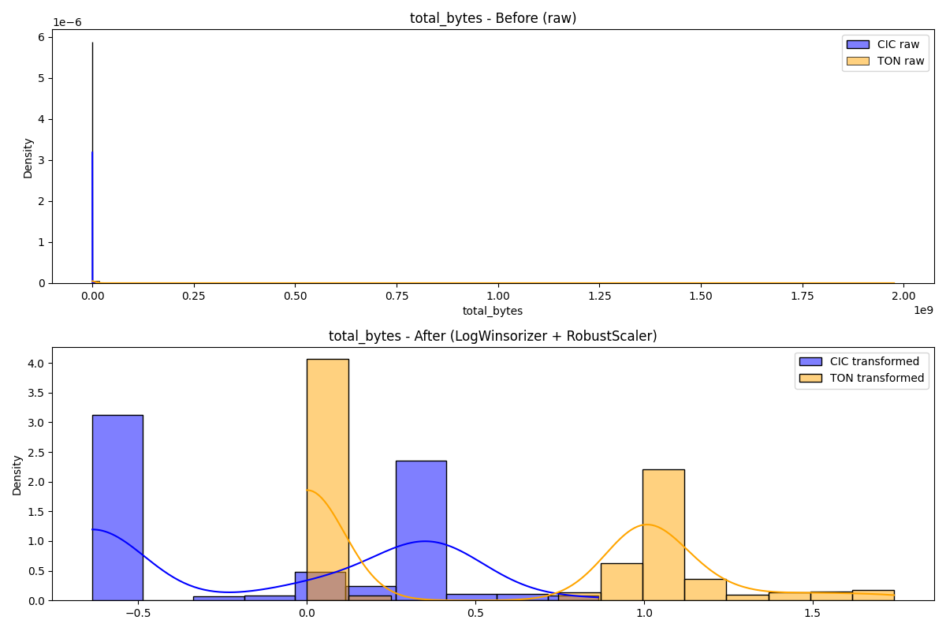

before_after_total_fwd_bytes.png

Chart generated by the pipeline.

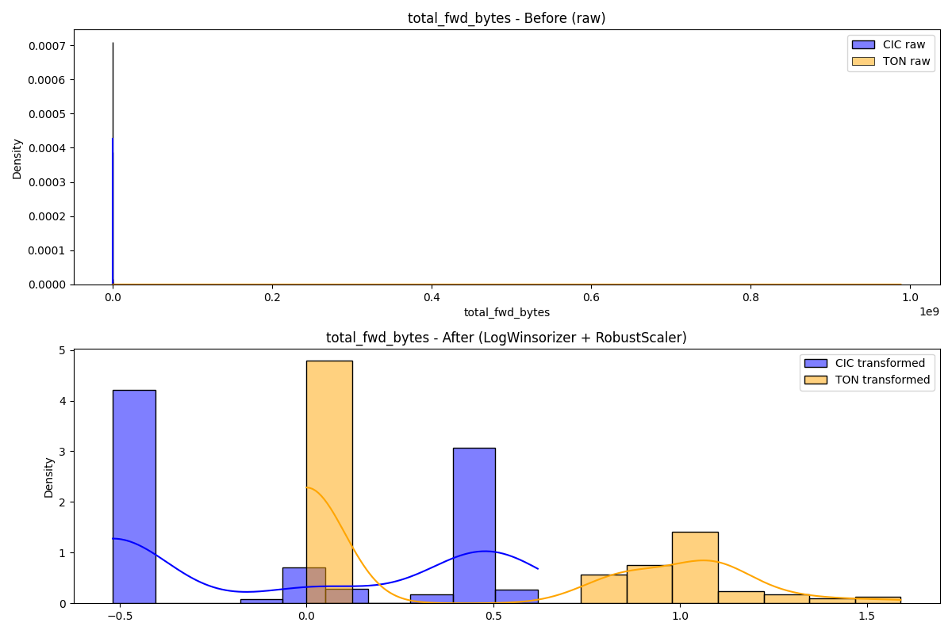

before_after_total_fwd_packets.png

Chart generated by the pipeline.

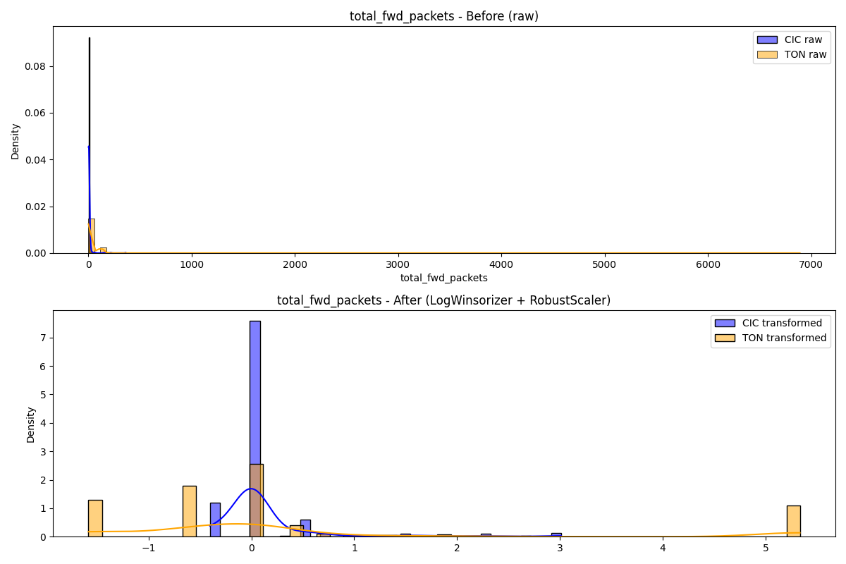

before_after_total_packets.png

Chart generated by the pipeline.

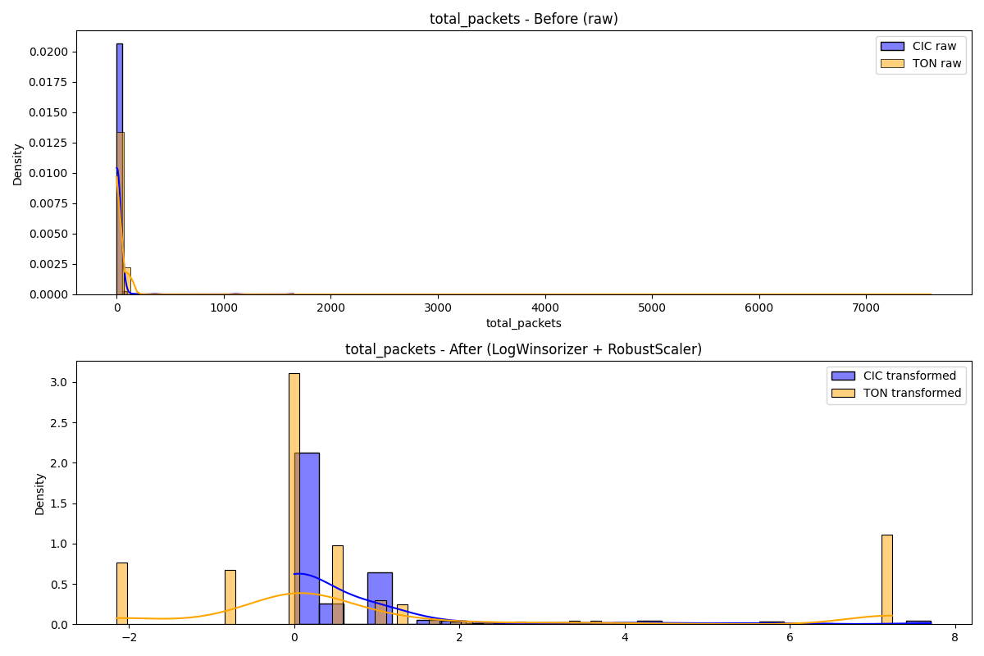

dist_avg_packet_size.png

Chart generated by the pipeline.

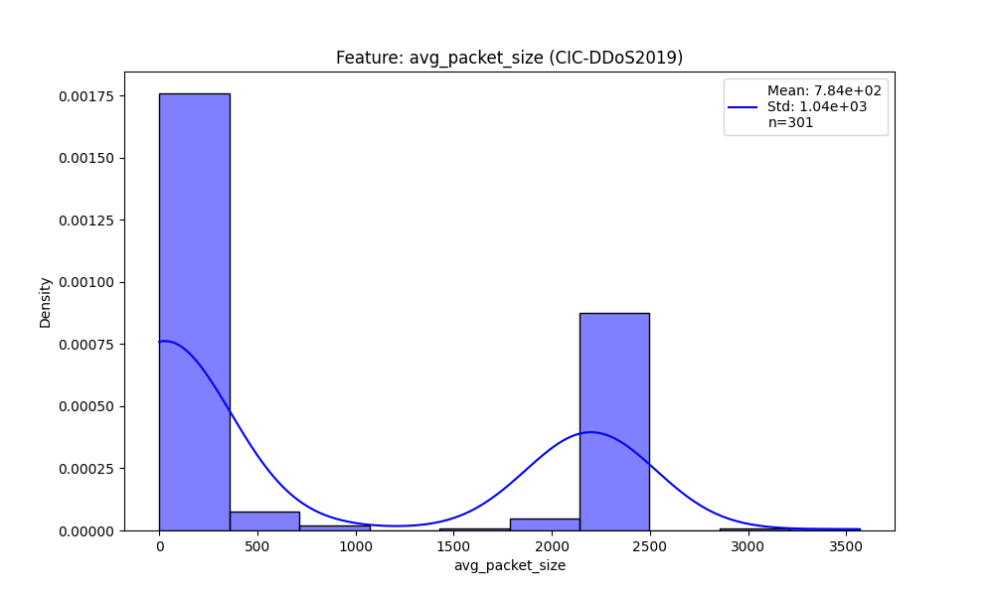

dist_bytes_per_packet.png

Chart generated by the pipeline.

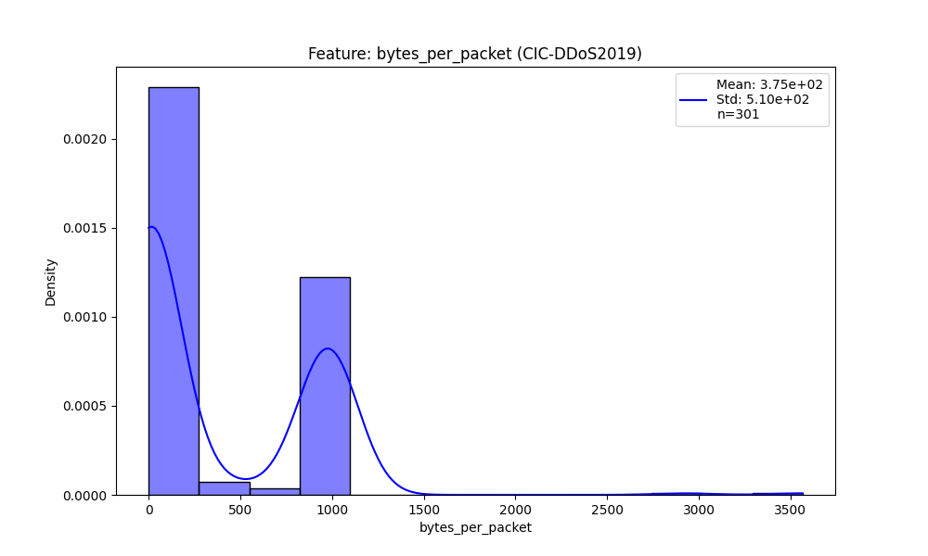

dist_bytes_per_second.png

Chart generated by the pipeline.

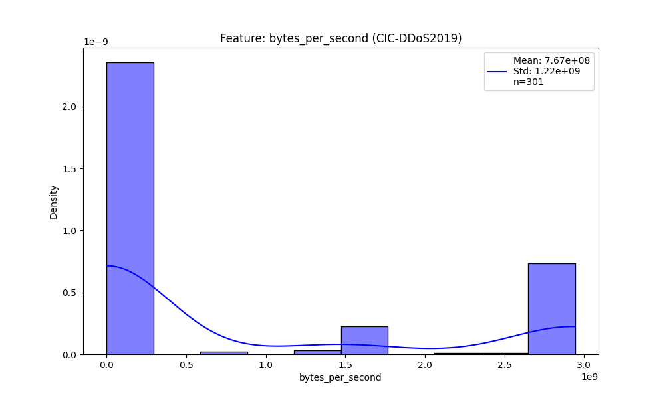

dist_flow_asymmetry.png

Chart generated by the pipeline.

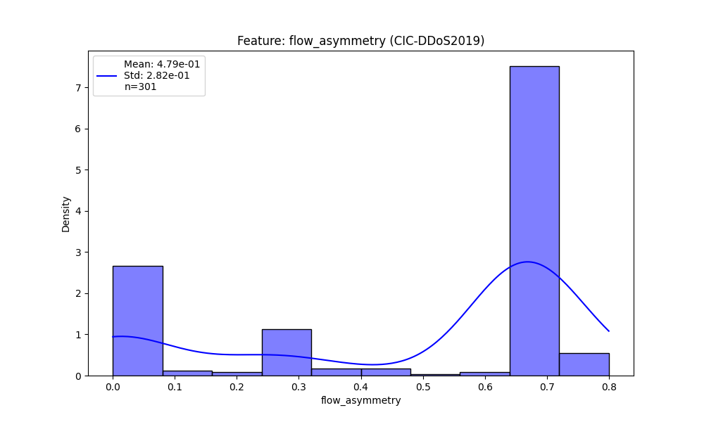

dist_flow_duration.png

Chart generated by the pipeline.

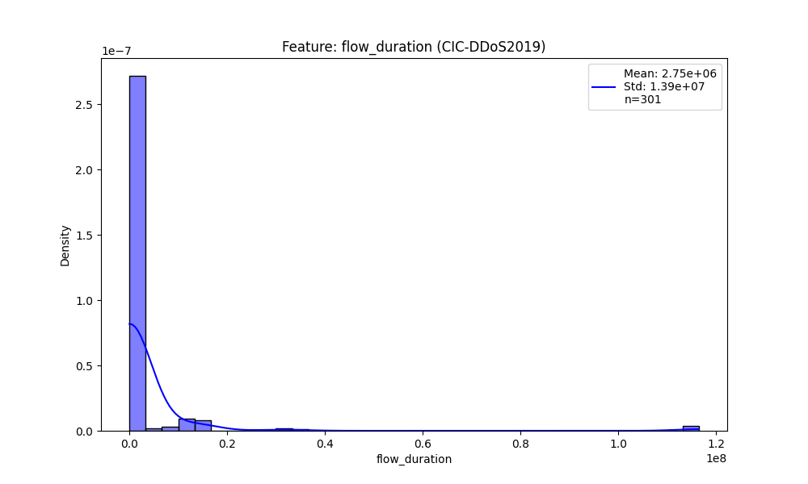

dist_fwd_byte_ratio.png

Chart generated by the pipeline.

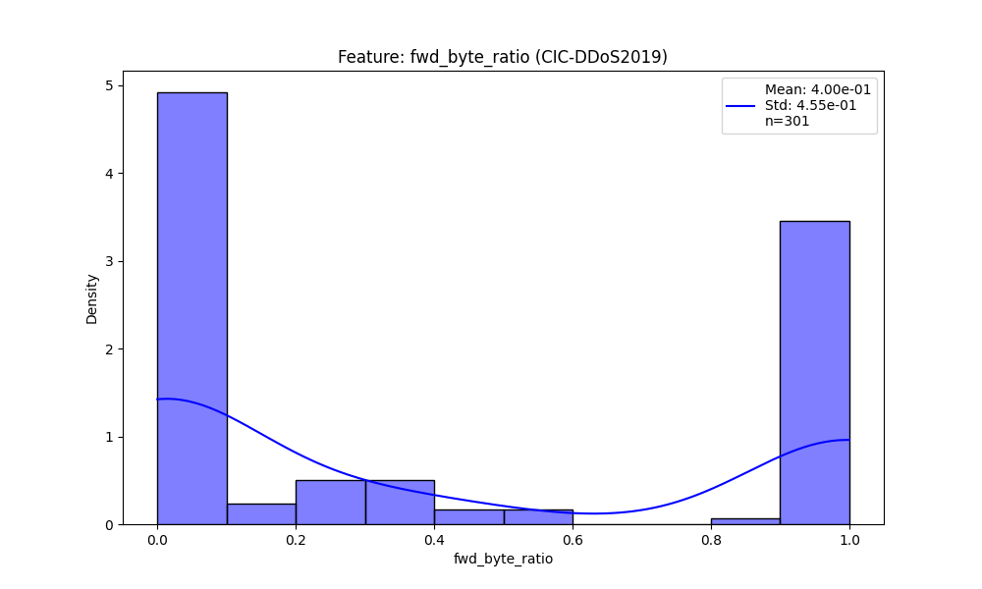

dist_fwd_packet_ratio.png

Chart generated by the pipeline.

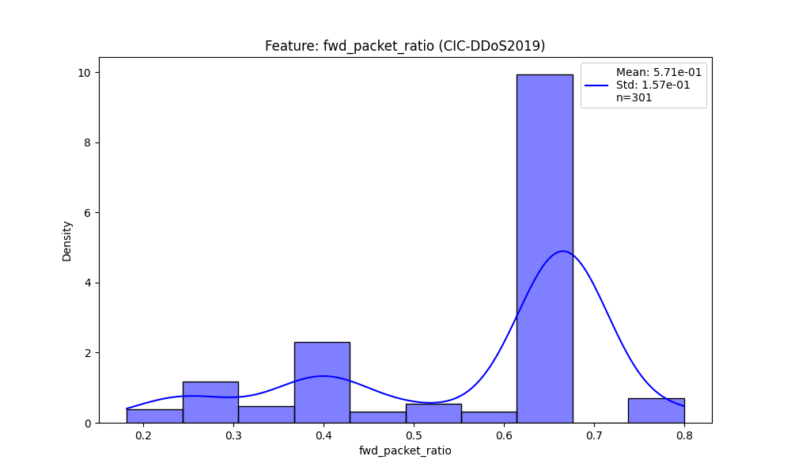

dist_header_ratio.png

Chart generated by the pipeline.

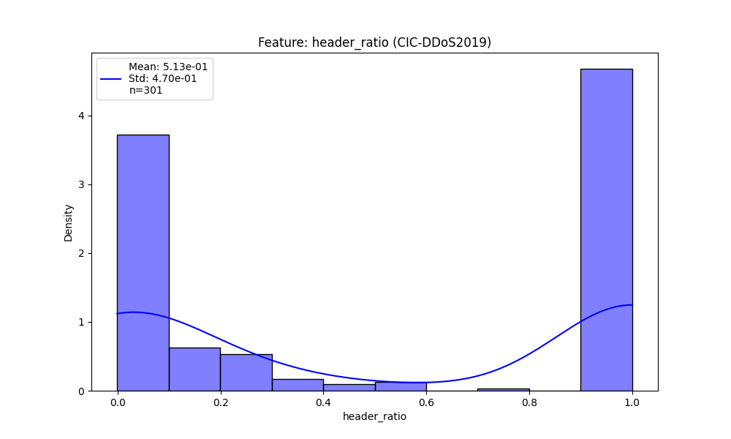

dist_packets_per_second.png

Chart generated by the pipeline.

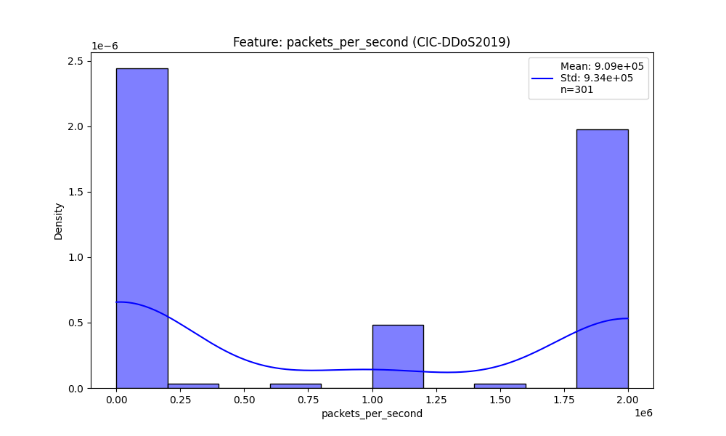

dist_total_bwd_bytes.png

Chart generated by the pipeline.

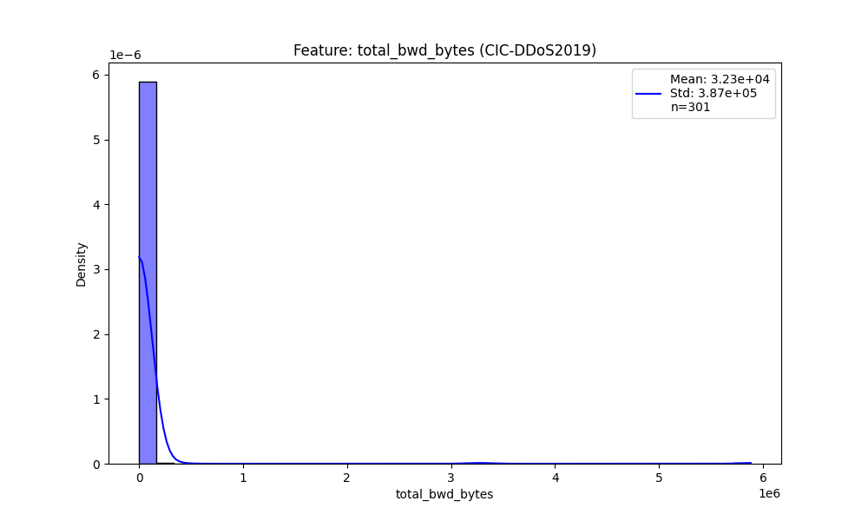

dist_total_bwd_packets.png

Chart generated by the pipeline.

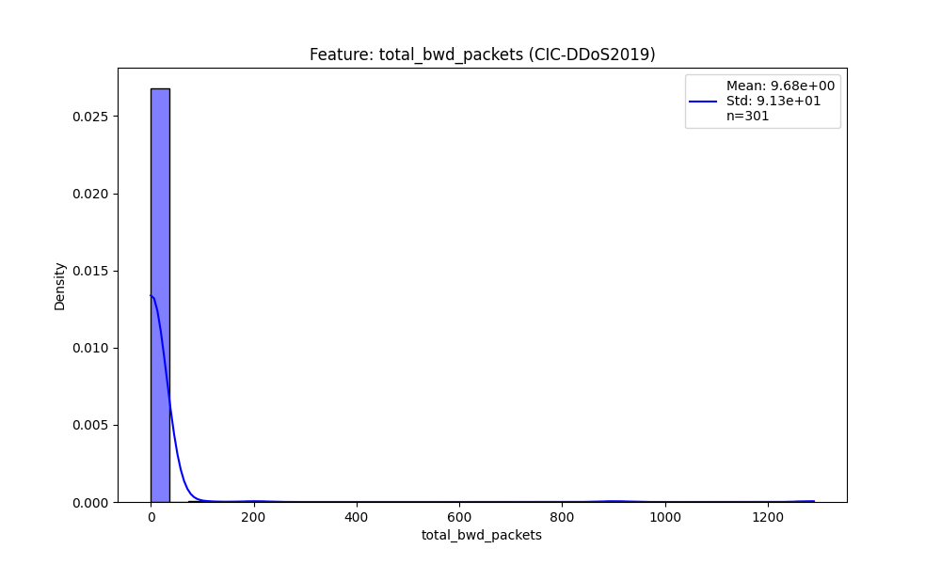

dist_total_bytes.png

Chart generated by the pipeline.

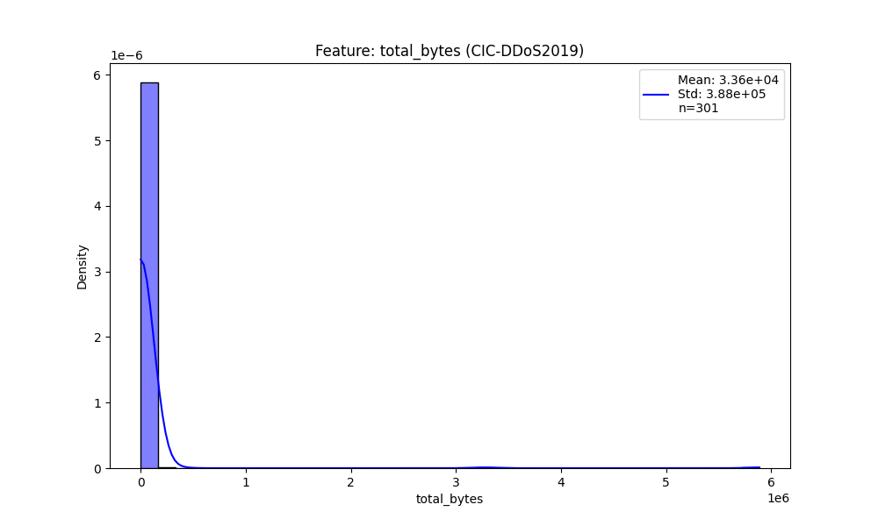

dist_total_fwd_bytes.png

Chart generated by the pipeline.

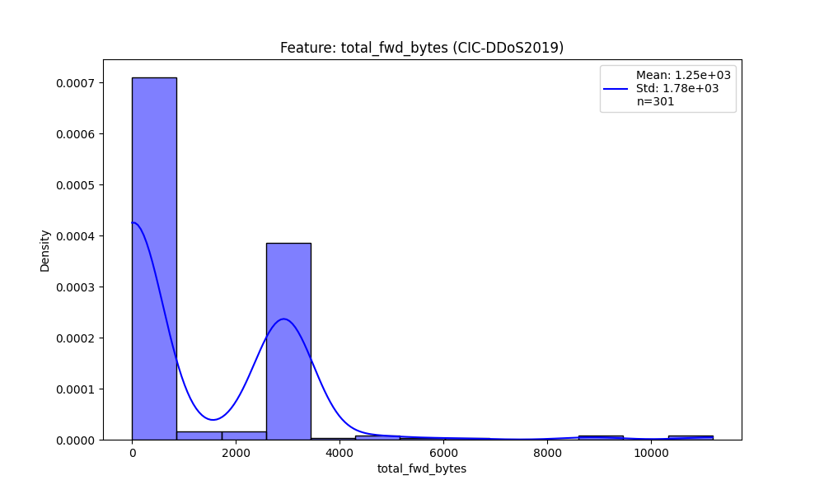

dist_total_fwd_packets.png

Chart generated by the pipeline.

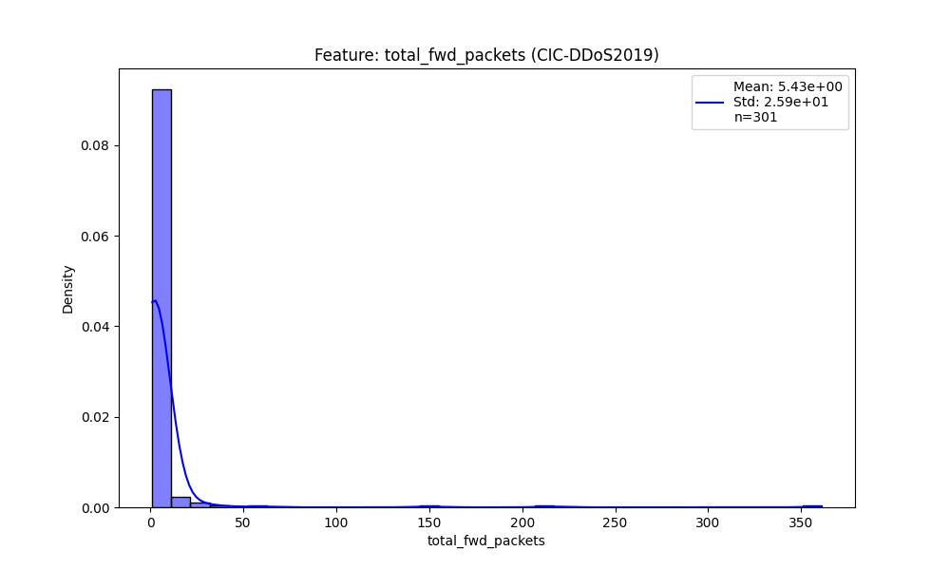

dist_total_packets.png

Chart generated by the pipeline.

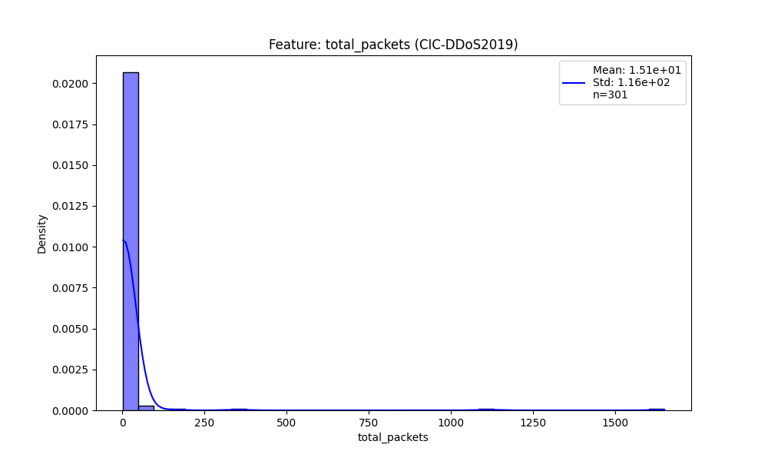

dist_avg_packet_size.png

Chart generated by the pipeline.

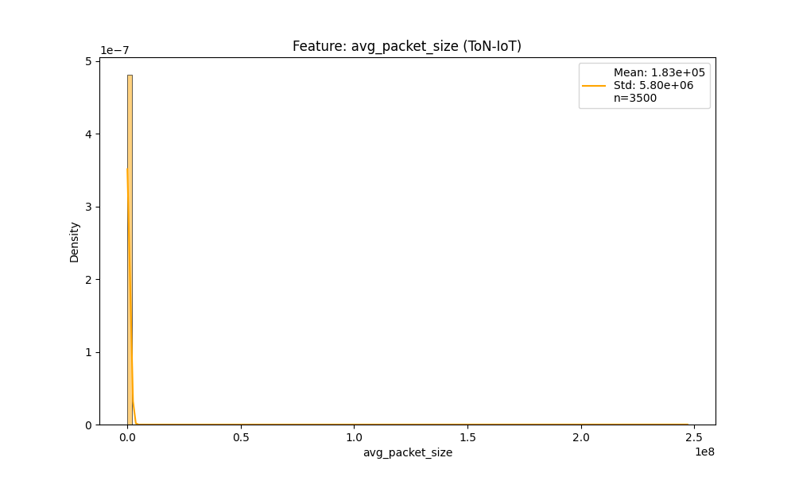

dist_bytes_per_packet.png

Chart generated by the pipeline.

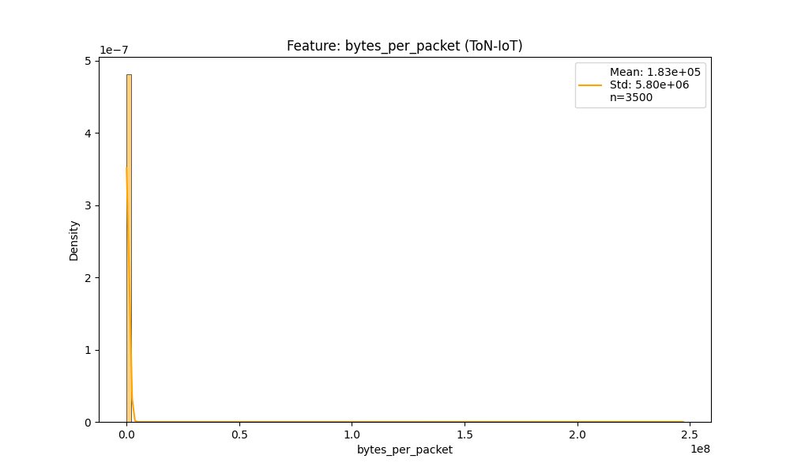

dist_bytes_per_second.png

Chart generated by the pipeline.

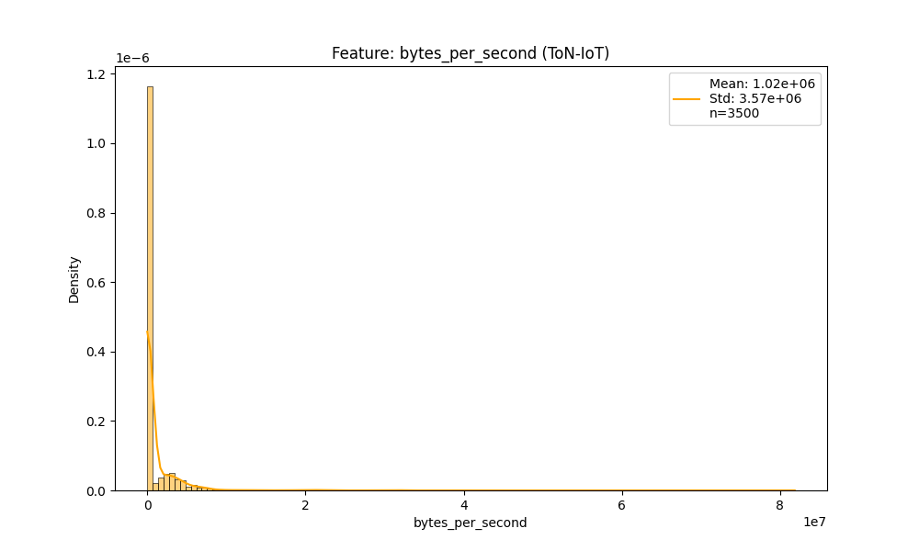

dist_flow_asymmetry.png

Chart generated by the pipeline.

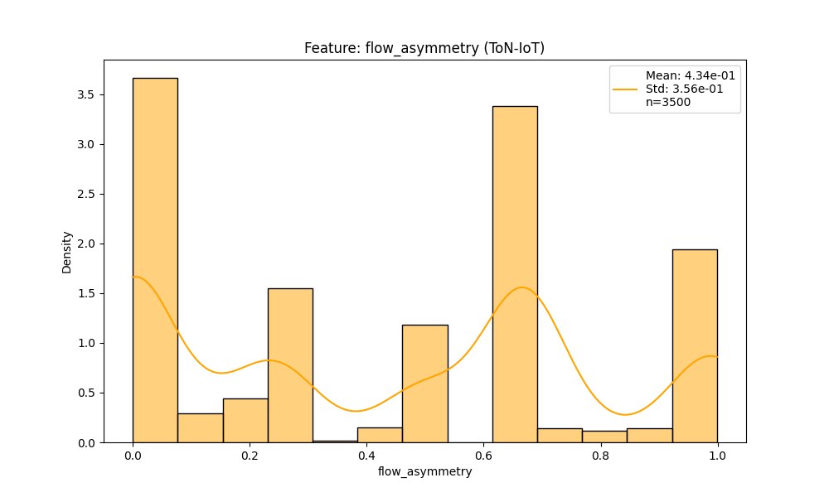

dist_flow_duration.png

Chart generated by the pipeline.

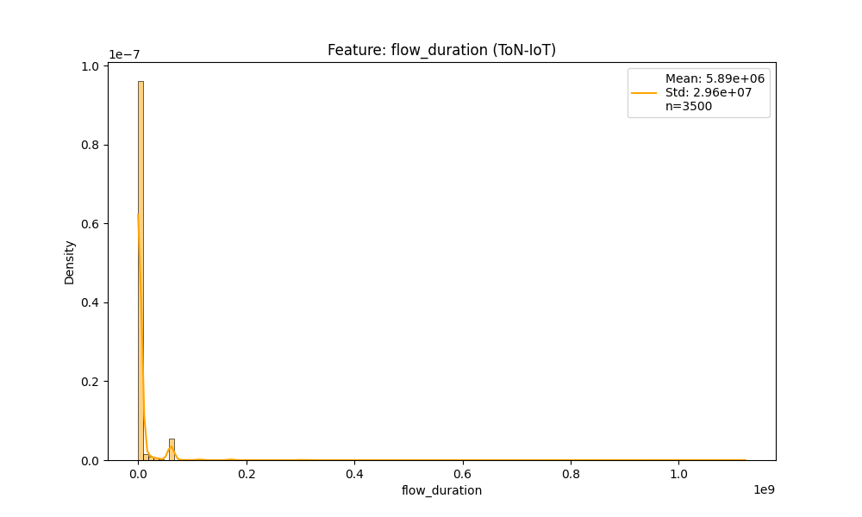

dist_fwd_byte_ratio.png

Chart generated by the pipeline.

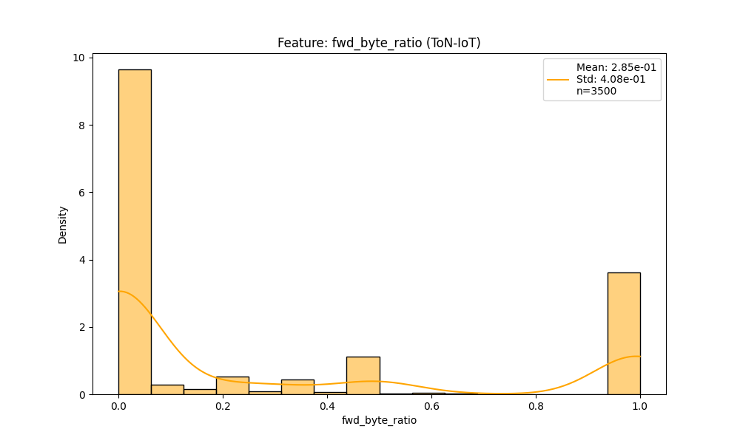

dist_fwd_packet_ratio.png

Chart generated by the pipeline.

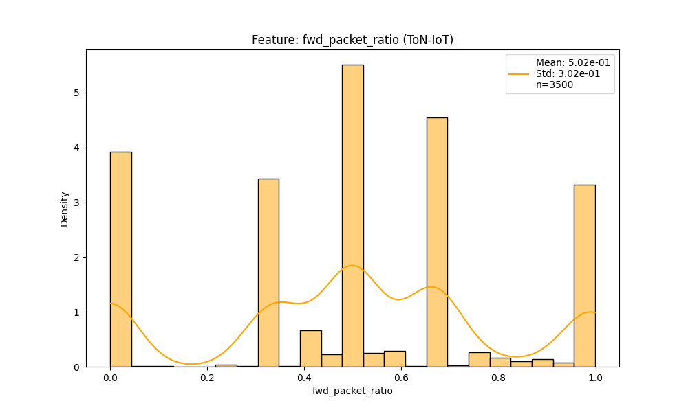

dist_header_ratio.png

Chart generated by the pipeline.

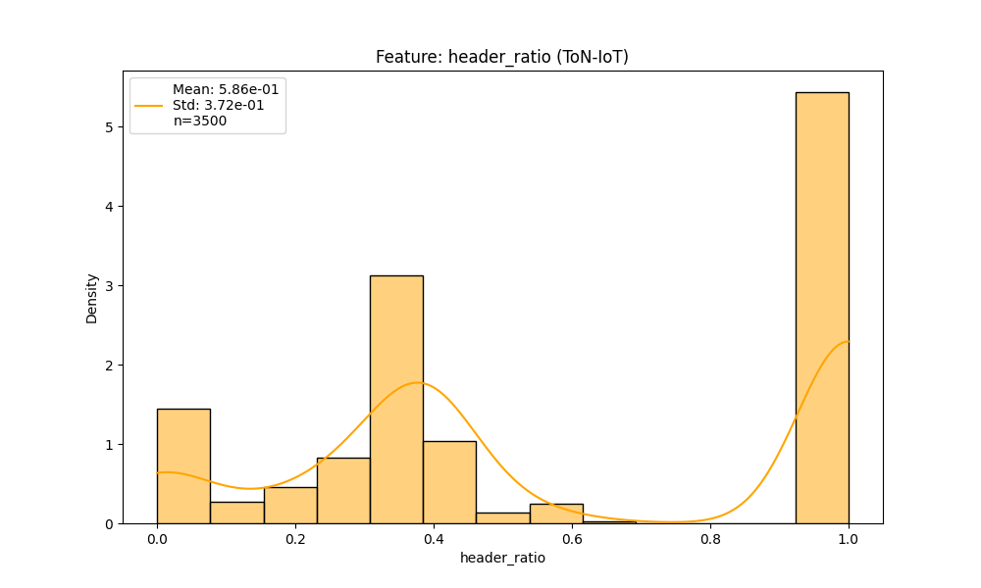

dist_packets_per_second.png

Chart generated by the pipeline.

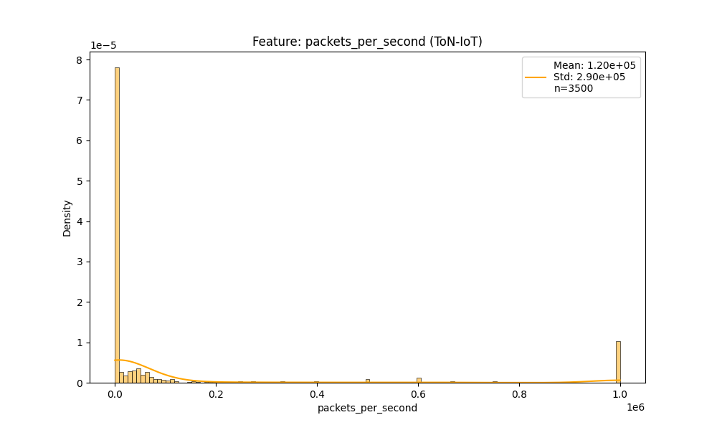

dist_total_bwd_bytes.png

Chart generated by the pipeline.

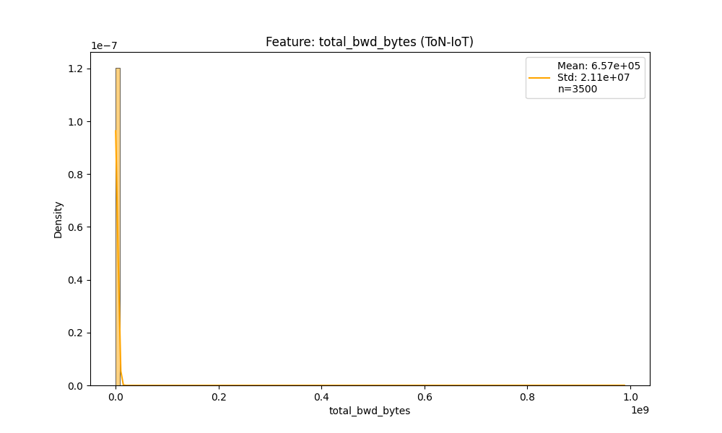

dist_total_bwd_packets.png

Chart generated by the pipeline.

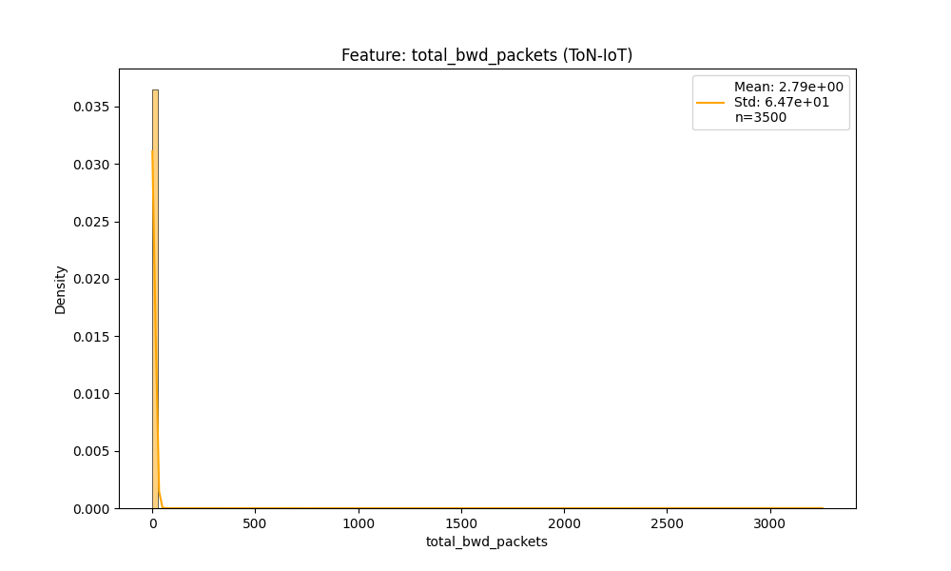

dist_total_bytes.png

Chart generated by the pipeline.

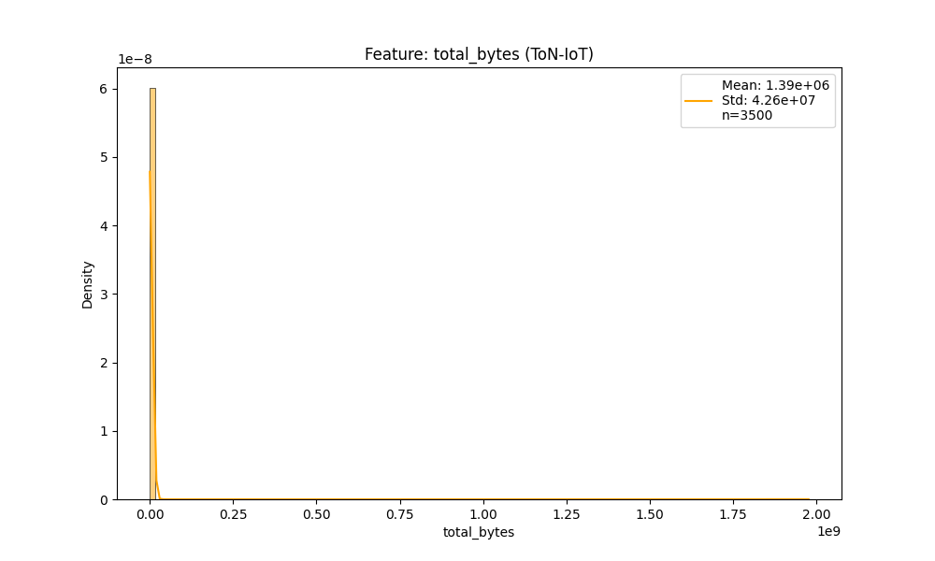

dist_total_fwd_bytes.png

Chart generated by the pipeline.

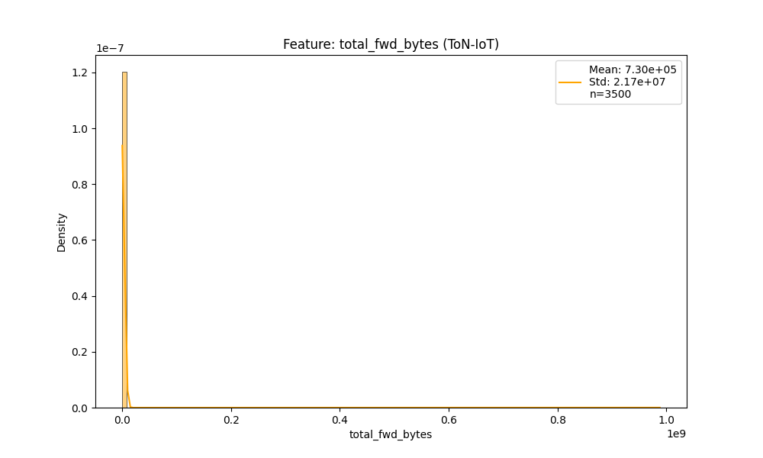

dist_total_fwd_packets.png

Chart generated by the pipeline.

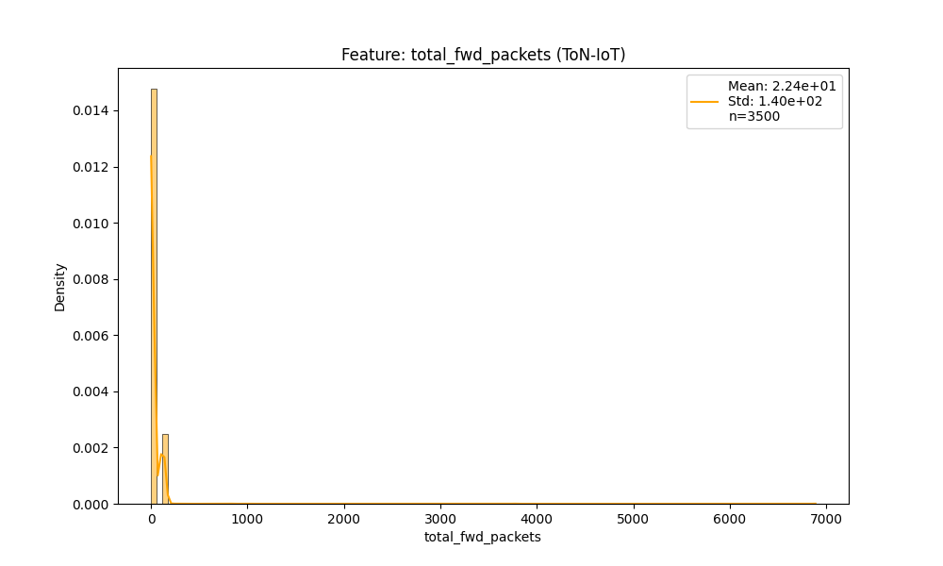

dist_total_packets.png

Chart generated by the pipeline.

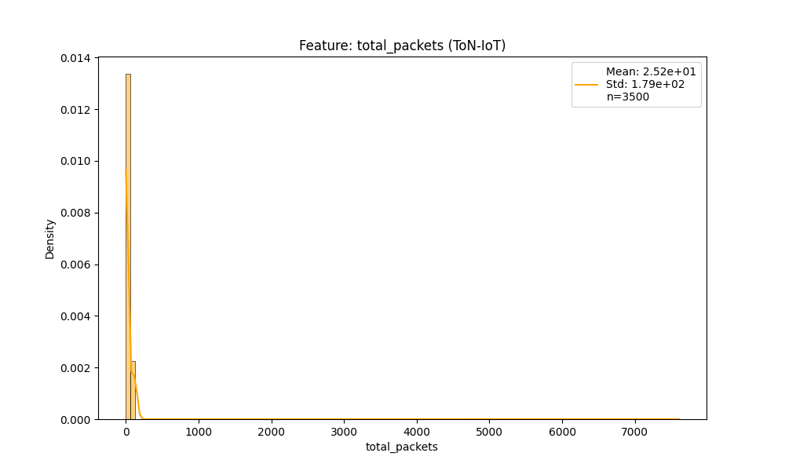

# Decision charts (MCDM)

Summarizes decision matrix, TOPSIS steps, and ranking views.

3d_solution_space.png

Chart generated by the pipeline.

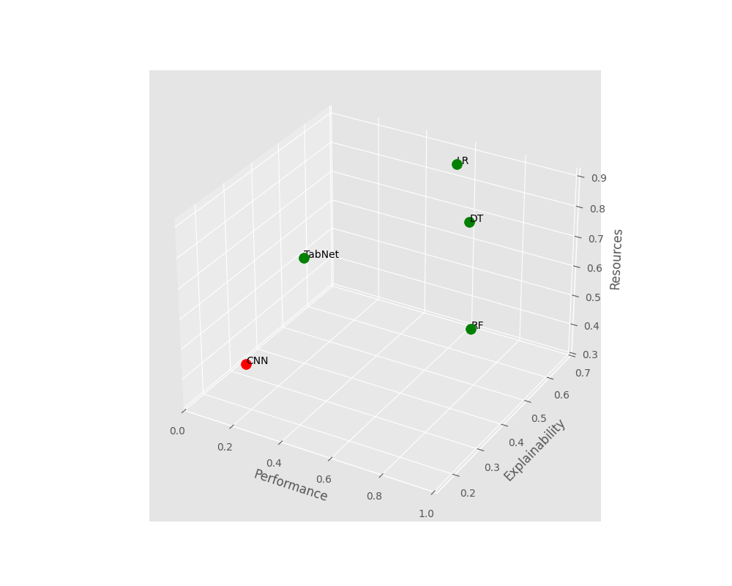

decision_matrix_heatmap.png

Chart generated by the pipeline.

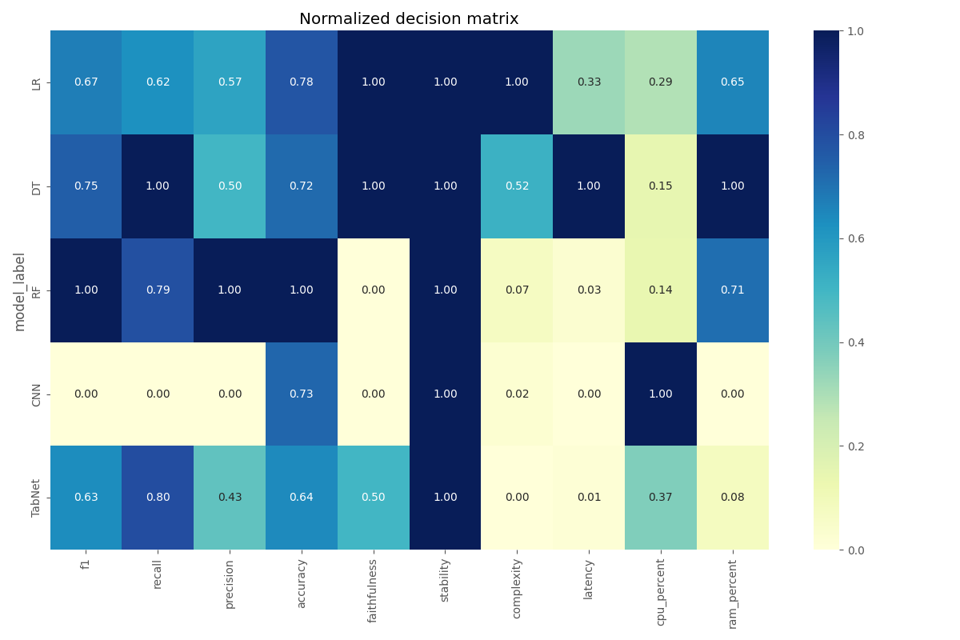

radar_comparison.png

Radar comparison of top alternatives.

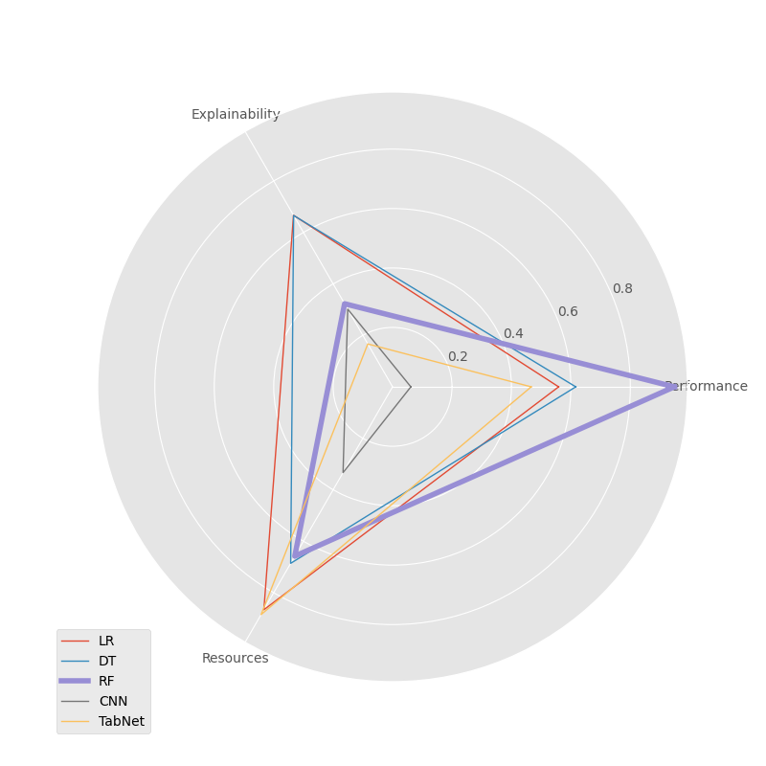

unified_dimensions_comparison.png

Chart generated by the pipeline.

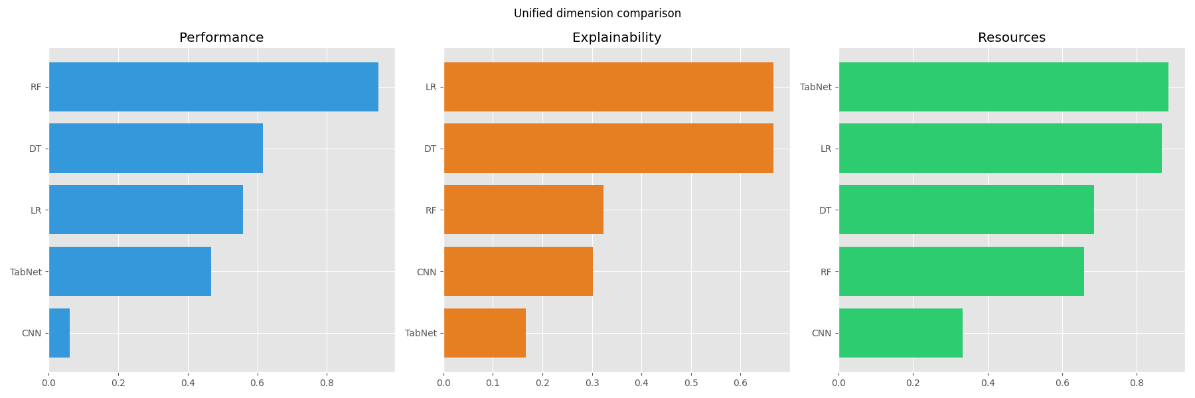

viz_01_matrix_M.png

Chart generated by the pipeline.

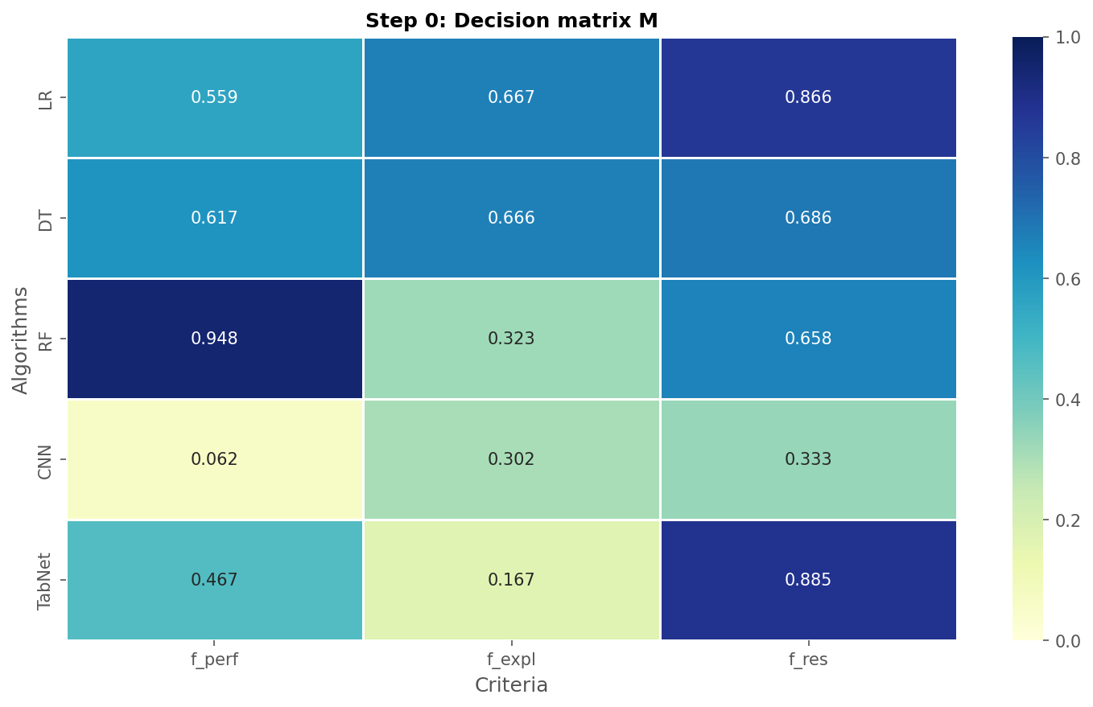

viz_02_3d_tradeoffs.png

Chart generated by the pipeline.

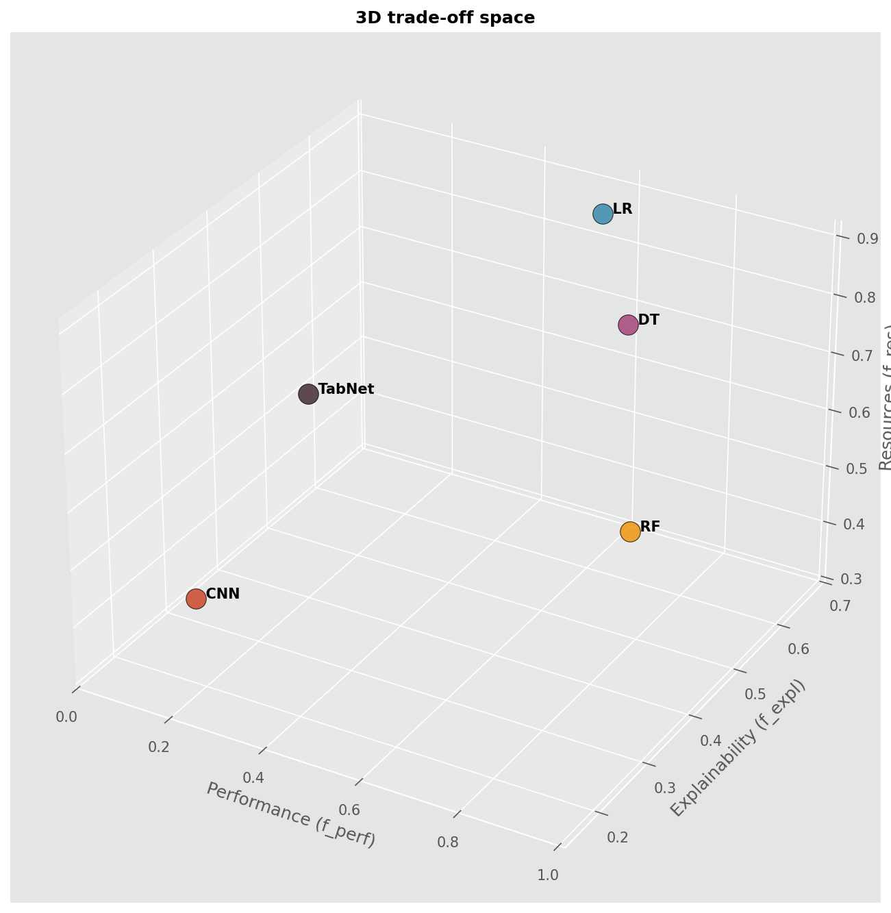

viz_03_normalization.png

Chart generated by the pipeline.

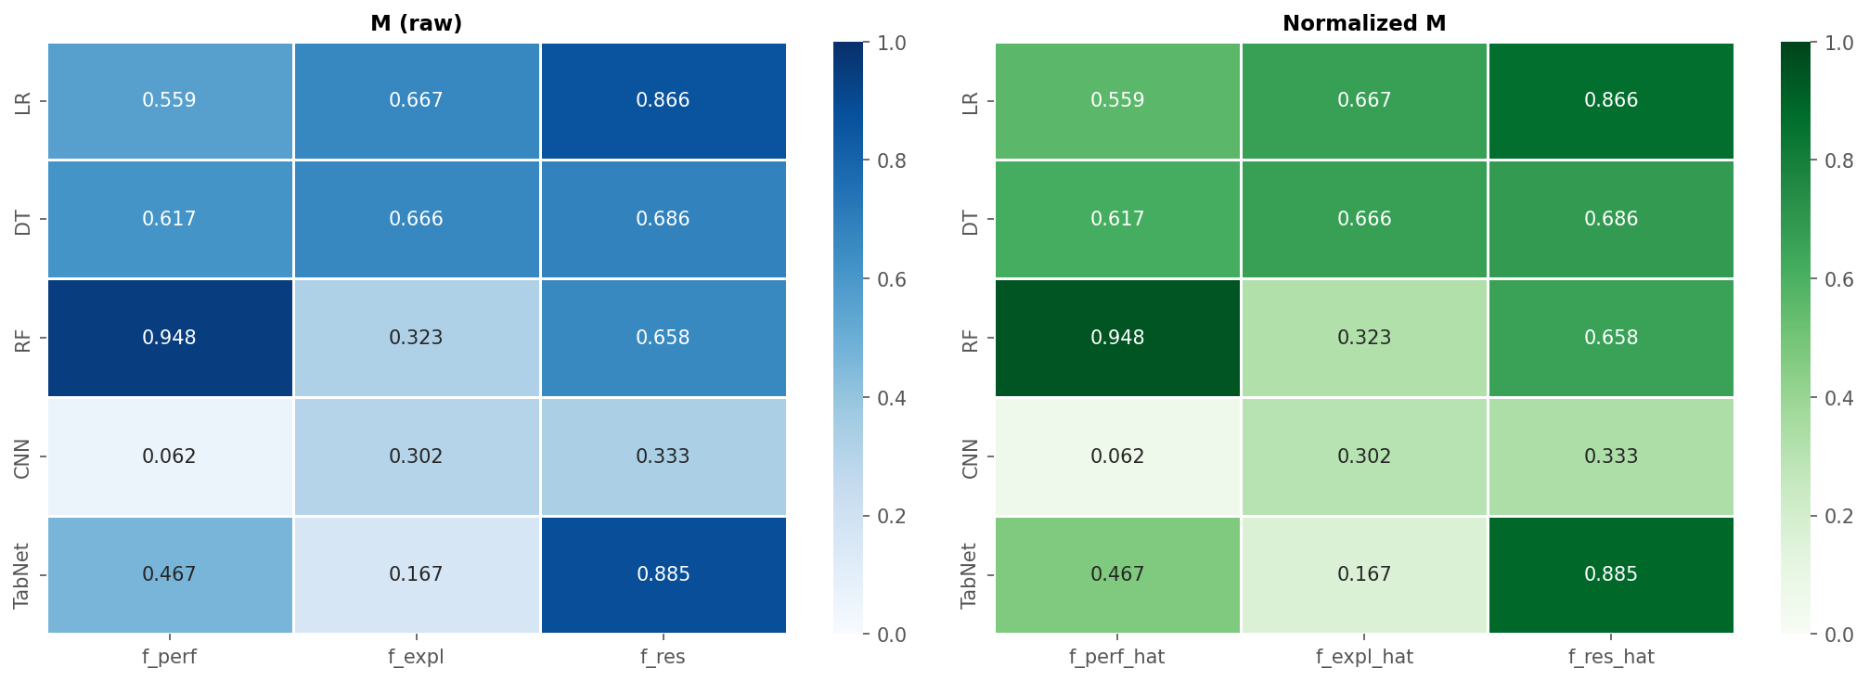

viz_04_weighting.png

Chart generated by the pipeline.

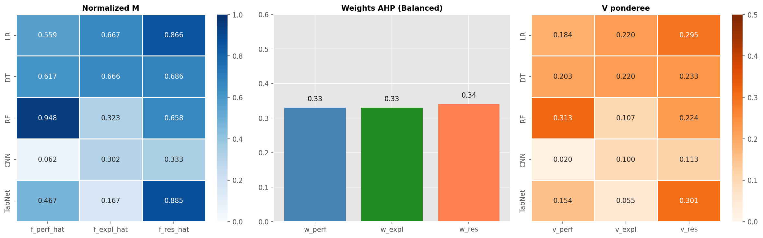

viz_05_profiles.png

Chart generated by the pipeline.

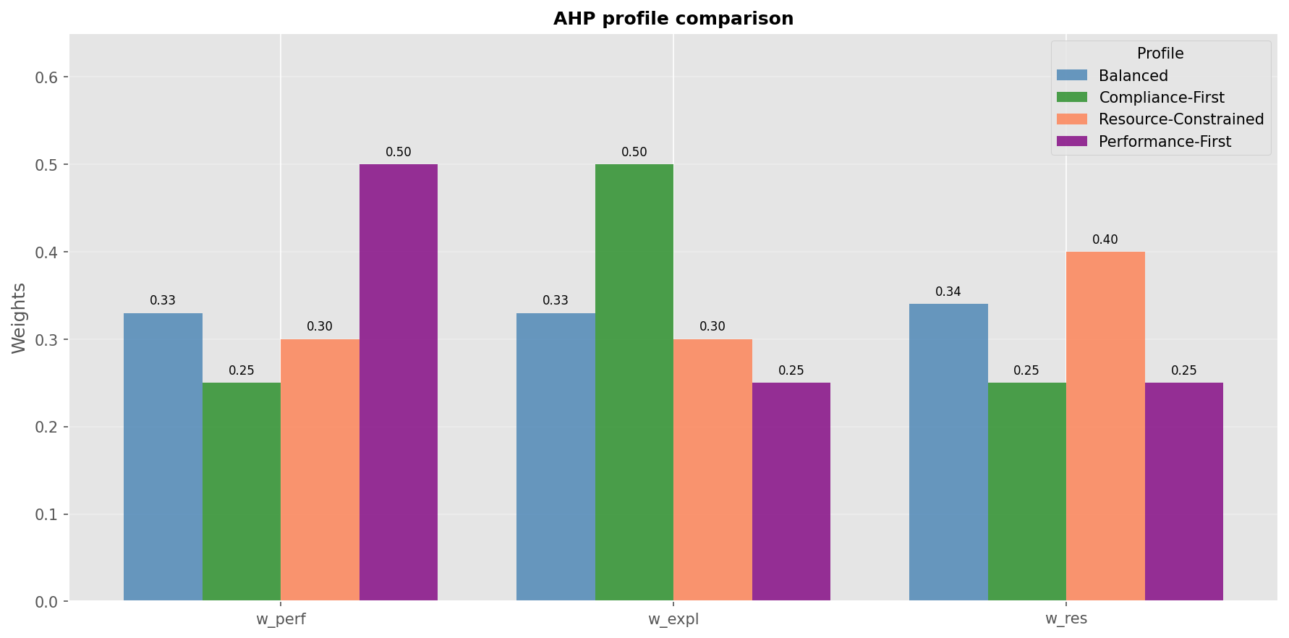

viz_06_ideal_solutions.png

Chart generated by the pipeline.

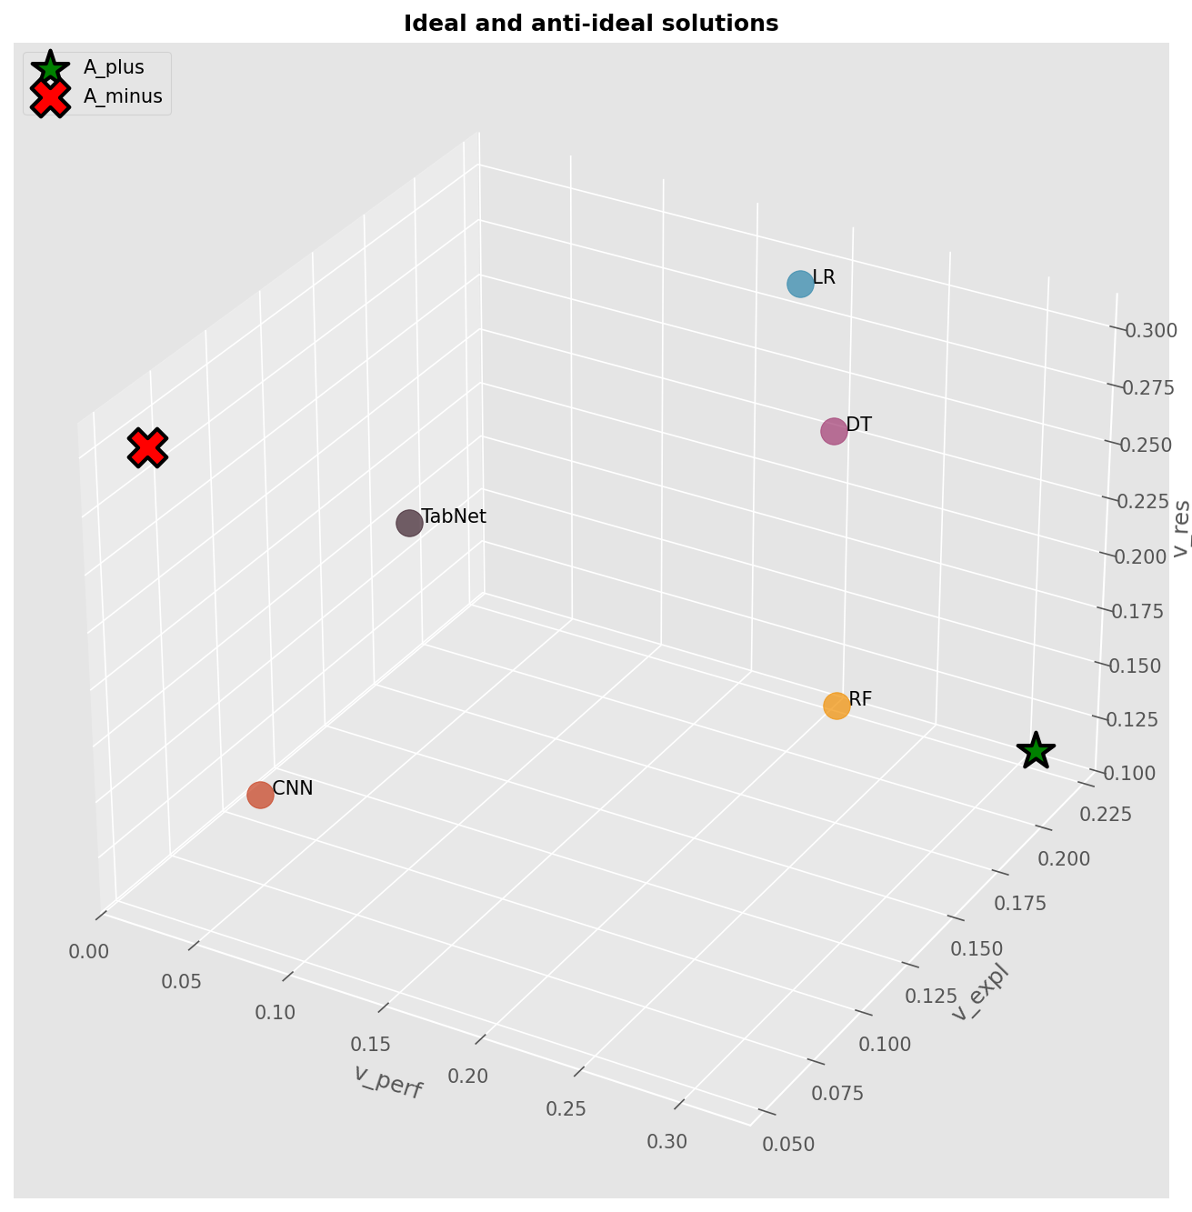

viz_07_distances.png

Chart generated by the pipeline.

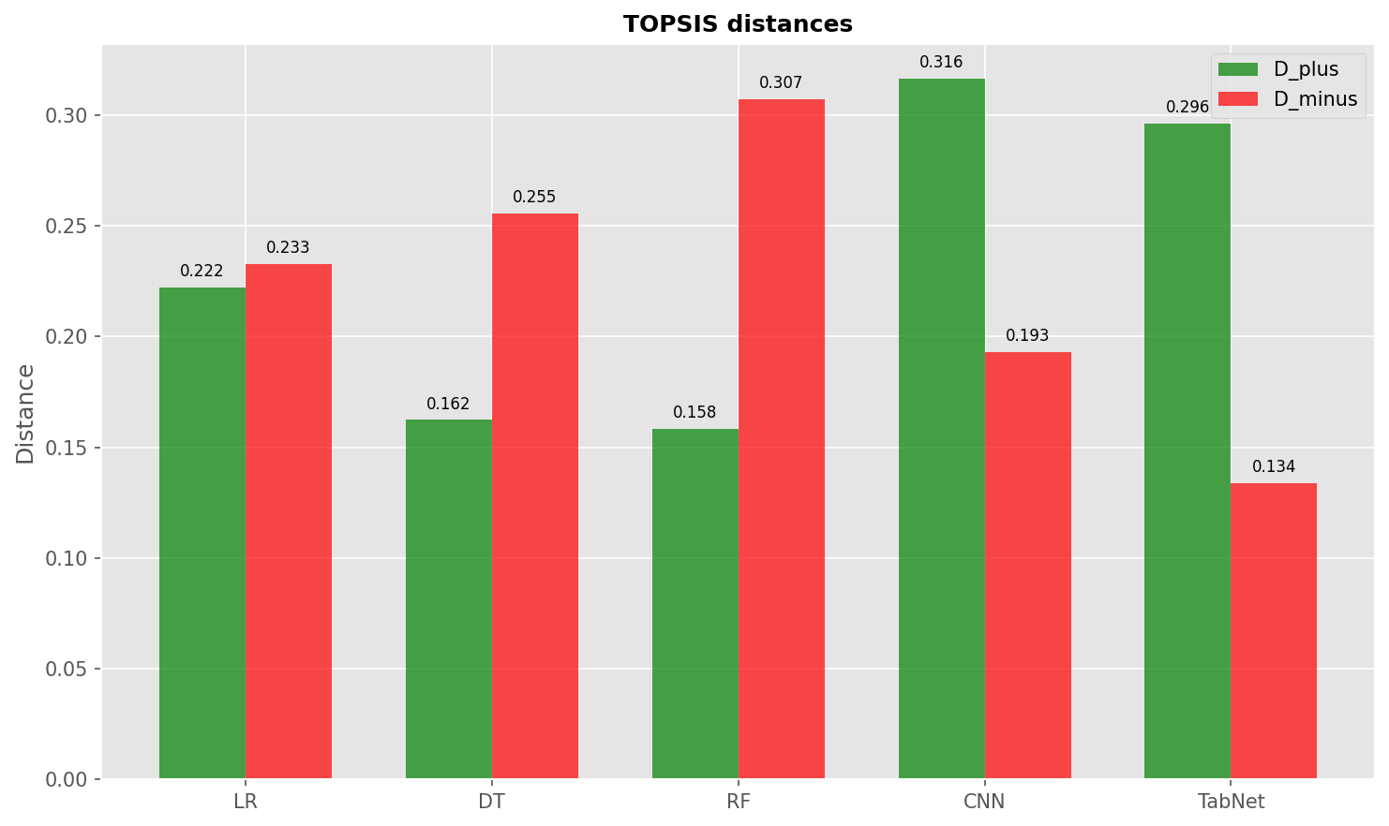

viz_08_closeness.png

TOPSIS closeness coefficients for each alternative.

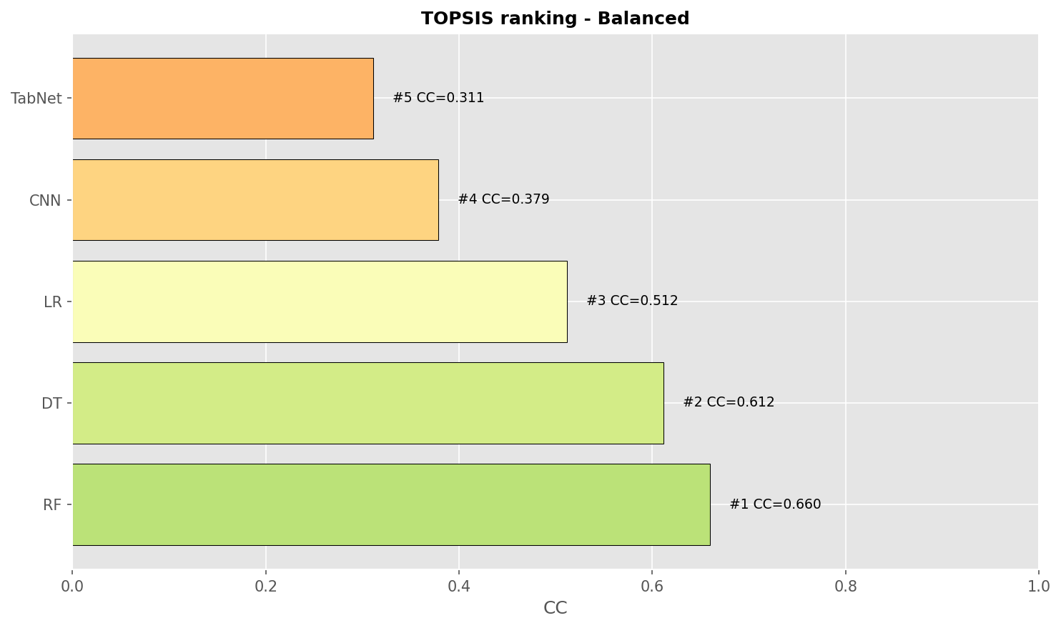

viz_09_radar.png

Radar comparison of top alternatives.

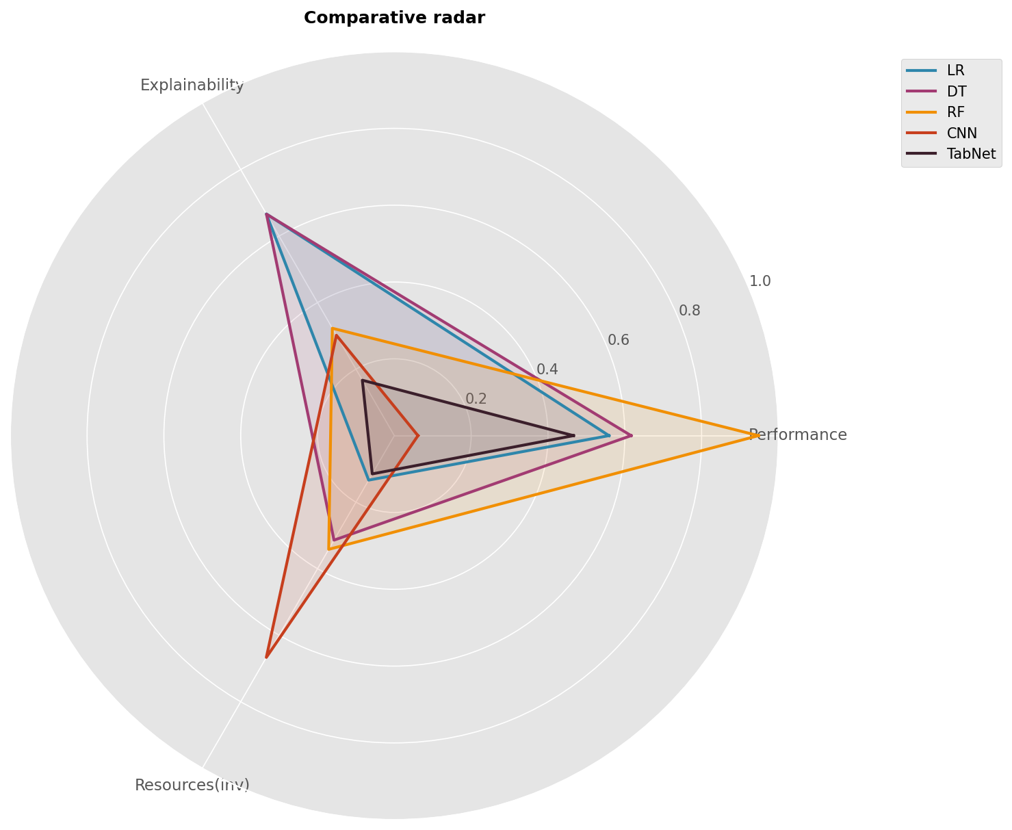

viz_10_2d_perf_expl.png

Chart generated by the pipeline.

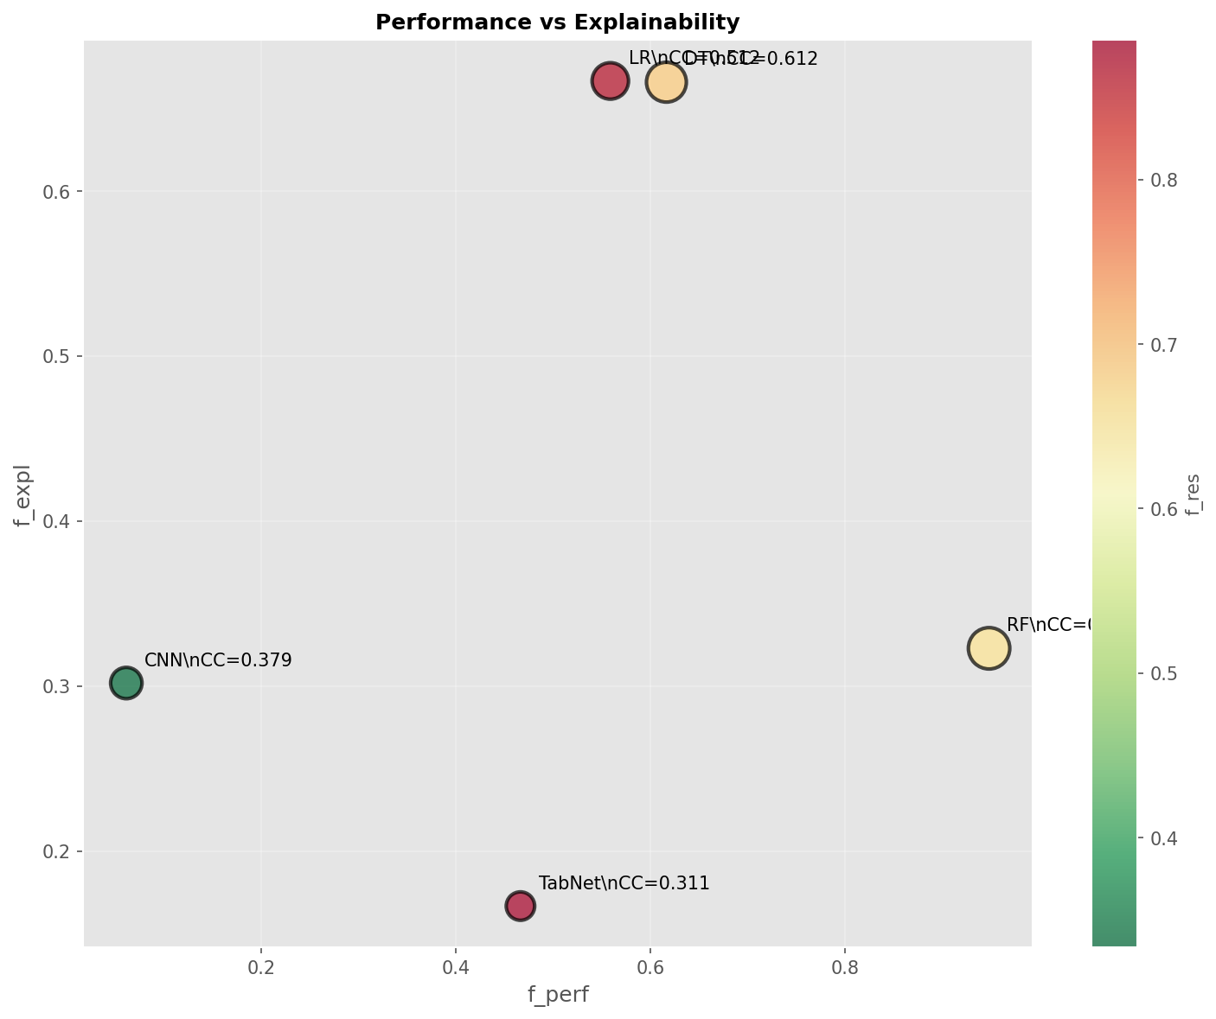

viz_11_pareto_3d.png

Pareto front visualization of non-dominated vs dominated solutions.

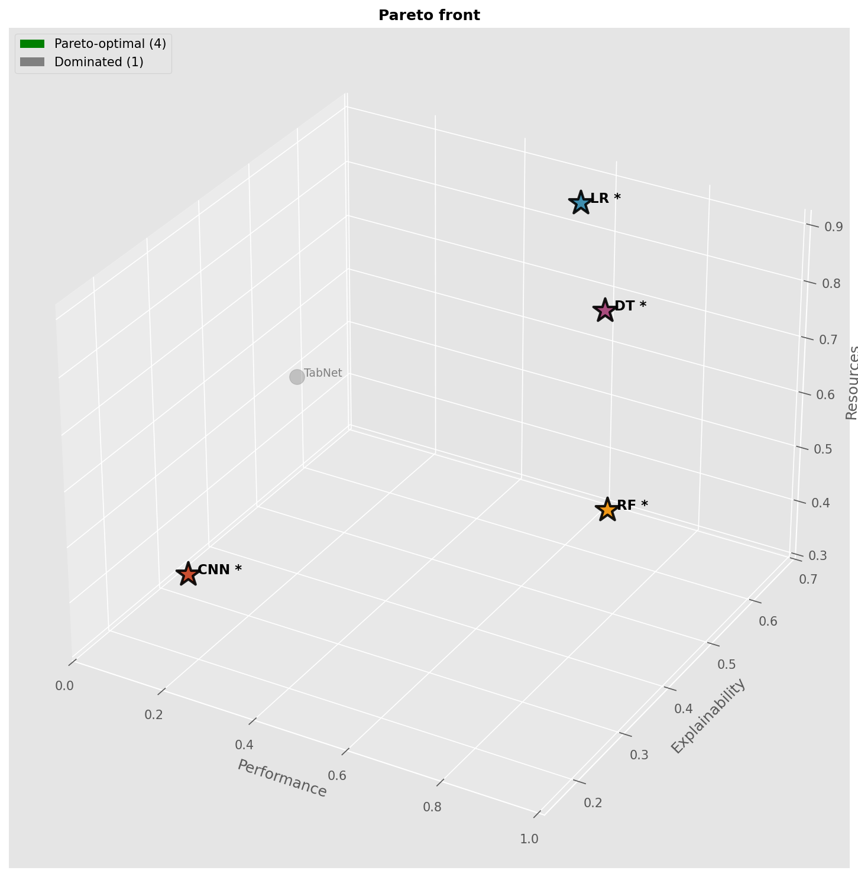

viz_12_pareto_2d.png

Pareto front visualization of non-dominated vs dominated solutions.

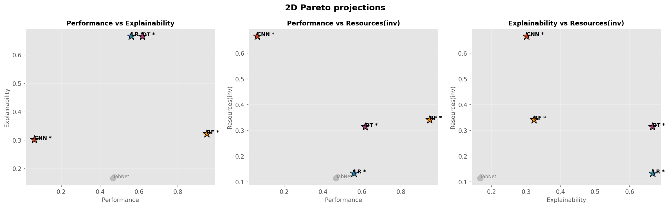

viz_13_pareto_list.png

Pareto front visualization of non-dominated vs dominated solutions.

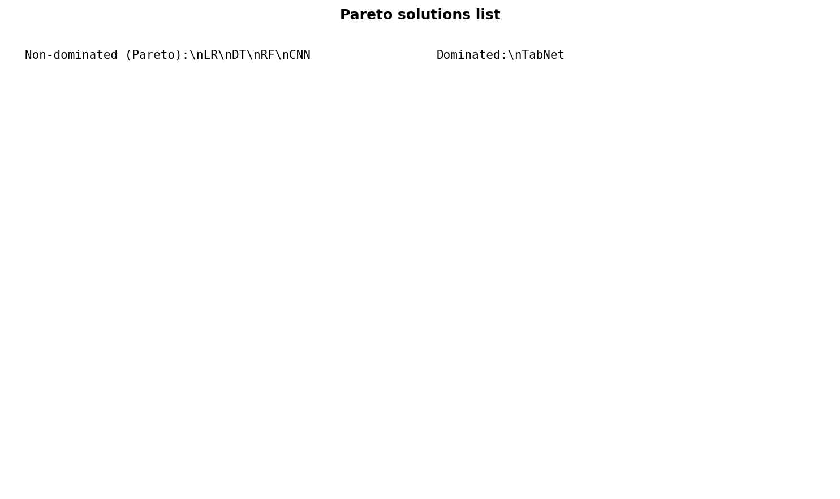

viz_constraints_impact.png

Chart generated by the pipeline.

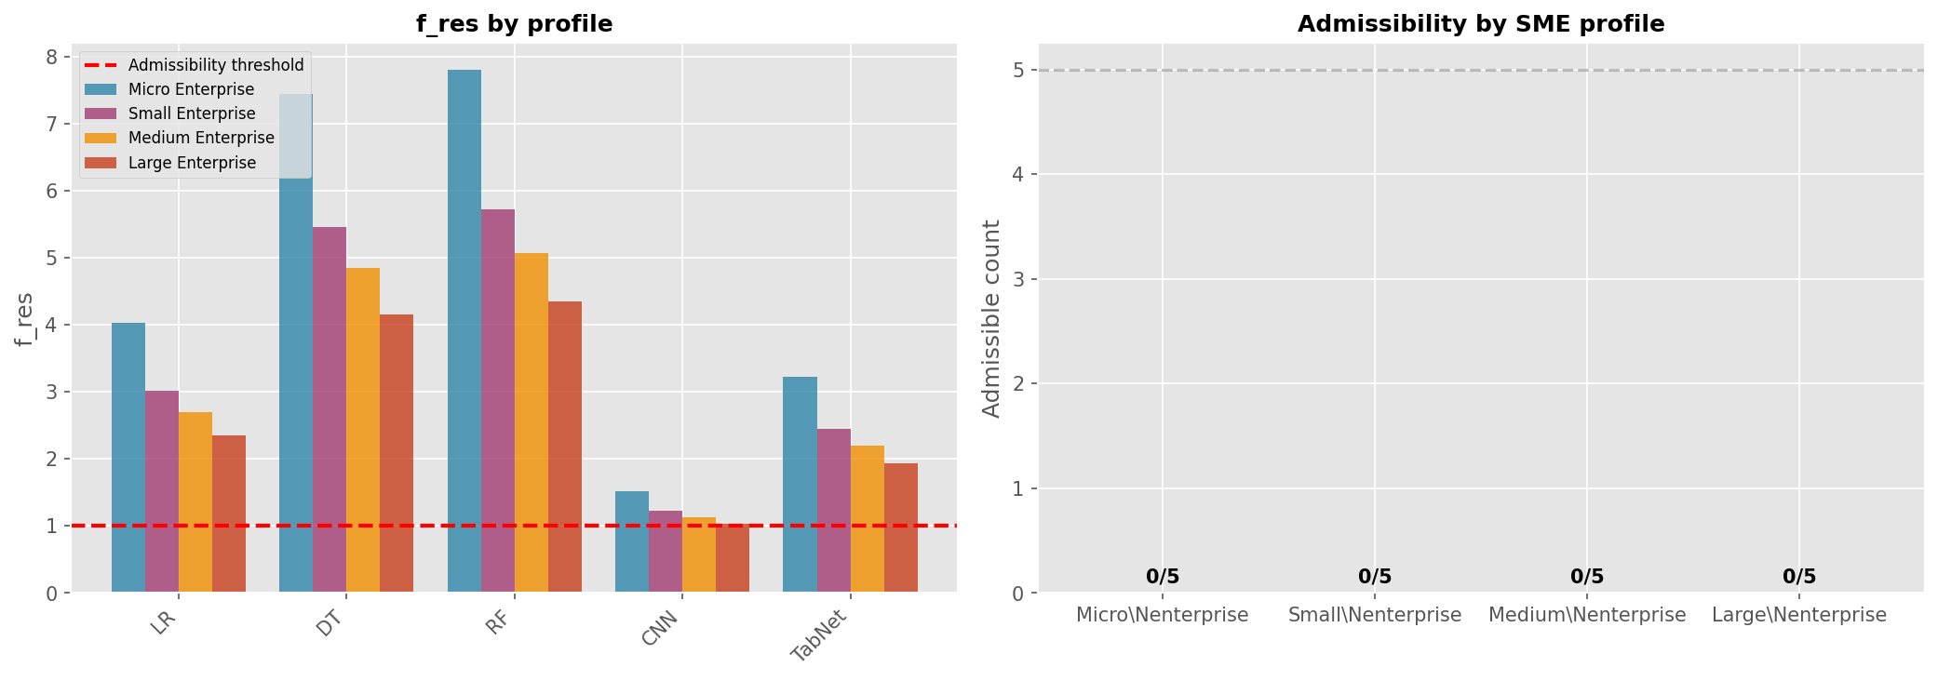

viz_sensitivity_algorithms.png

Chart generated by the pipeline.

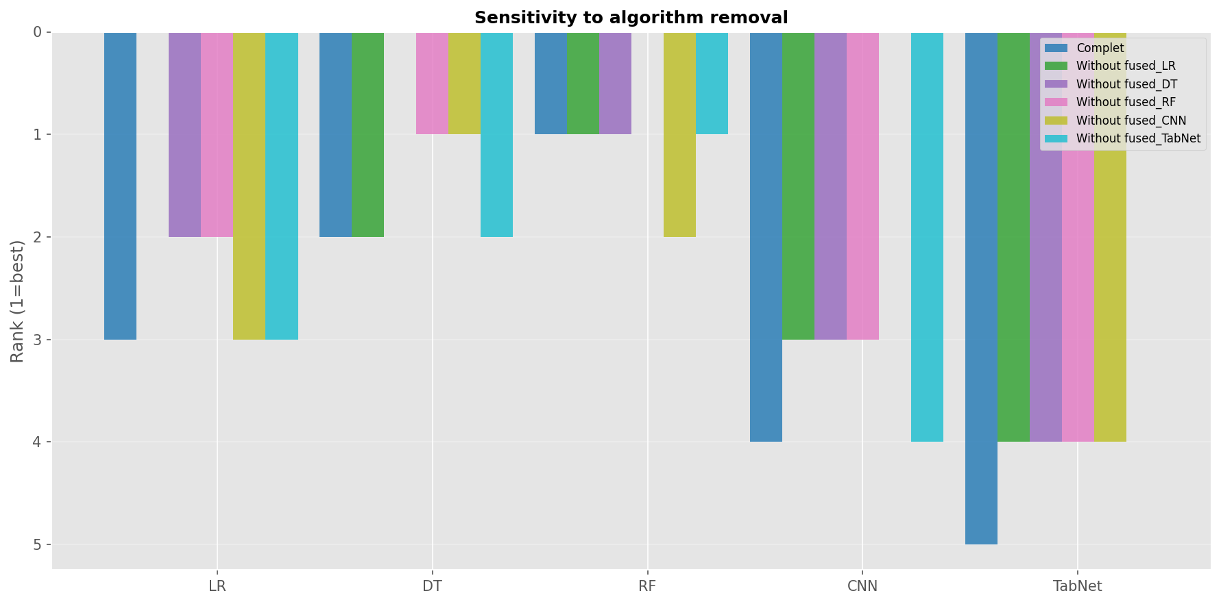

viz_sensitivity_criteria.png

Chart generated by the pipeline.

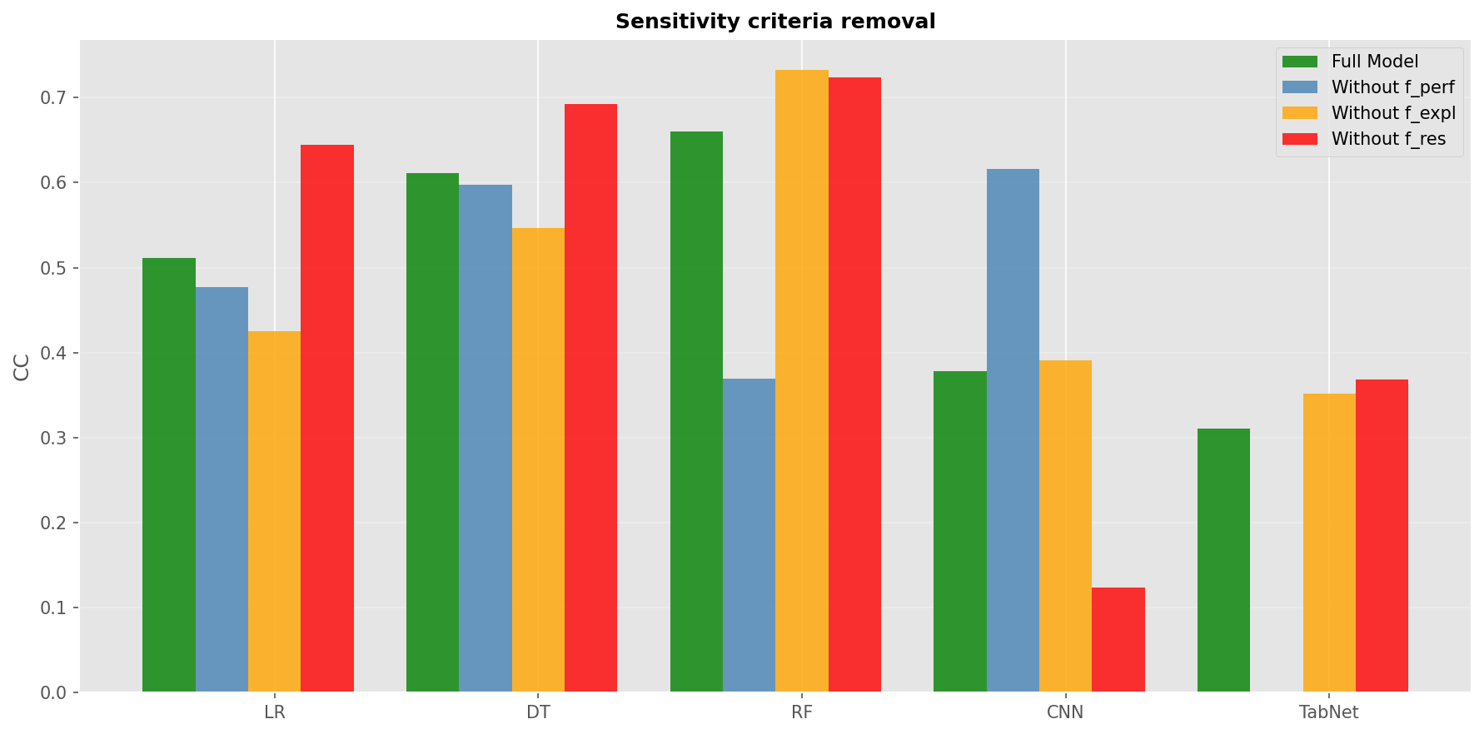

viz_sensitivity_weights.png

AHP weights used for TOPSIS.

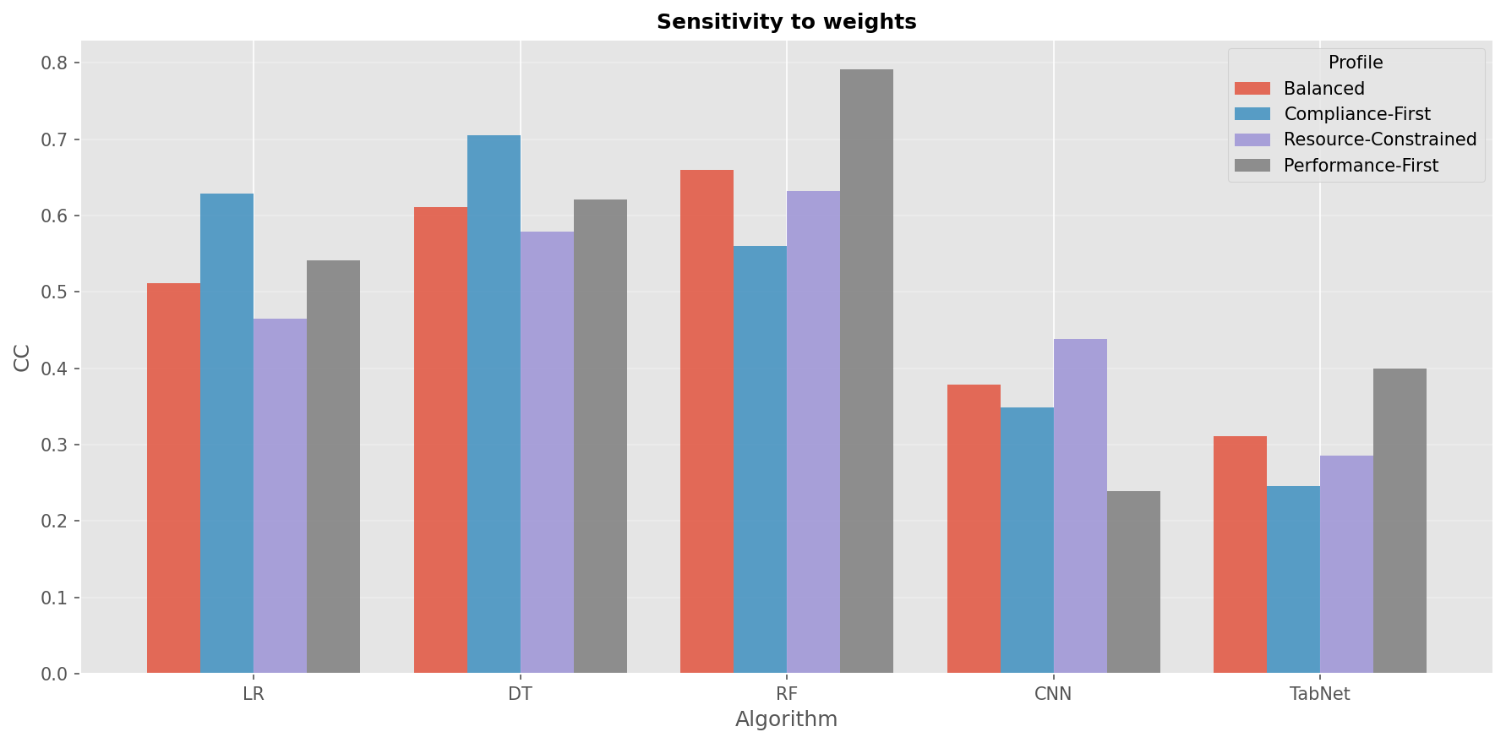

# Threshold variations

Shows admissible vs rejected solutions across threshold levels.

resource_pareto_threshold_100.png

Pareto front visualization of non-dominated vs dominated solutions.

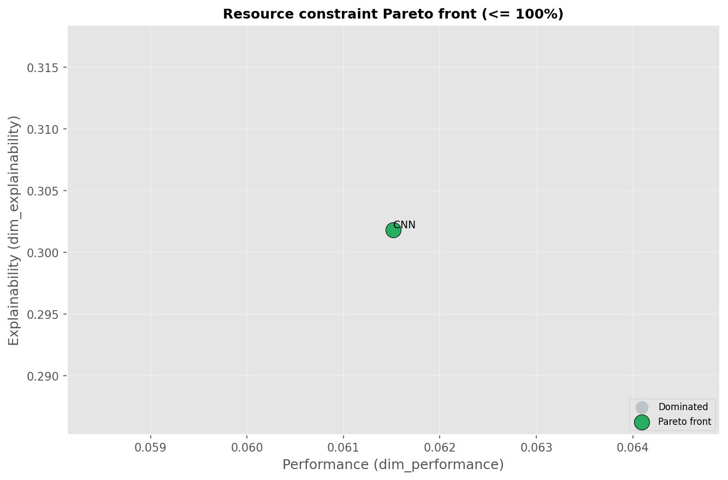

resource_pareto_threshold_100_3d_color.png

Pareto front visualization of non-dominated vs dominated solutions.

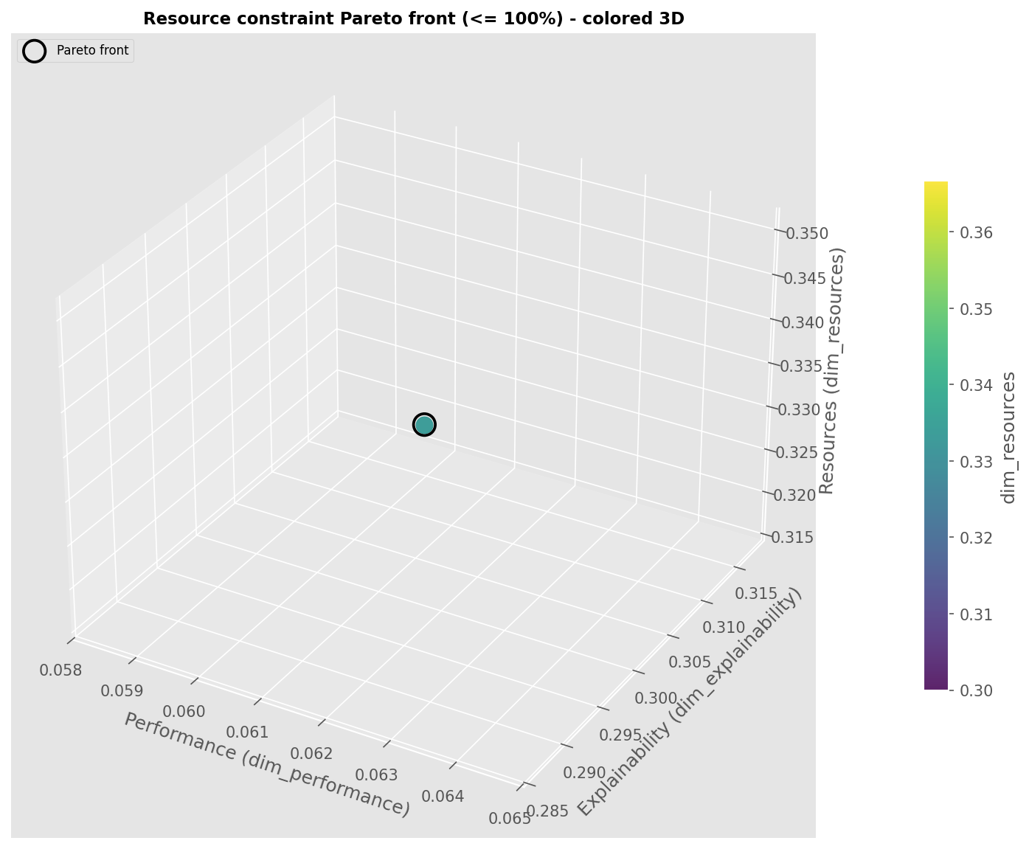

resource_pareto_threshold_100_3d_points.png

Pareto front visualization of non-dominated vs dominated solutions.

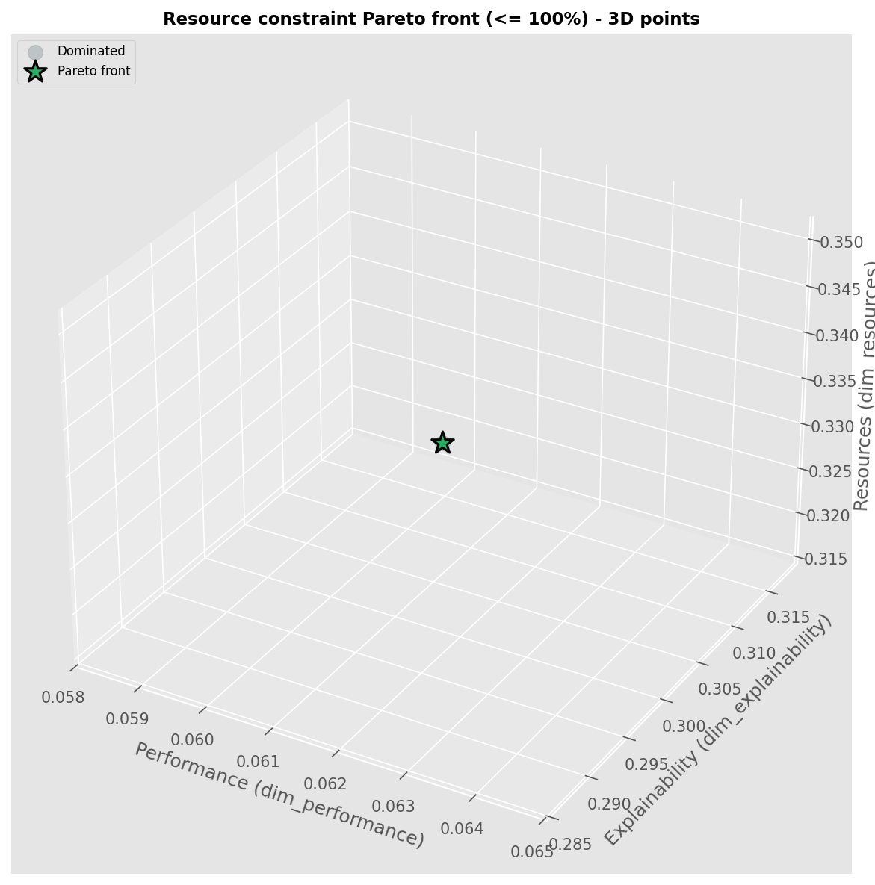

resource_pareto_threshold_50.png

Pareto front visualization of non-dominated vs dominated solutions.

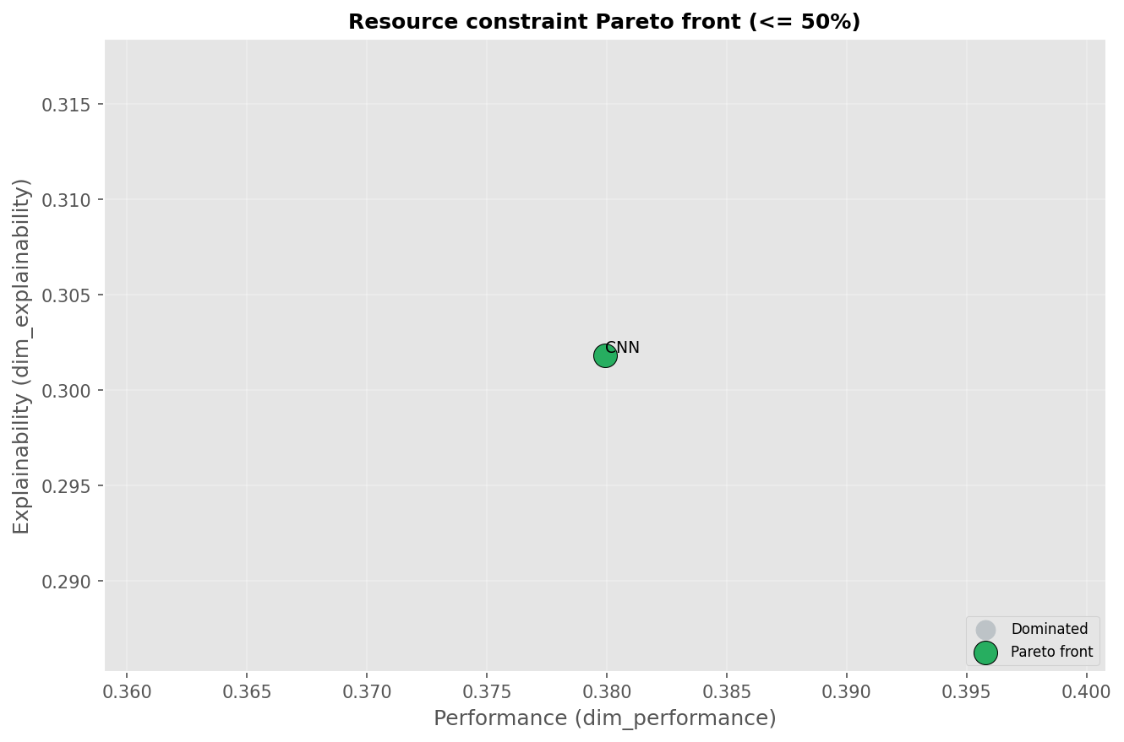

resource_pareto_threshold_50_3d_color.png

Pareto front visualization of non-dominated vs dominated solutions.

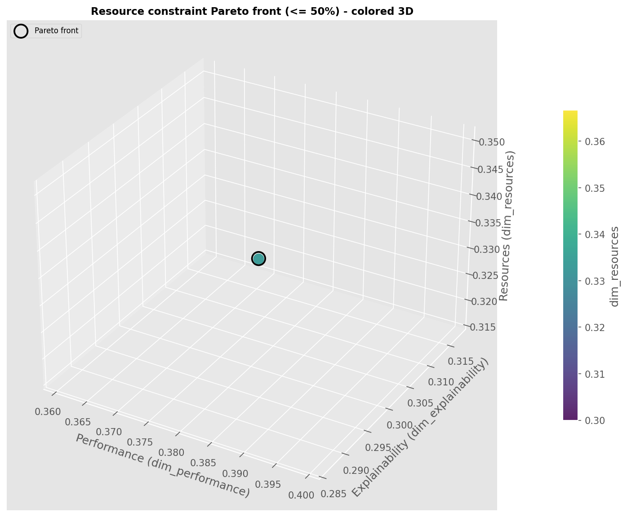

resource_pareto_threshold_50_3d_points.png

Pareto front visualization of non-dominated vs dominated solutions.

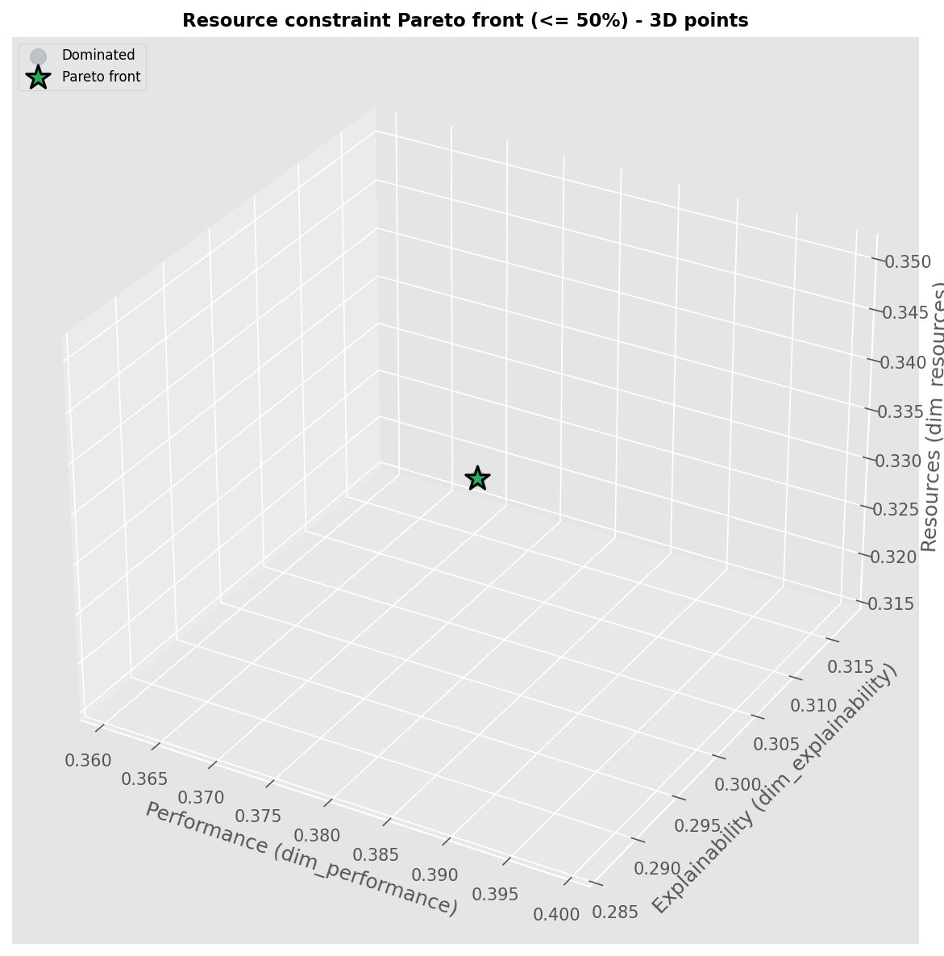

resource_pareto_threshold_60.png

Pareto front visualization of non-dominated vs dominated solutions.

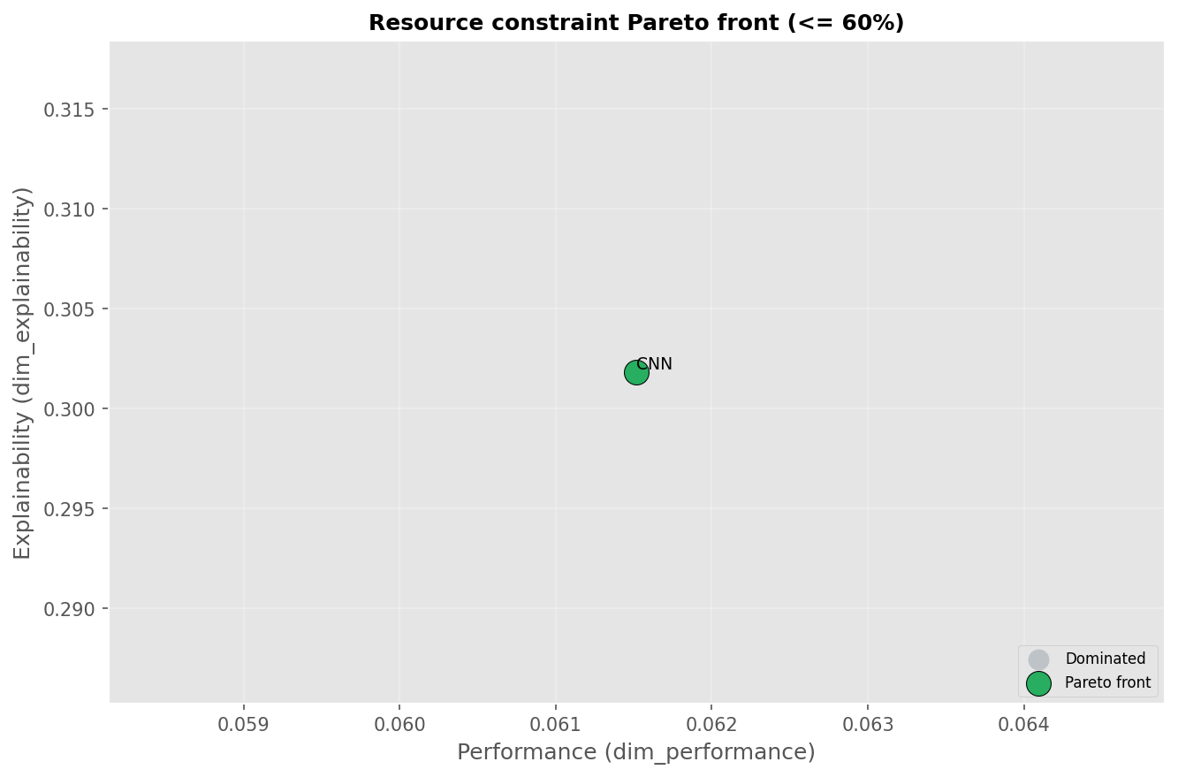

resource_pareto_threshold_60_3d_color.png

Pareto front visualization of non-dominated vs dominated solutions.

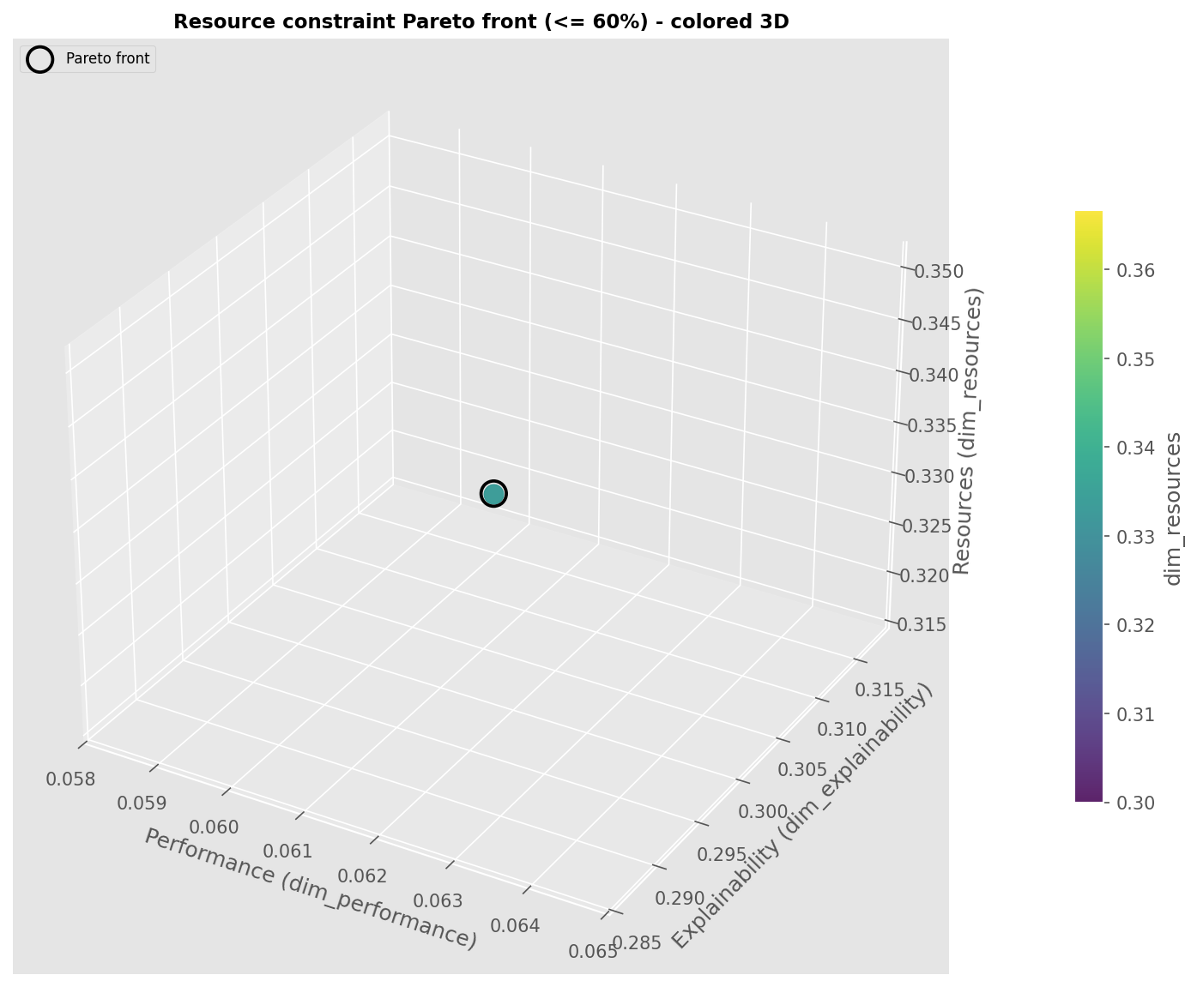

resource_pareto_threshold_60_3d_points.png

Pareto front visualization of non-dominated vs dominated solutions.

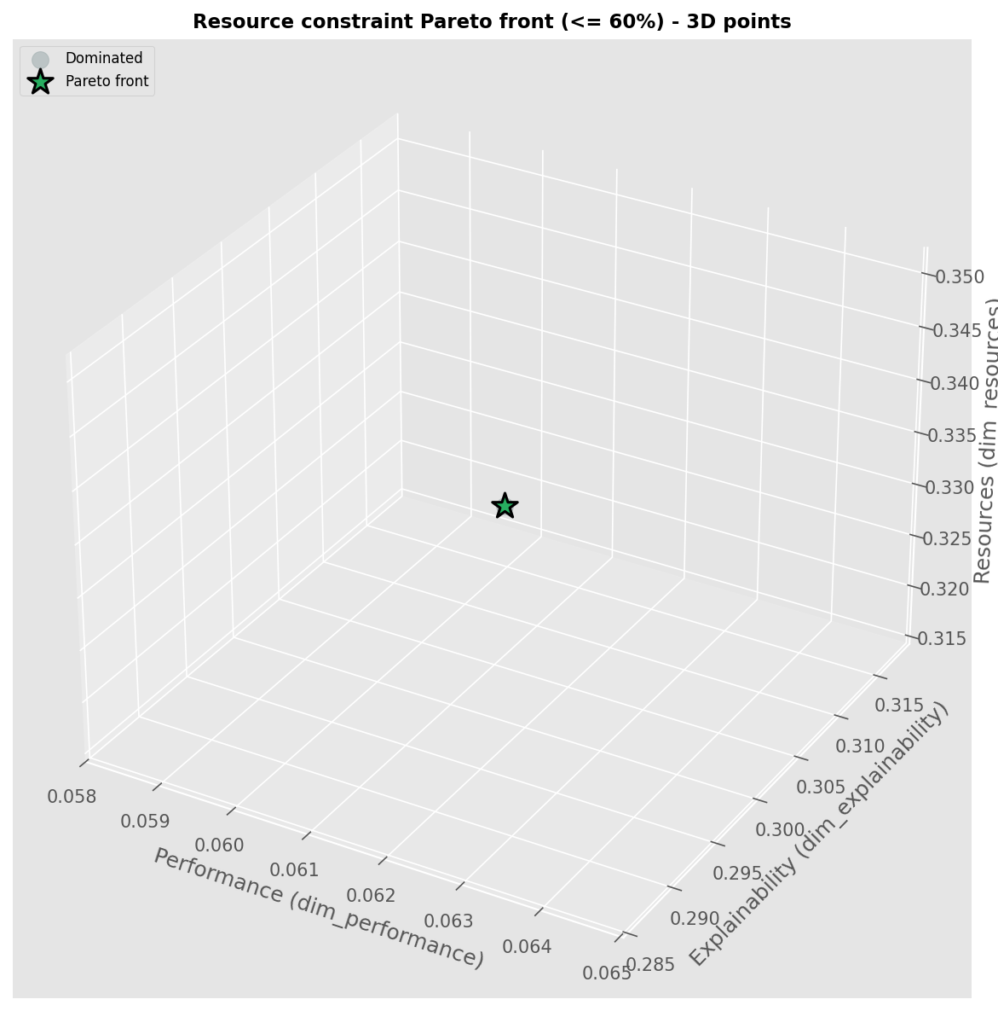

resource_pareto_threshold_70.png

Pareto front visualization of non-dominated vs dominated solutions.

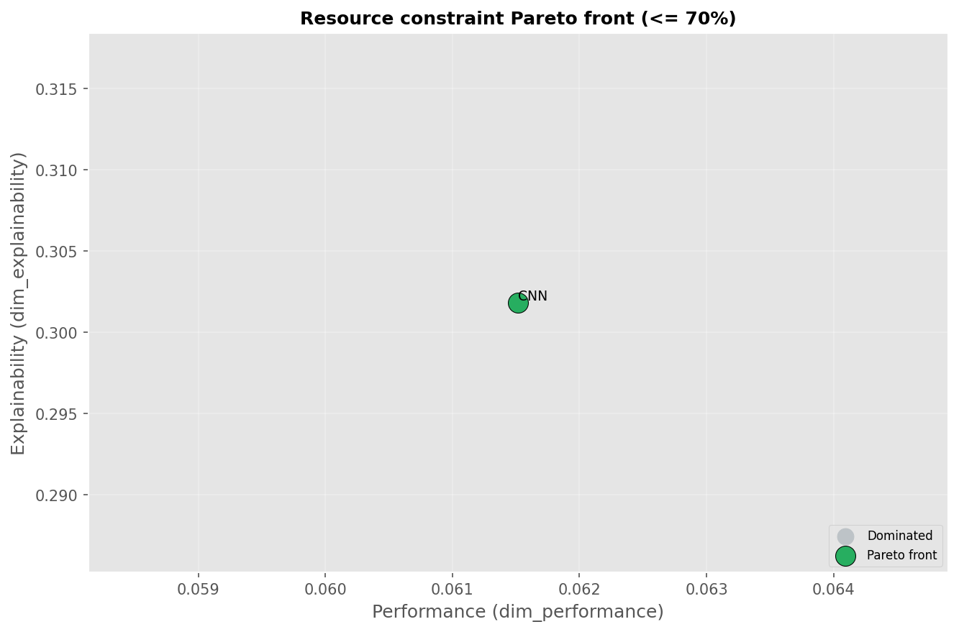

resource_pareto_threshold_70_3d_color.png

Pareto front visualization of non-dominated vs dominated solutions.

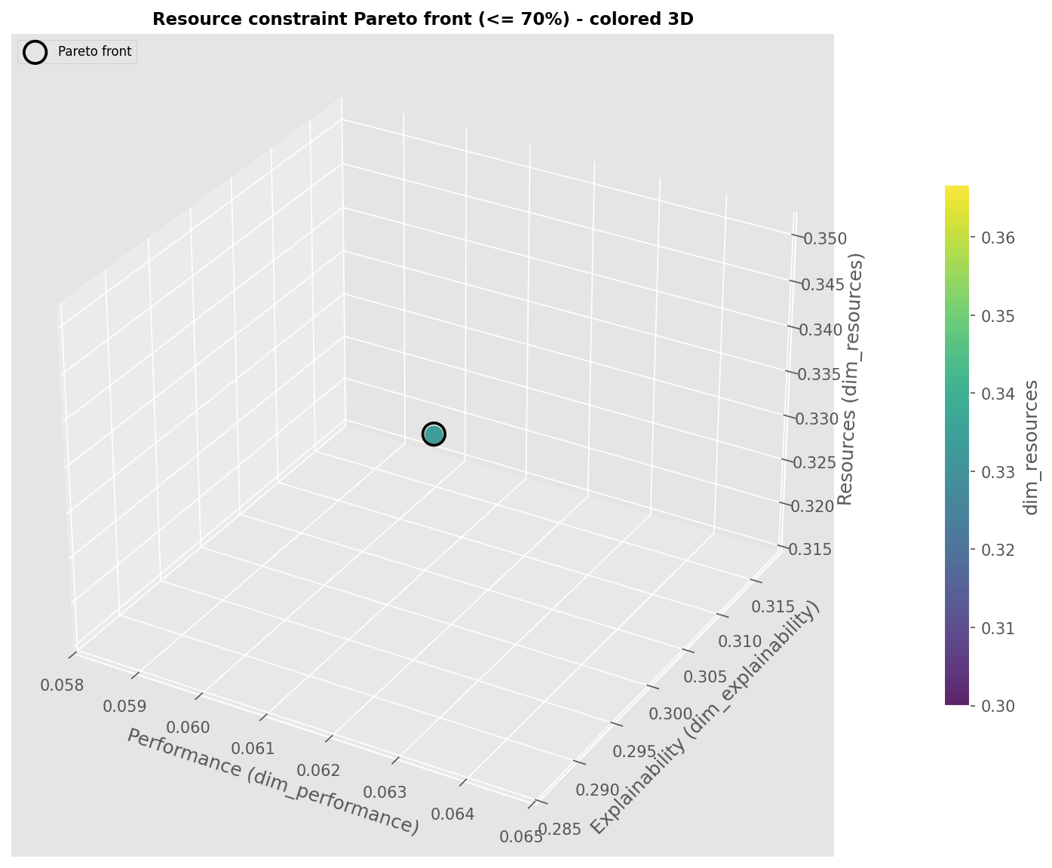

resource_pareto_threshold_70_3d_points.png

Pareto front visualization of non-dominated vs dominated solutions.

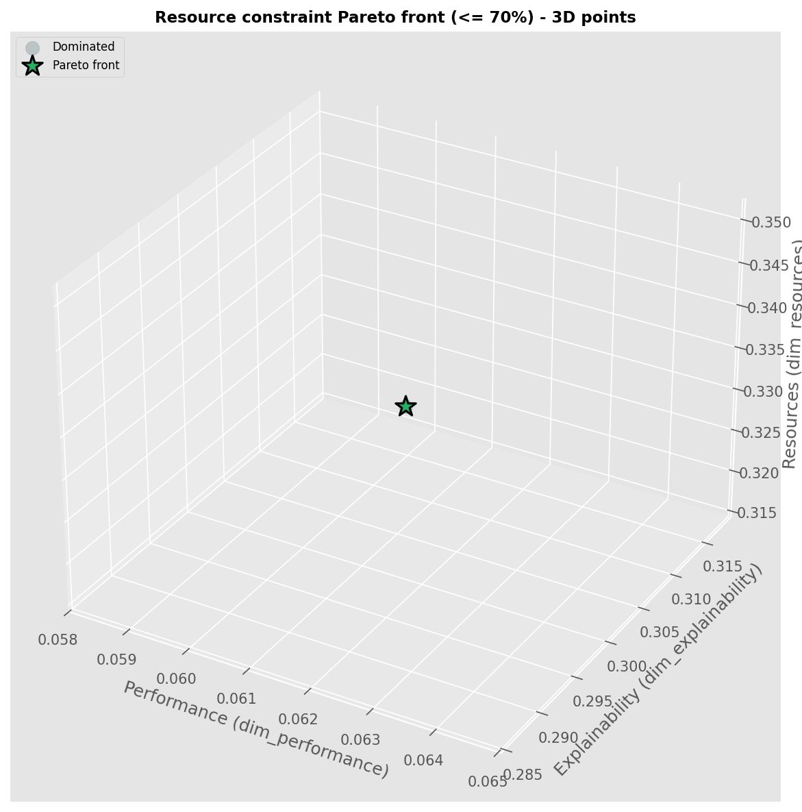

resource_pareto_threshold_80.png

Pareto front visualization of non-dominated vs dominated solutions.

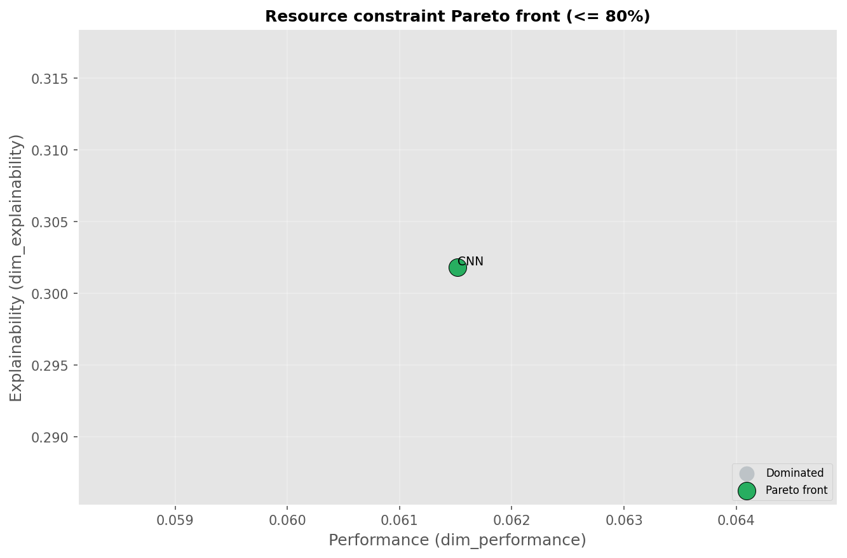

resource_pareto_threshold_80_3d_color.png

Pareto front visualization of non-dominated vs dominated solutions.

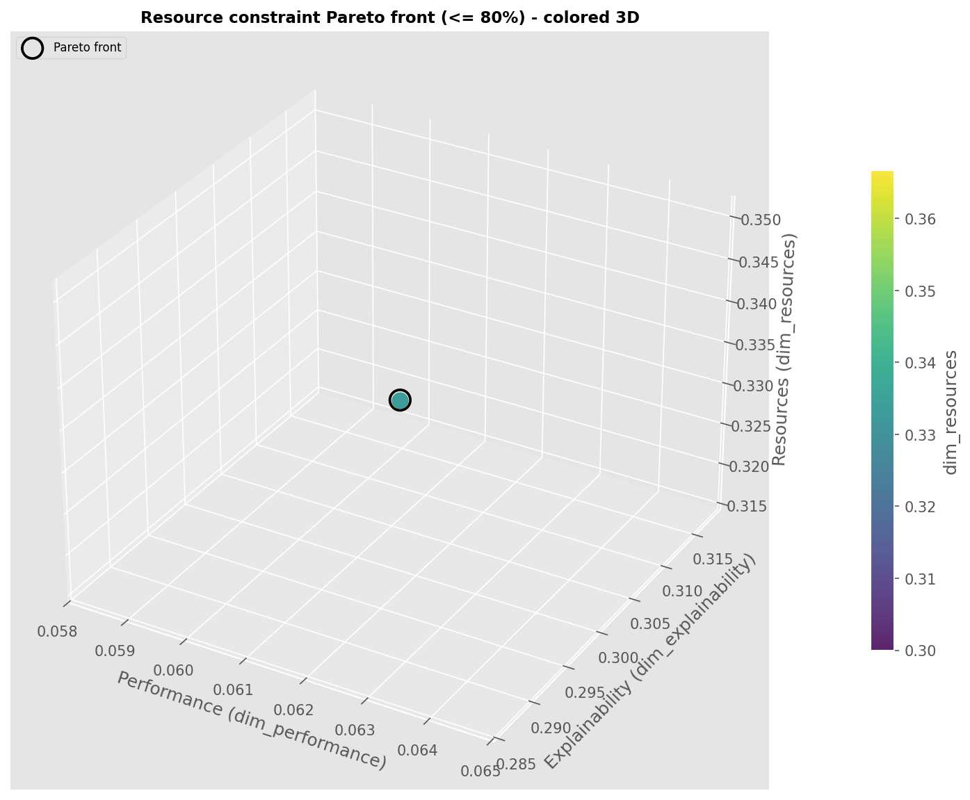

resource_pareto_threshold_80_3d_points.png

Pareto front visualization of non-dominated vs dominated solutions.

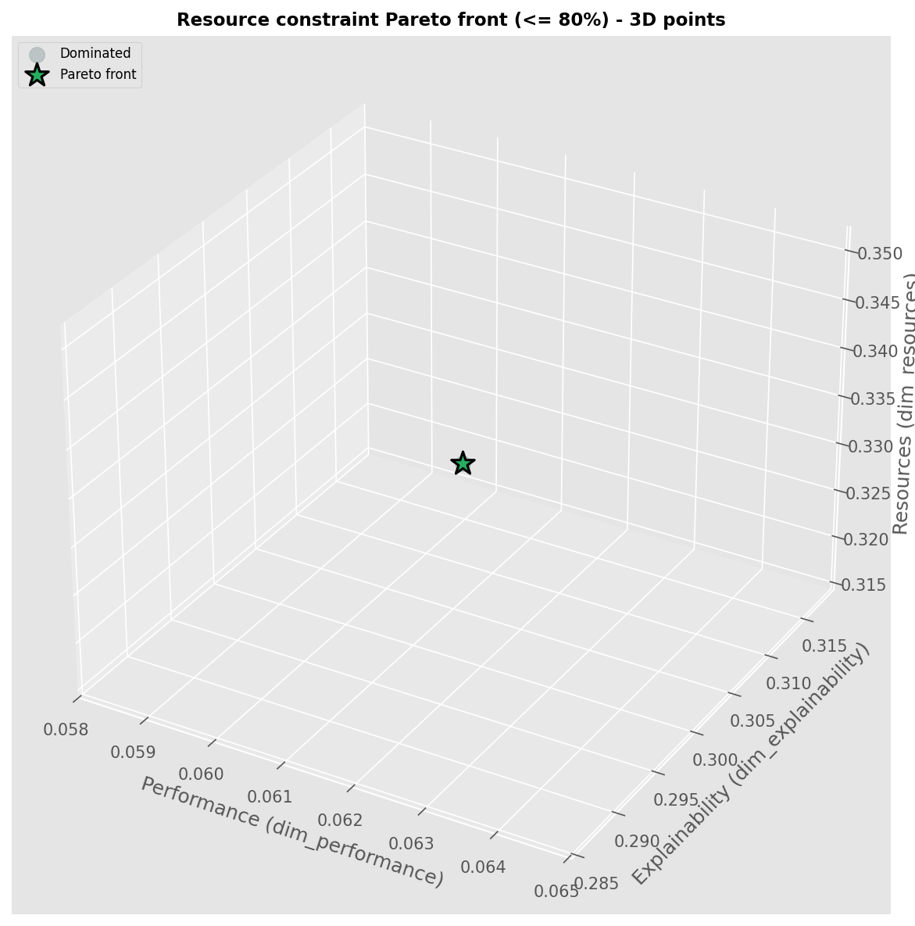

resource_pareto_threshold_90.png

Pareto front visualization of non-dominated vs dominated solutions.

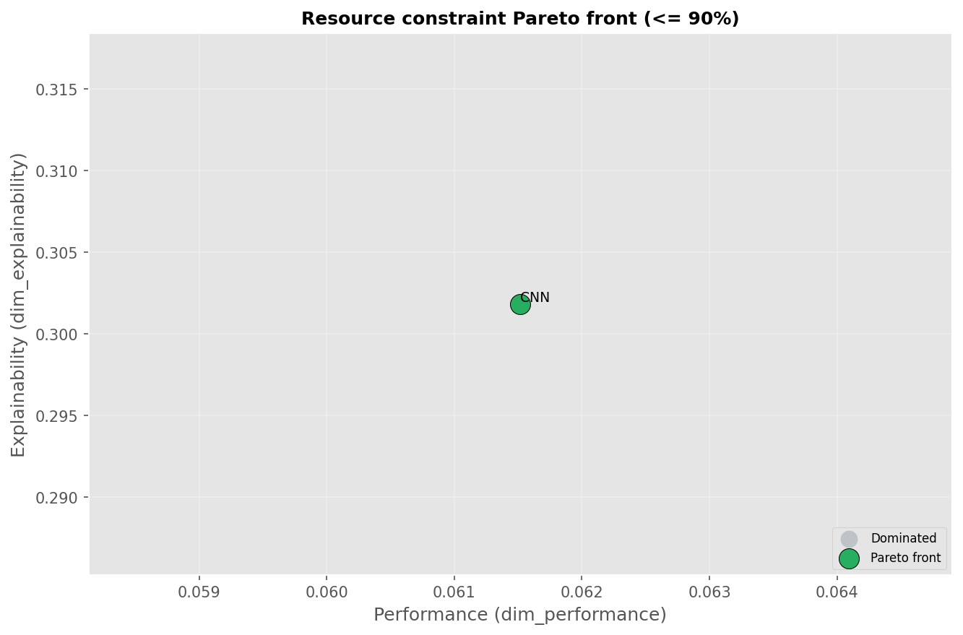

resource_pareto_threshold_90_3d_color.png

Pareto front visualization of non-dominated vs dominated solutions.

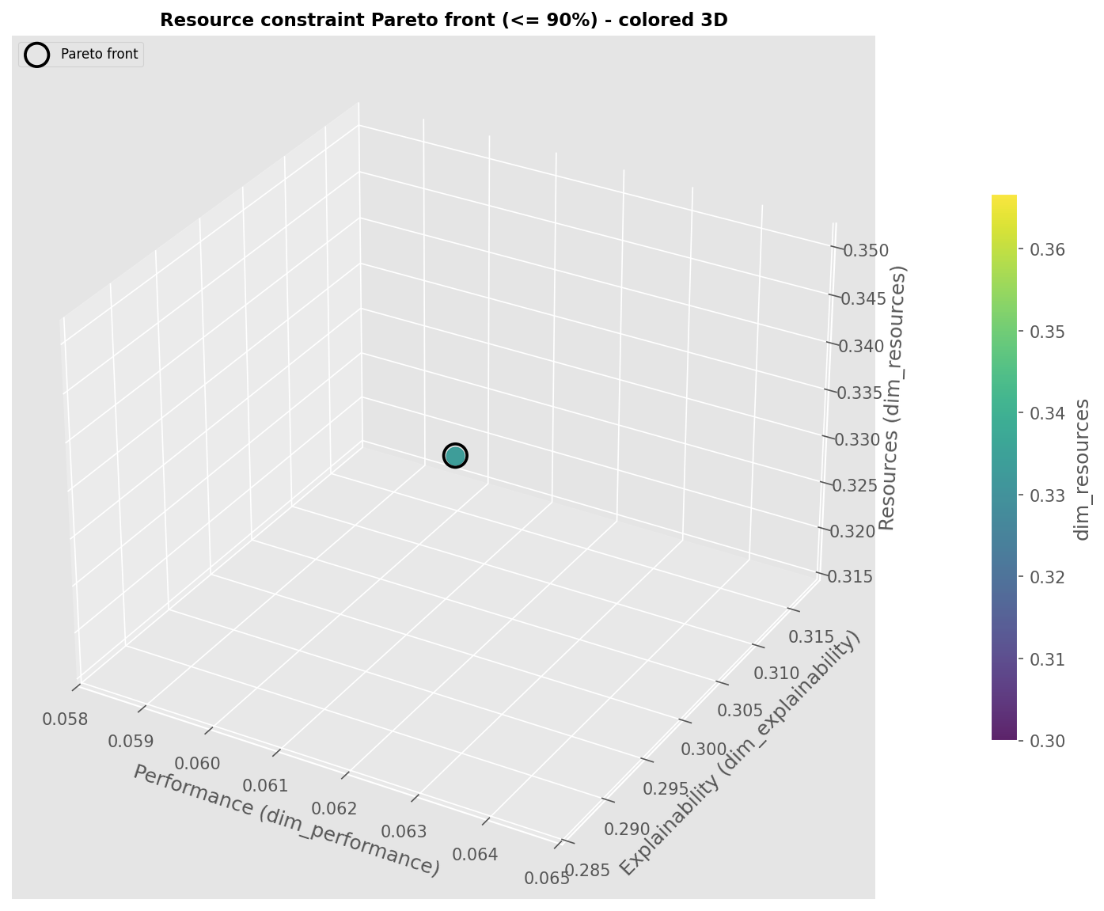

resource_pareto_threshold_90_3d_points.png

Pareto front visualization of non-dominated vs dominated solutions.

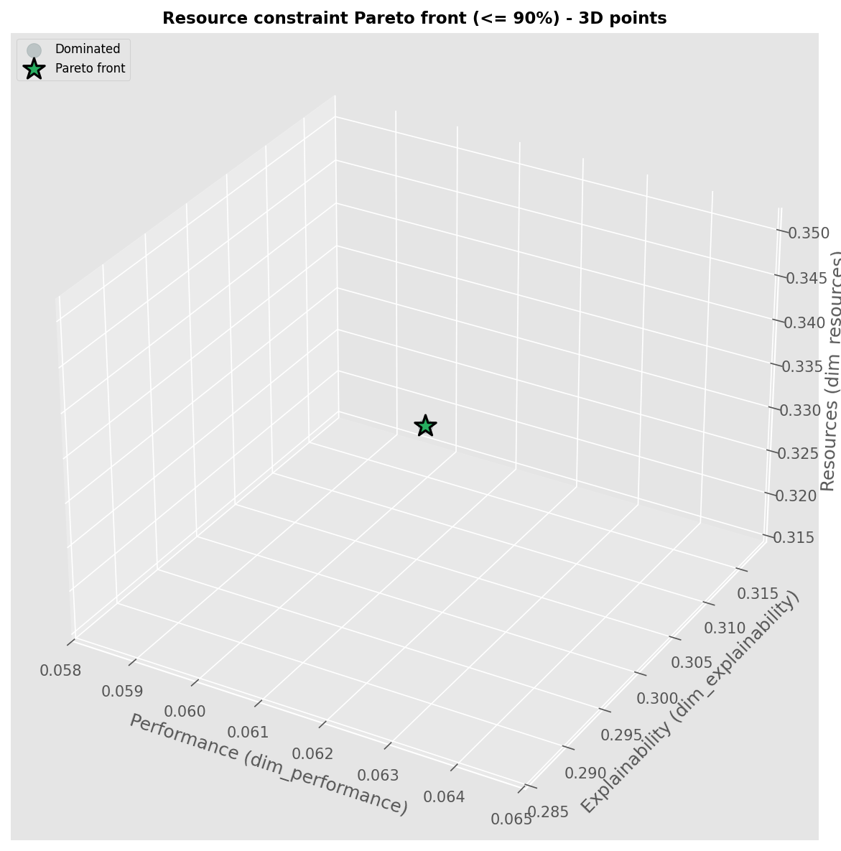

weights_explainability.png

AHP weights used for TOPSIS.

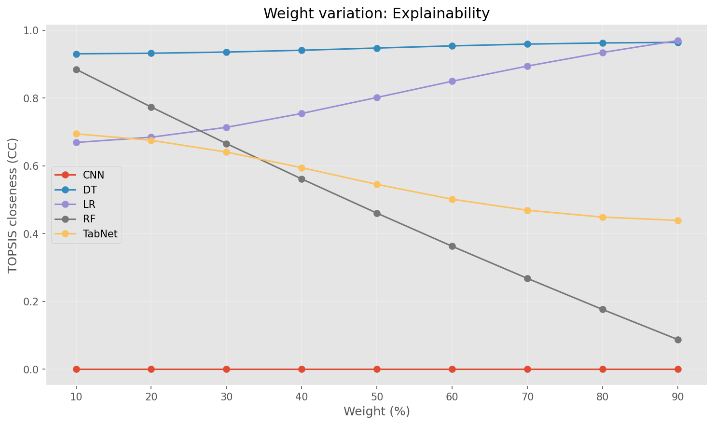

weights_performance.png

AHP weights used for TOPSIS.

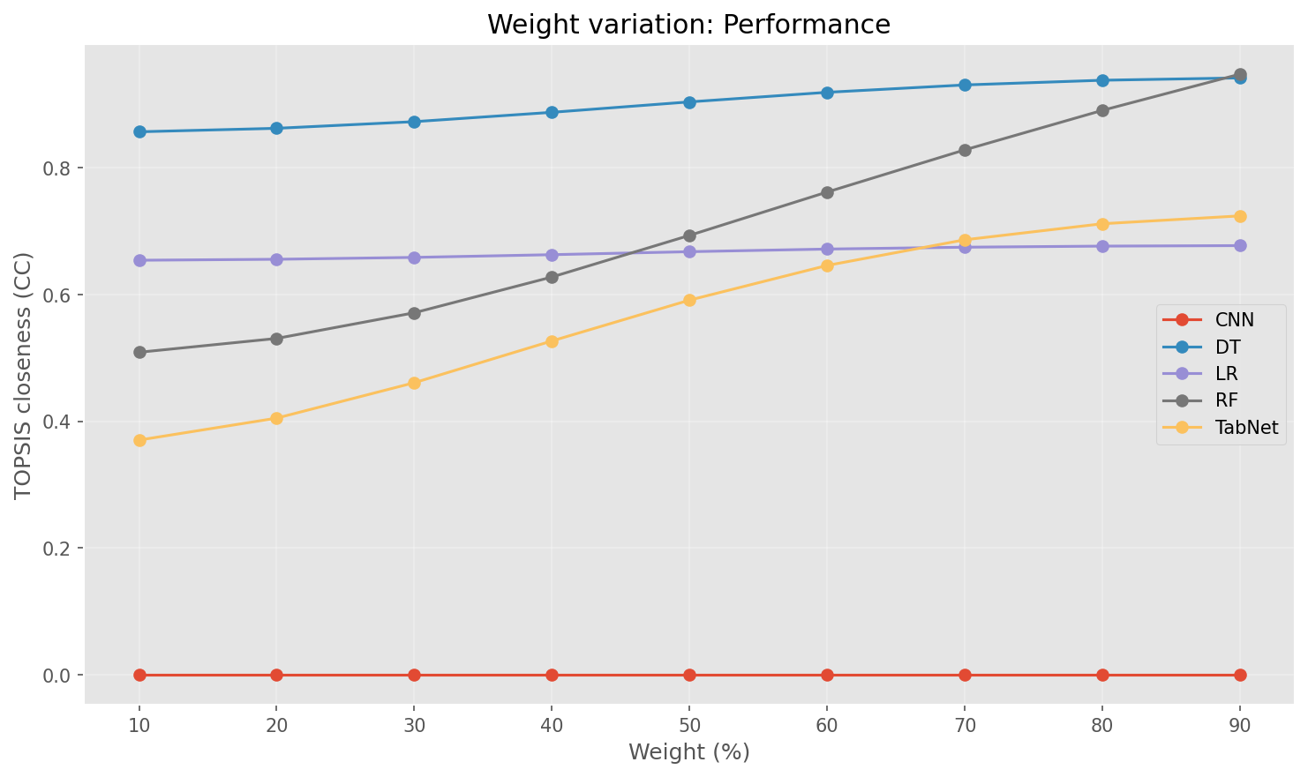

weights_resources.png

AHP weights used for TOPSIS.

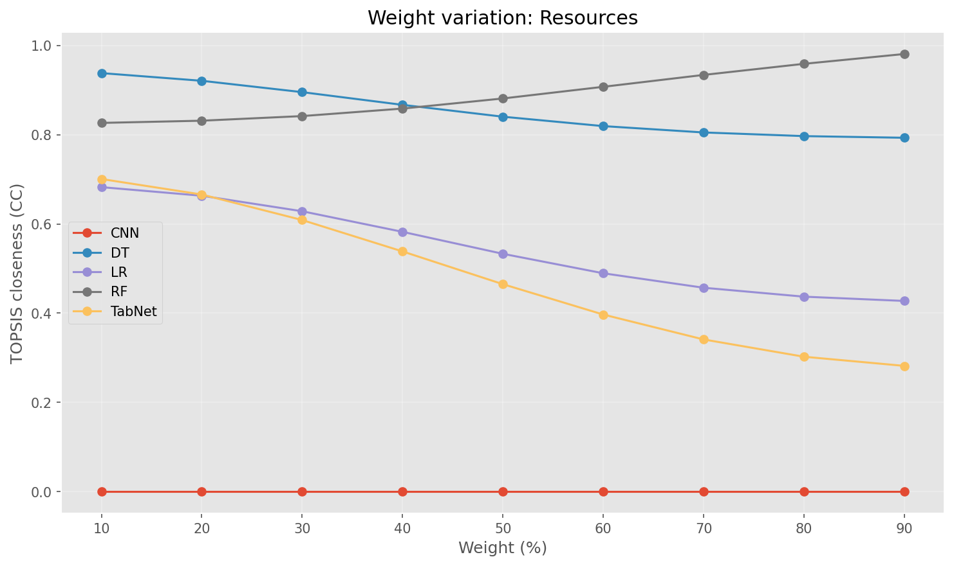

weights_grid_winner_counts.png

AHP weights used for TOPSIS.

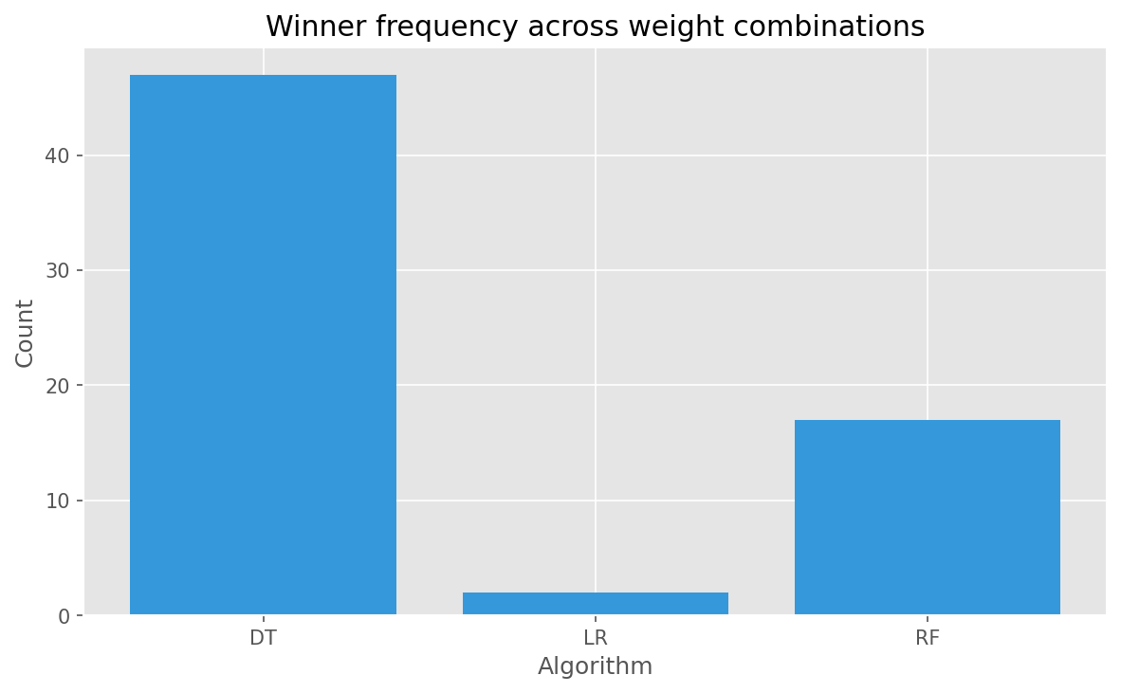

weights_grid_winner_map.png

AHP weights used for TOPSIS.

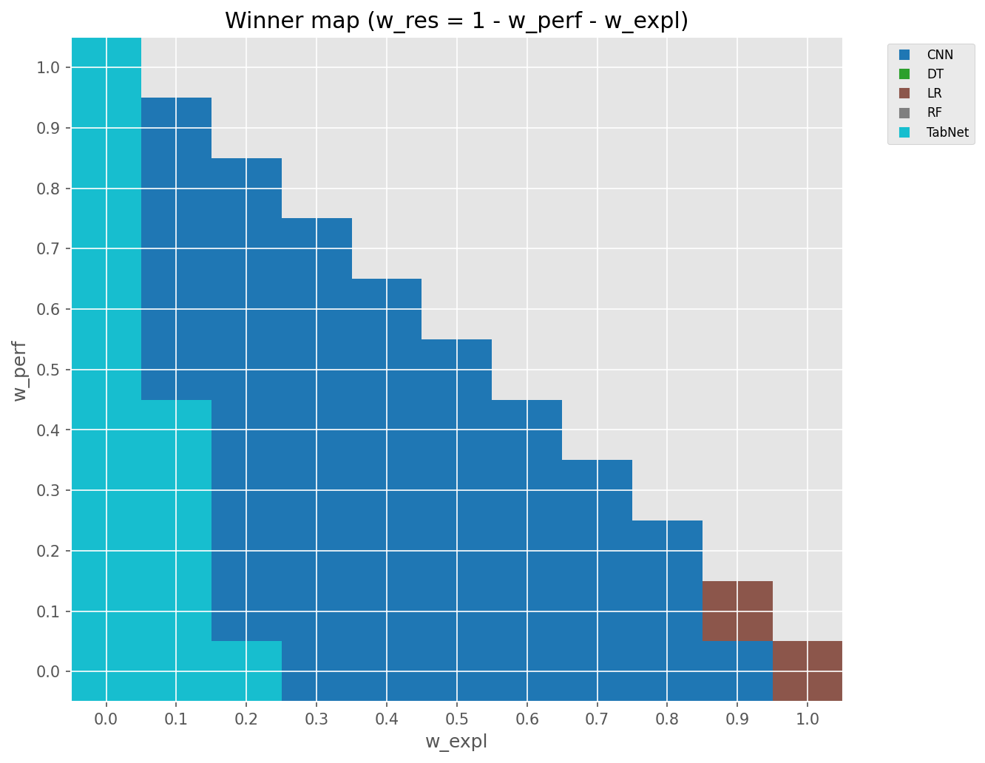

resource_constraint_resume.png

Chart generated by the pipeline.

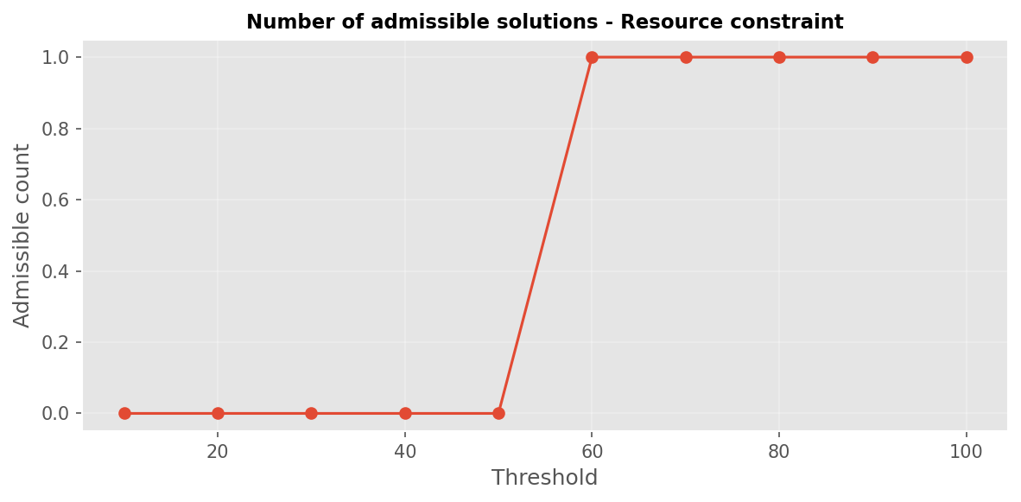

resource_constraint_threshold_10.png

Chart generated by the pipeline.

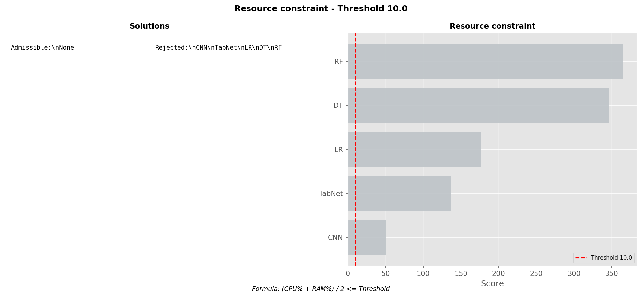

resource_constraint_threshold_100.png

Chart generated by the pipeline.

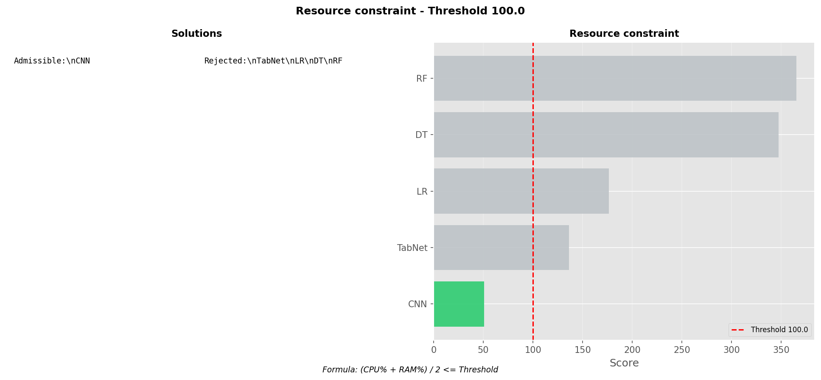

resource_constraint_threshold_20.png

Chart generated by the pipeline.

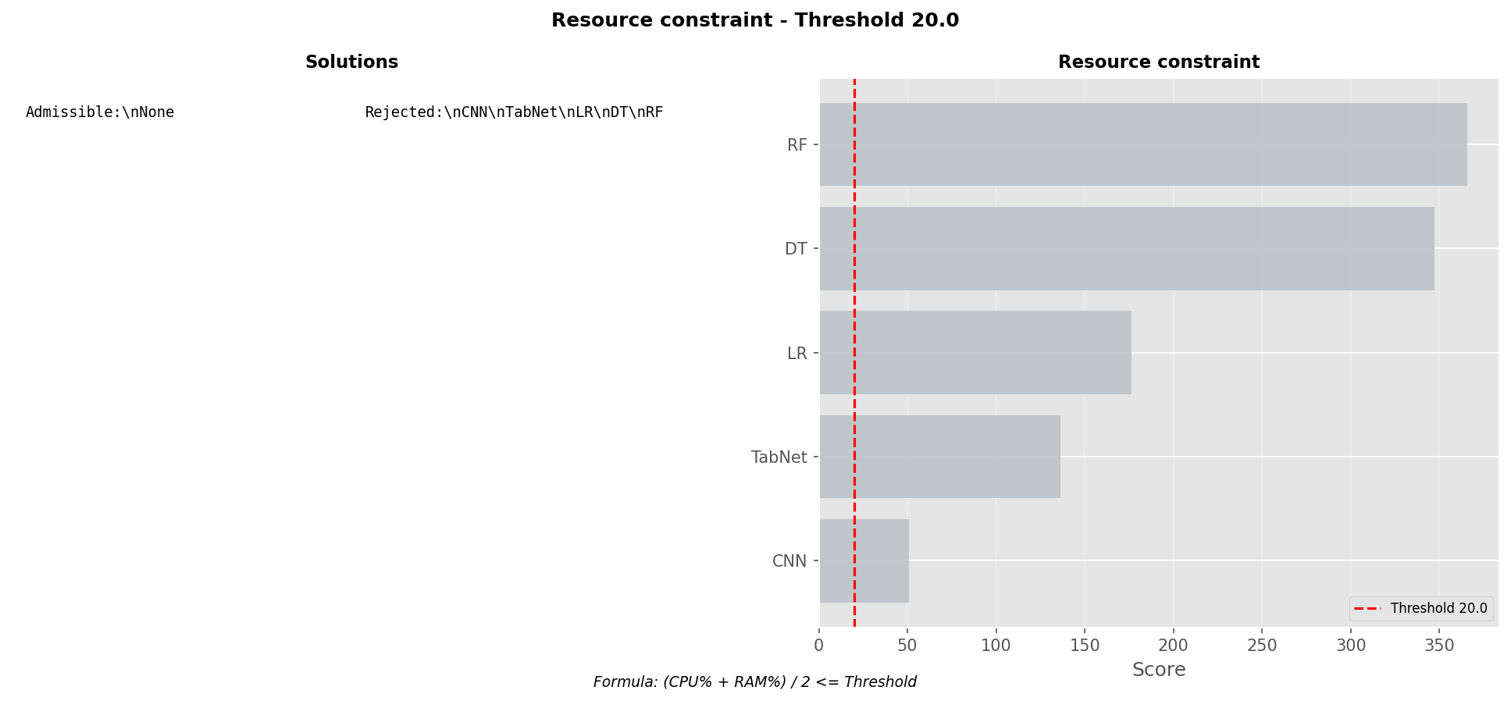

resource_constraint_threshold_30.png

Chart generated by the pipeline.

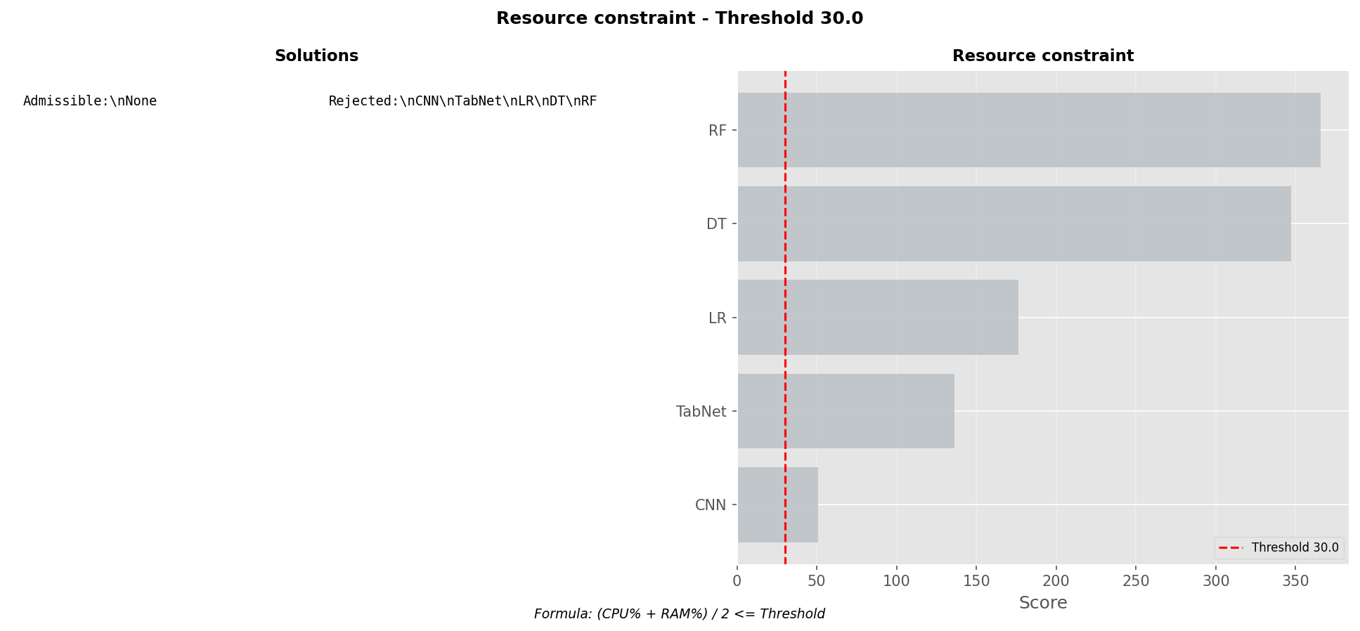

resource_constraint_threshold_40.png

Chart generated by the pipeline.

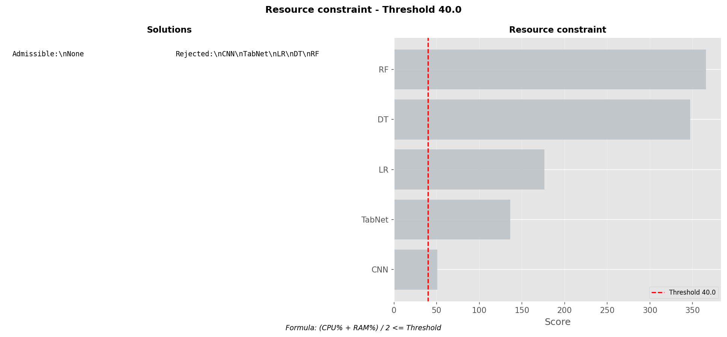

resource_constraint_threshold_50.png

Chart generated by the pipeline.

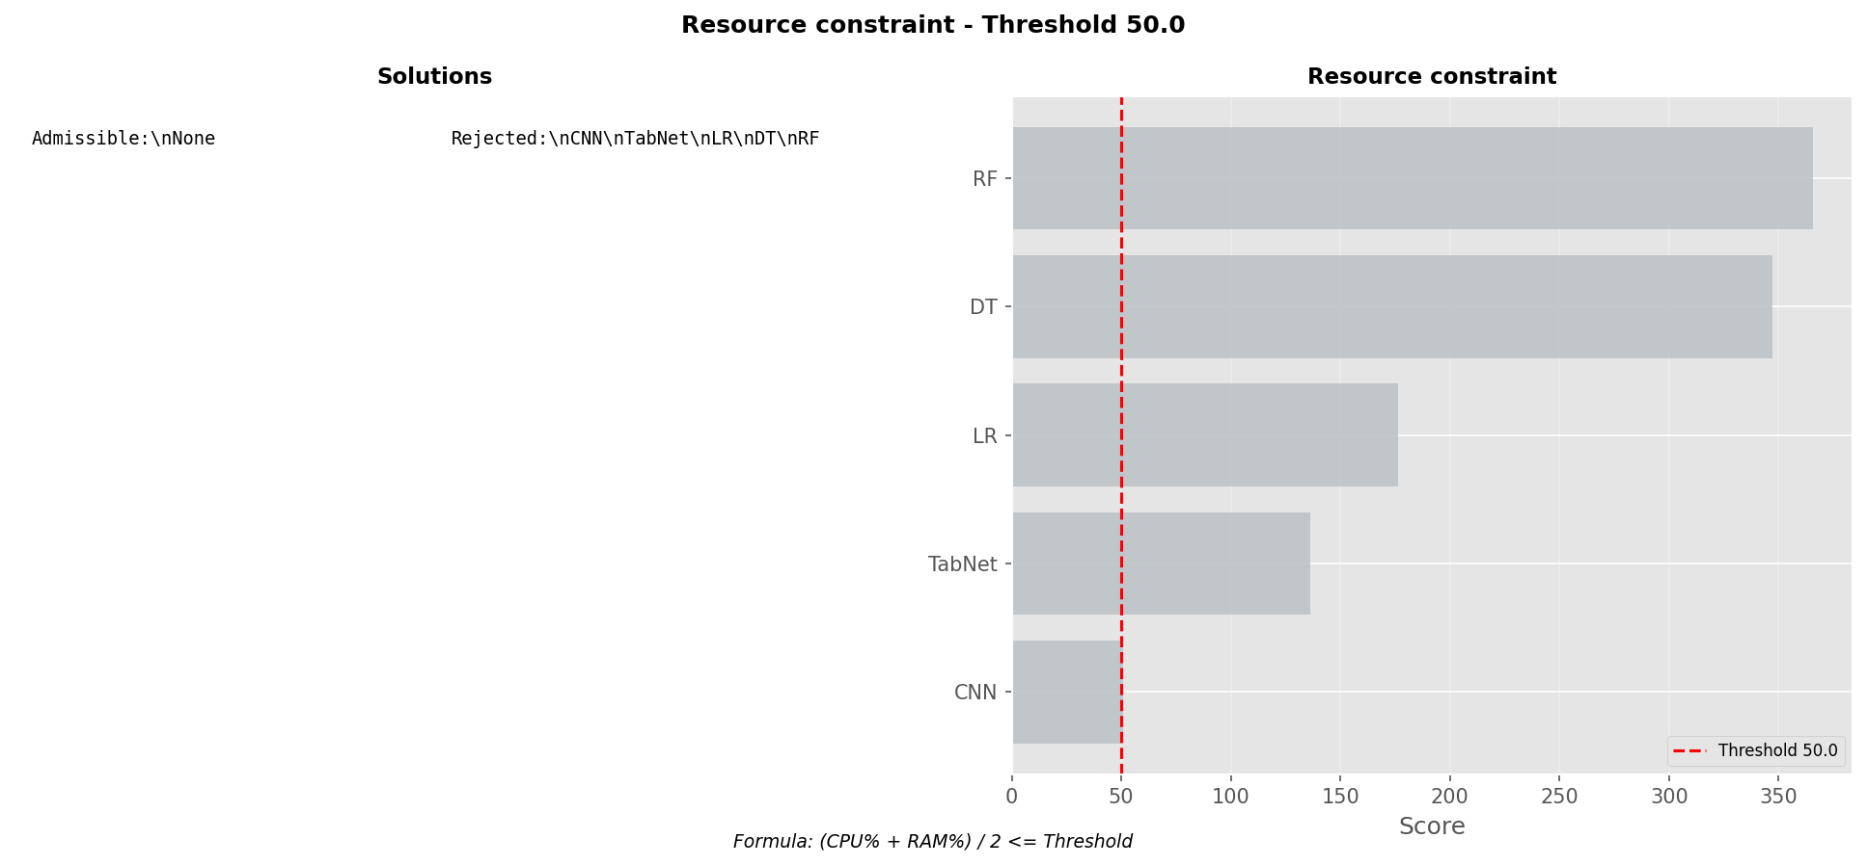

resource_constraint_threshold_60.png

Chart generated by the pipeline.

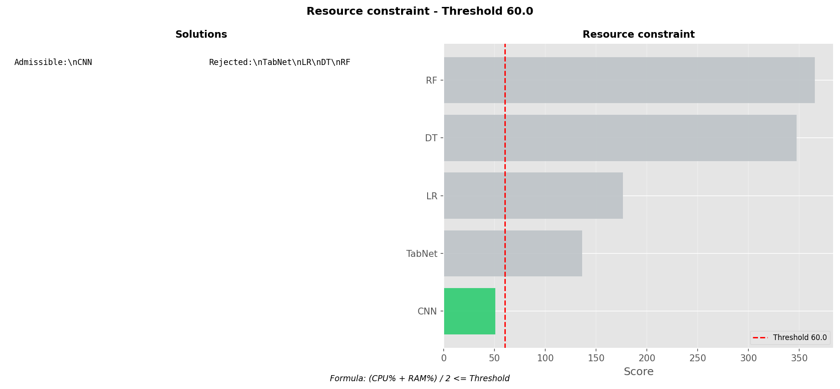

resource_constraint_threshold_70.png

Chart generated by the pipeline.

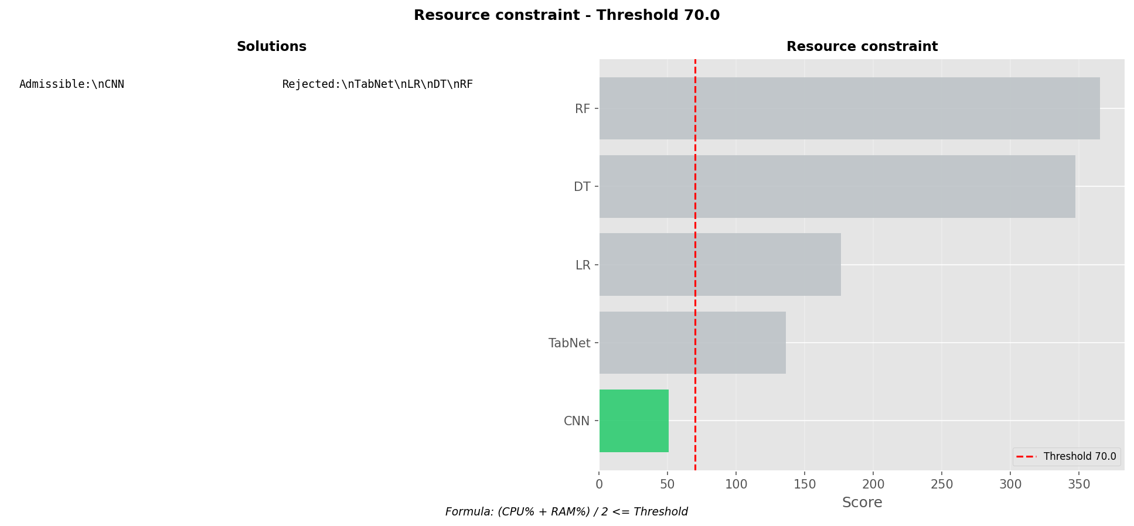

resource_constraint_threshold_80.png

Chart generated by the pipeline.

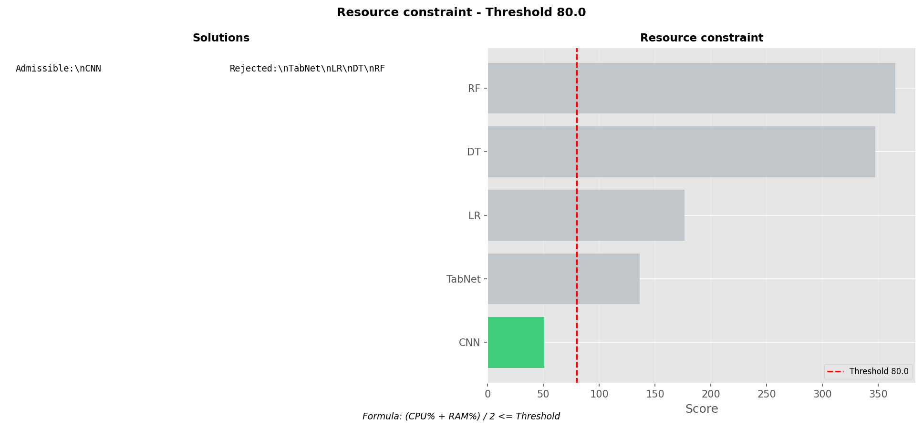

resource_constraint_threshold_90.png

Chart generated by the pipeline.

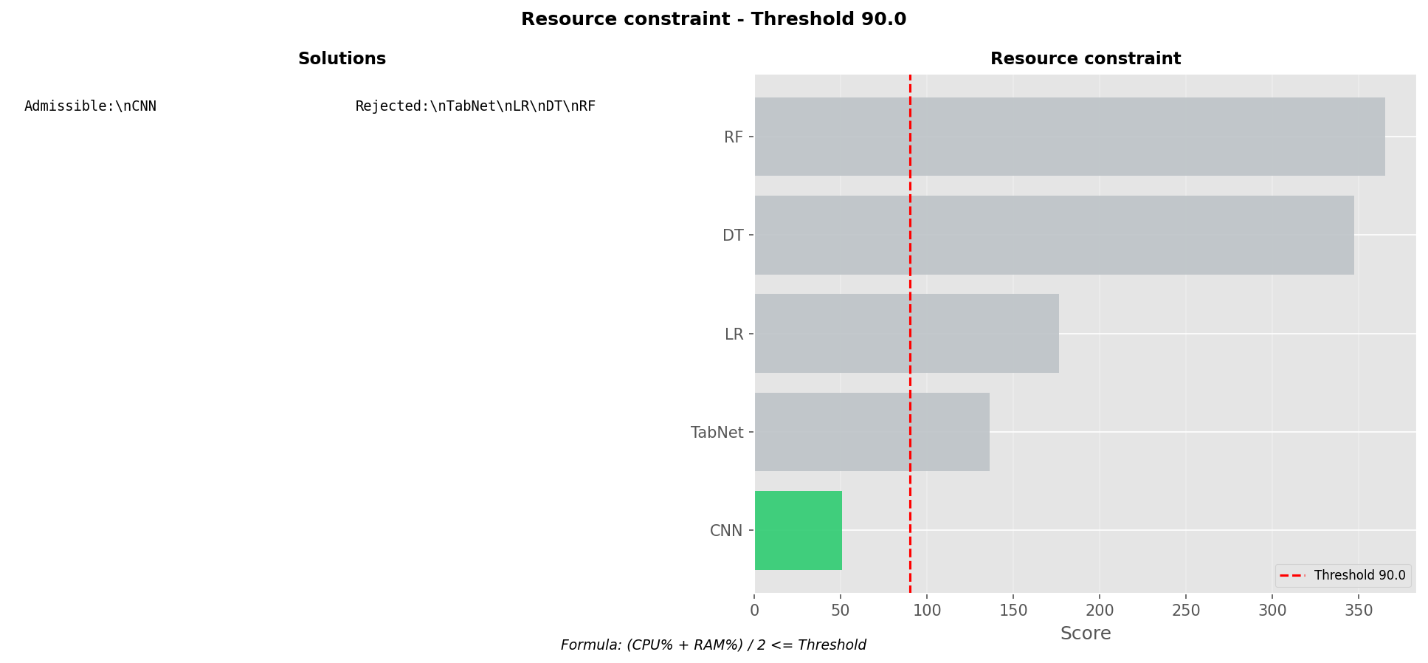

explainability_sampling_curve.png

Metric evolution across sampling ratios.

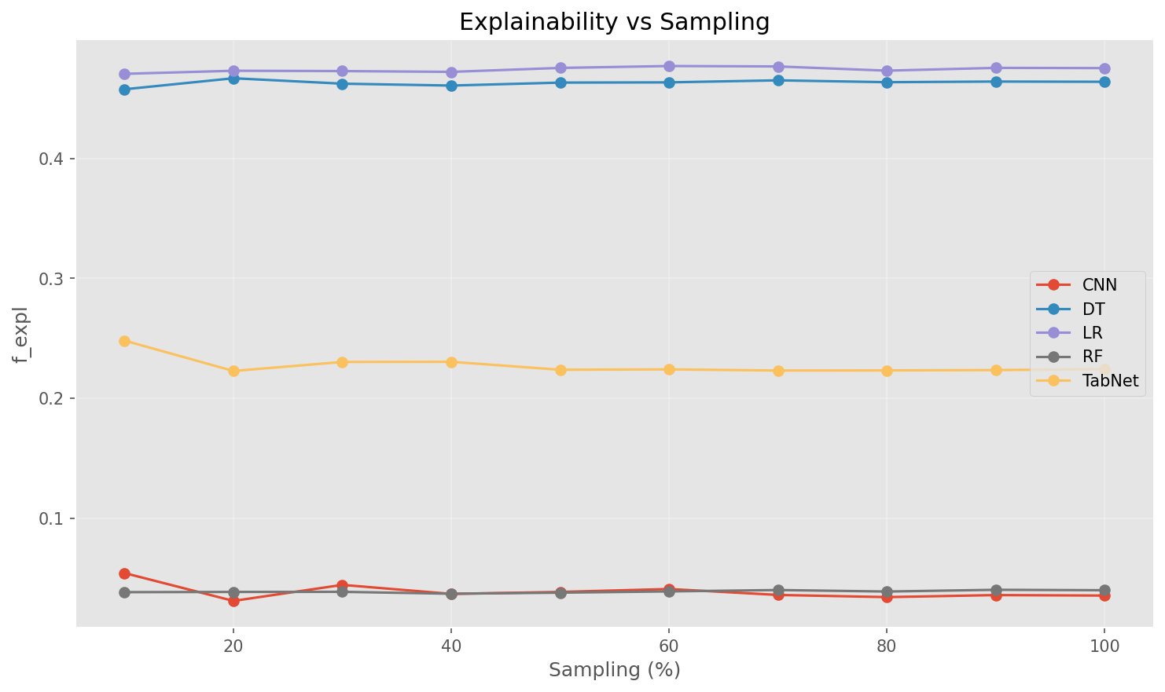

explainability_sampling_derivative.png

Derivative plot showing sensitivity of the metric to sampling rate.

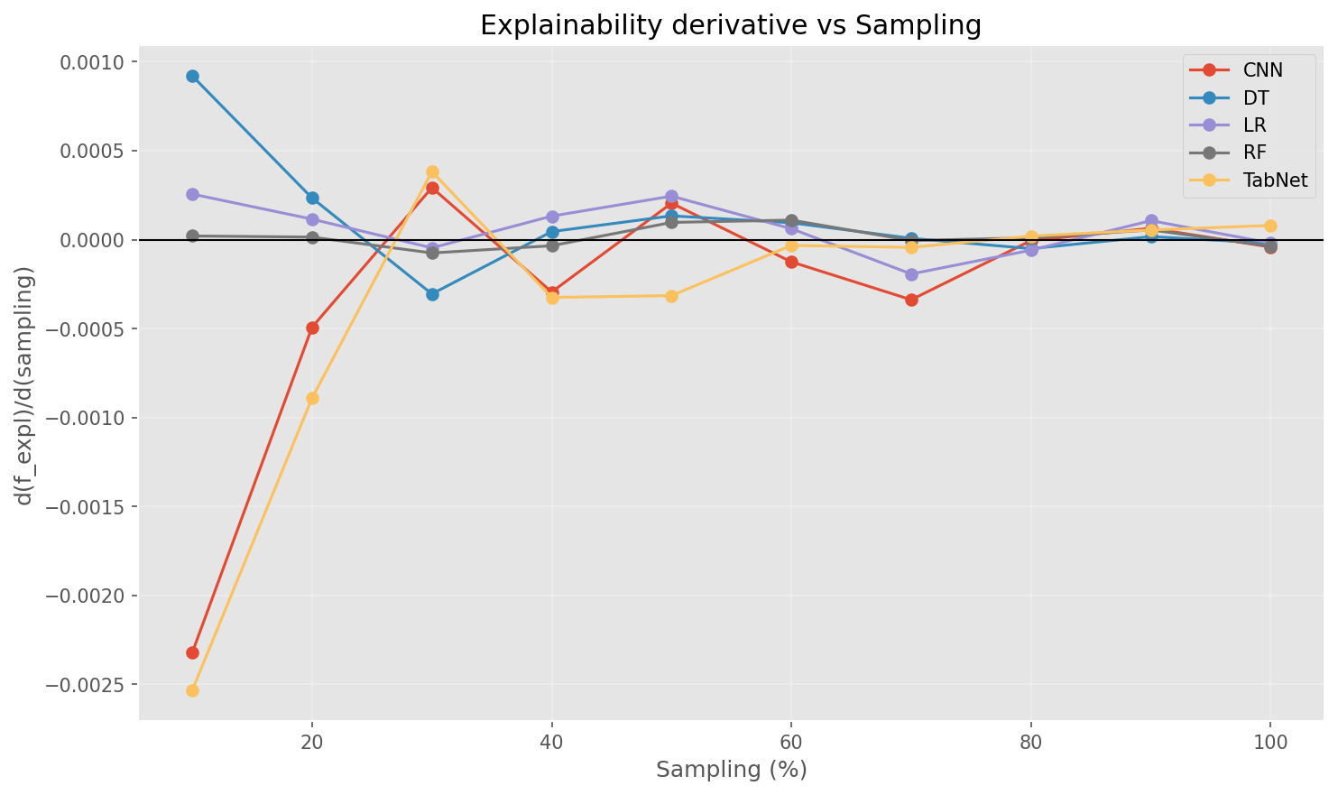

performance_sampling_curve.png

Metric evolution across sampling ratios.

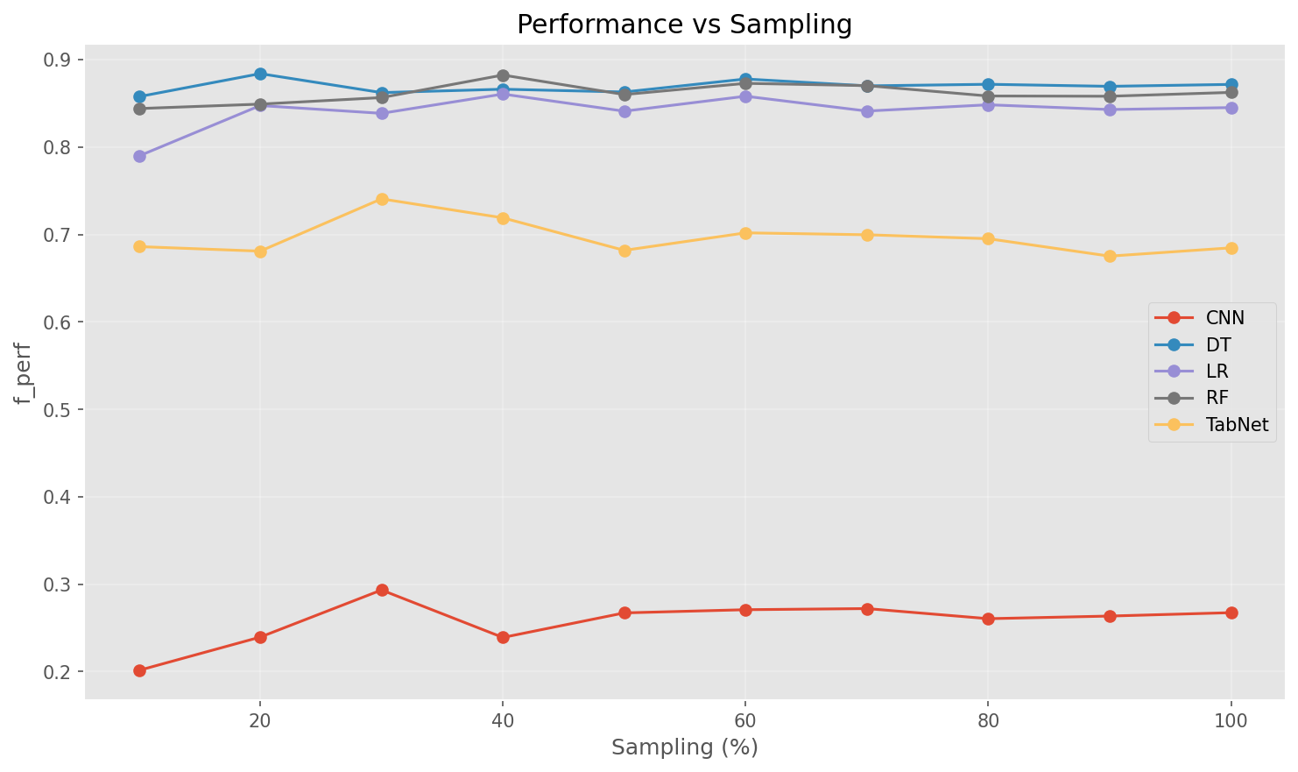

performance_sampling_derivative.png

Derivative plot showing sensitivity of the metric to sampling rate.

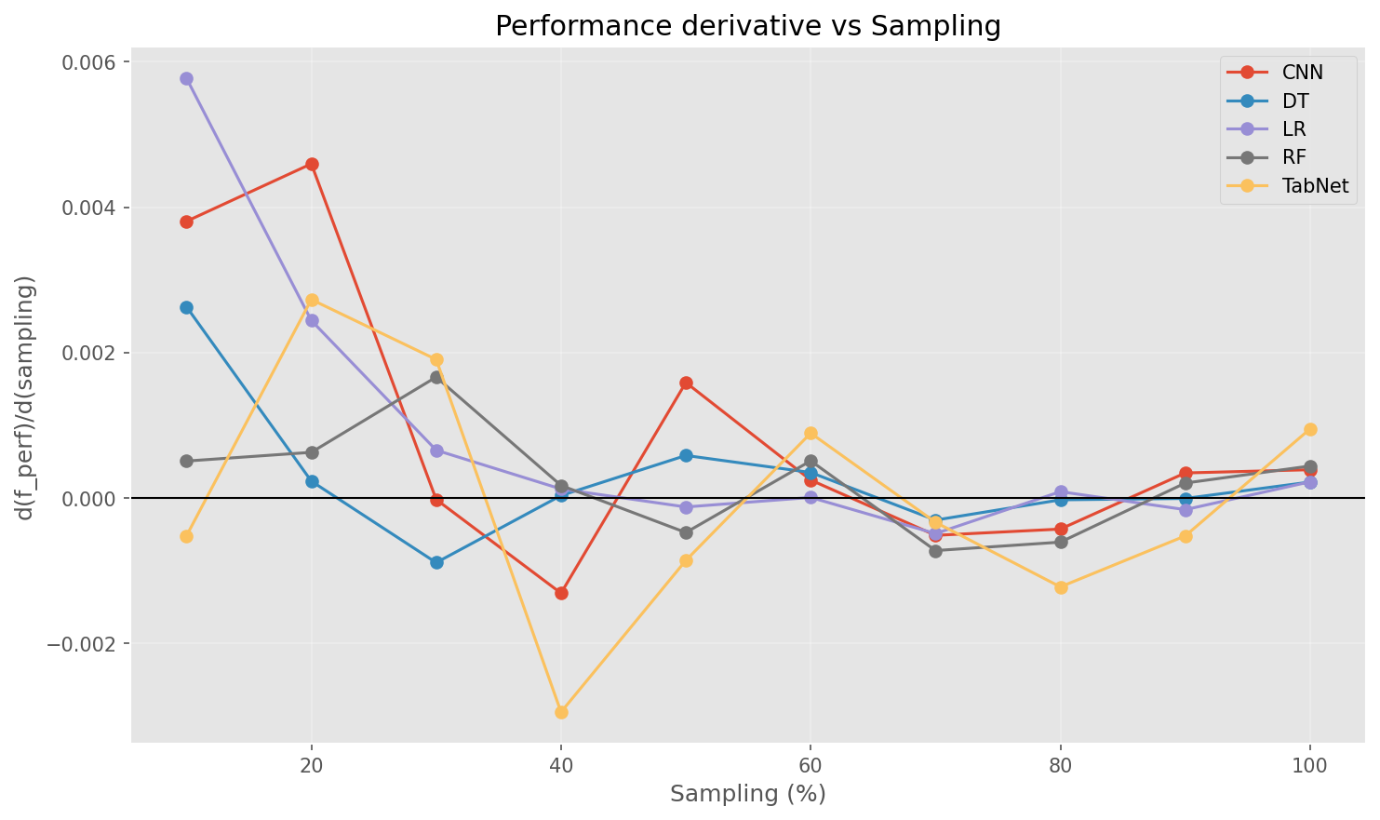

sampling_size_variation.png

Metric evolution across sampling ratios.

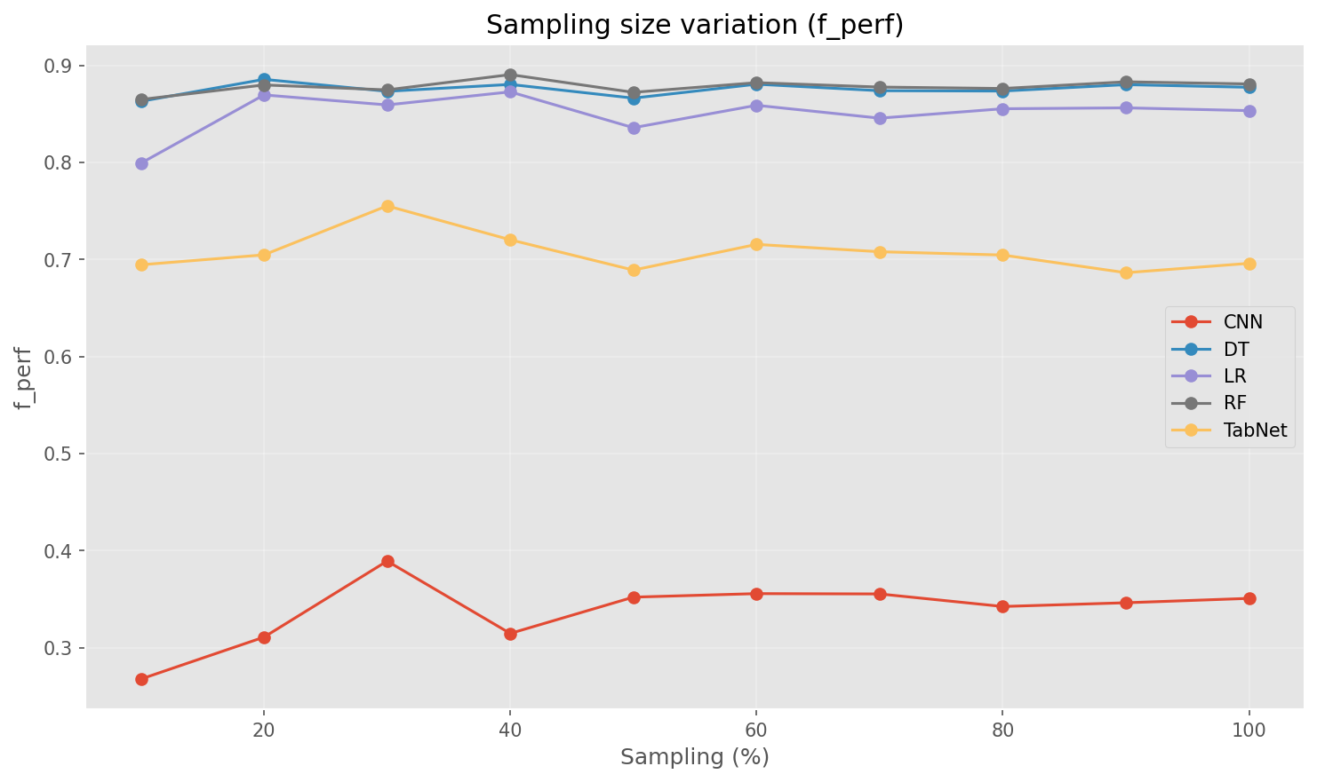

explainability_resume.png

Chart generated by the pipeline.

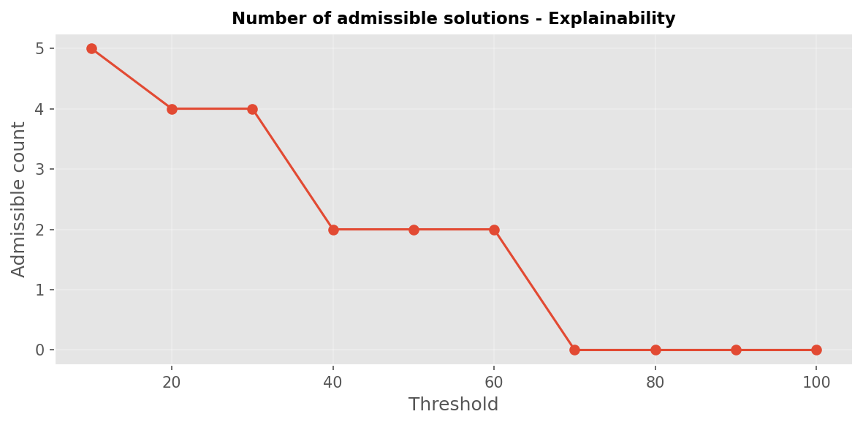

explainability_threshold_10.png

Chart generated by the pipeline.

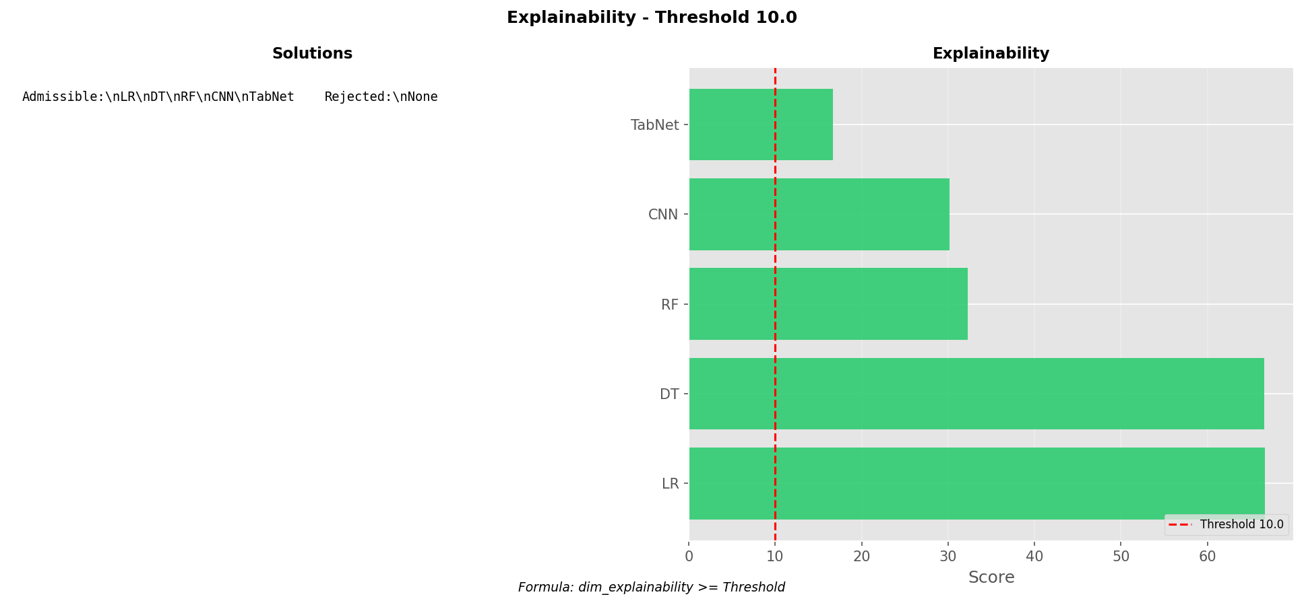

explainability_threshold_100.png

Chart generated by the pipeline.

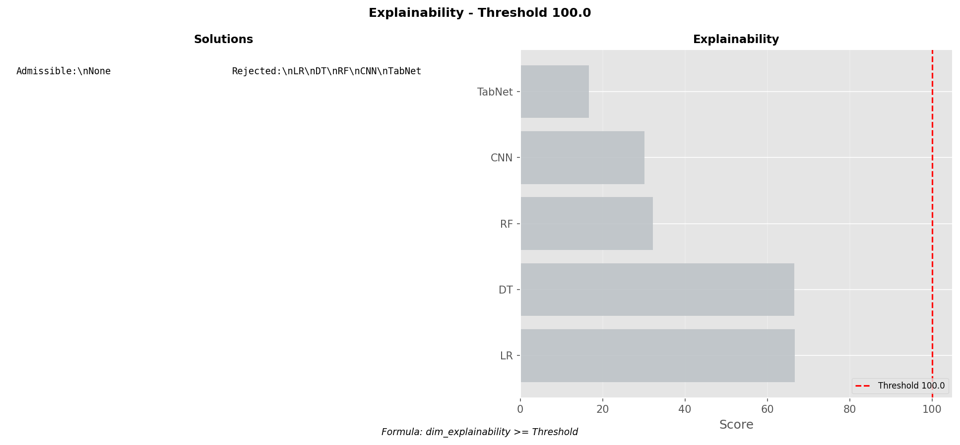

explainability_threshold_20.png

Chart generated by the pipeline.

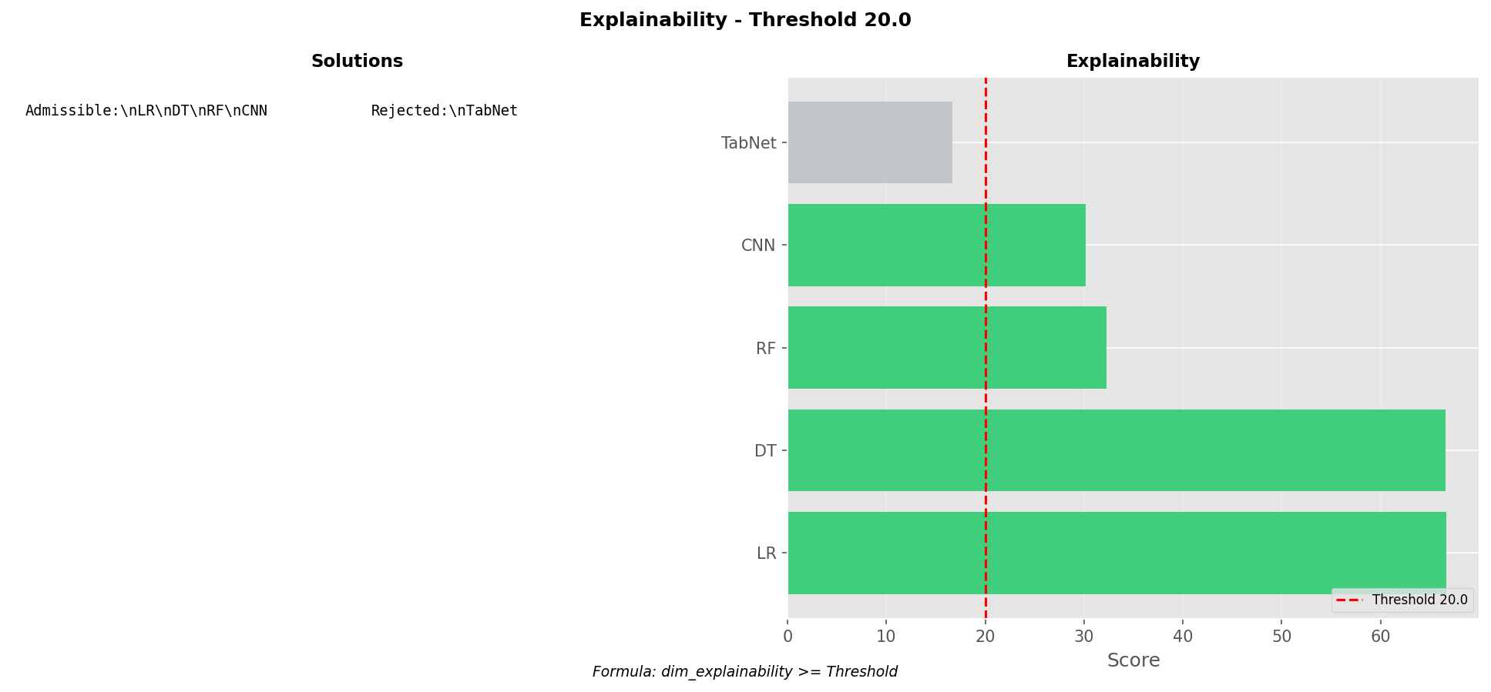

explainability_threshold_30.png

Chart generated by the pipeline.

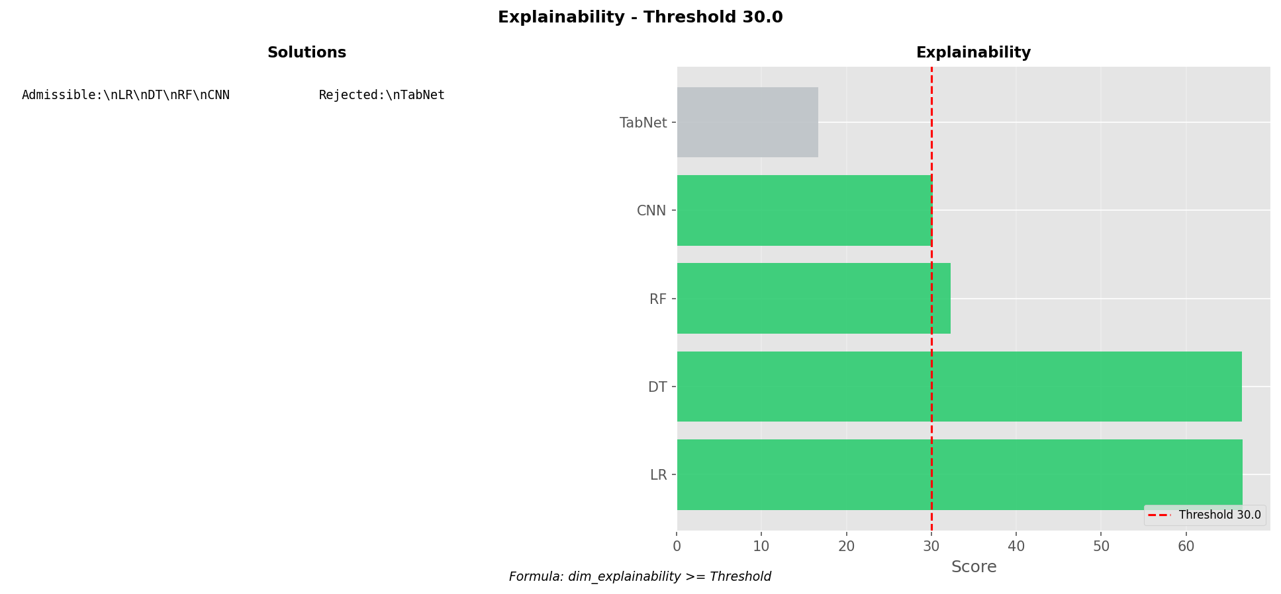

explainability_threshold_40.png

Chart generated by the pipeline.

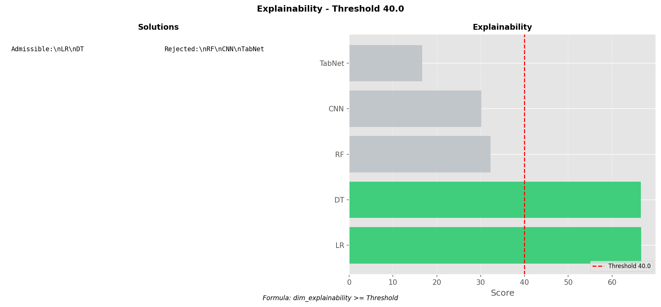

explainability_threshold_50.png

Chart generated by the pipeline.

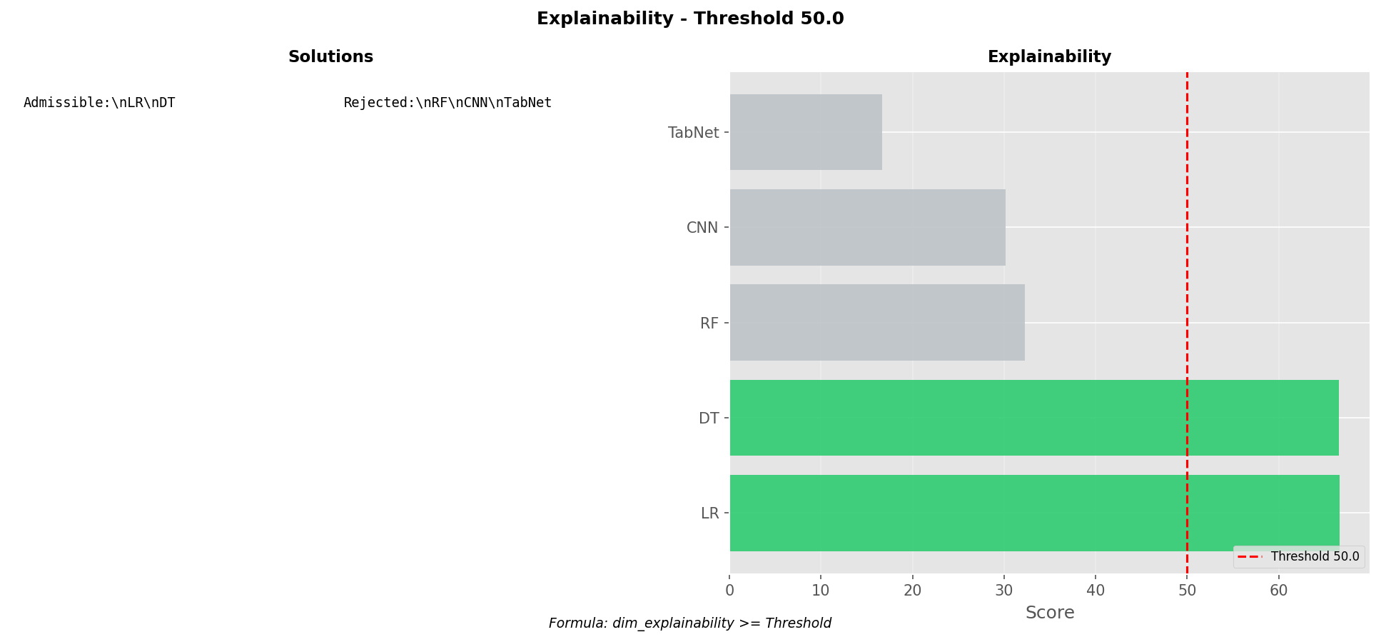

explainability_threshold_60.png

Chart generated by the pipeline.

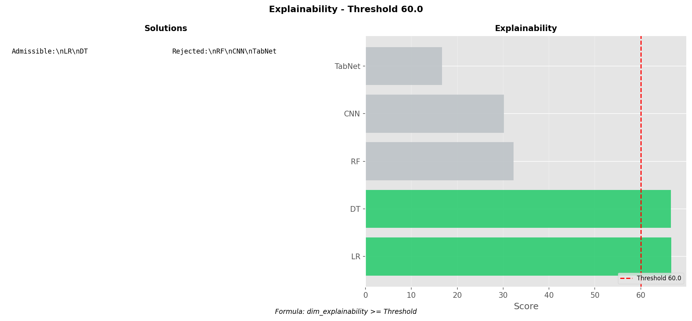

explainability_threshold_70.png

Chart generated by the pipeline.

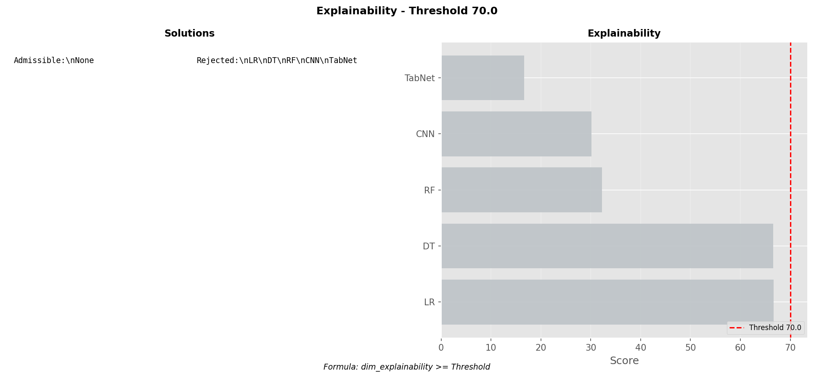

explainability_threshold_80.png

Chart generated by the pipeline.

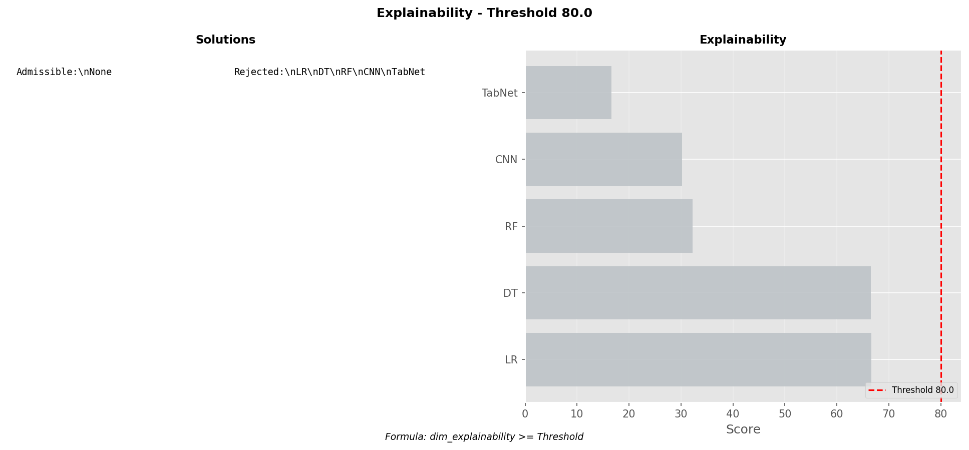

explainability_threshold_90.png

Chart generated by the pipeline.

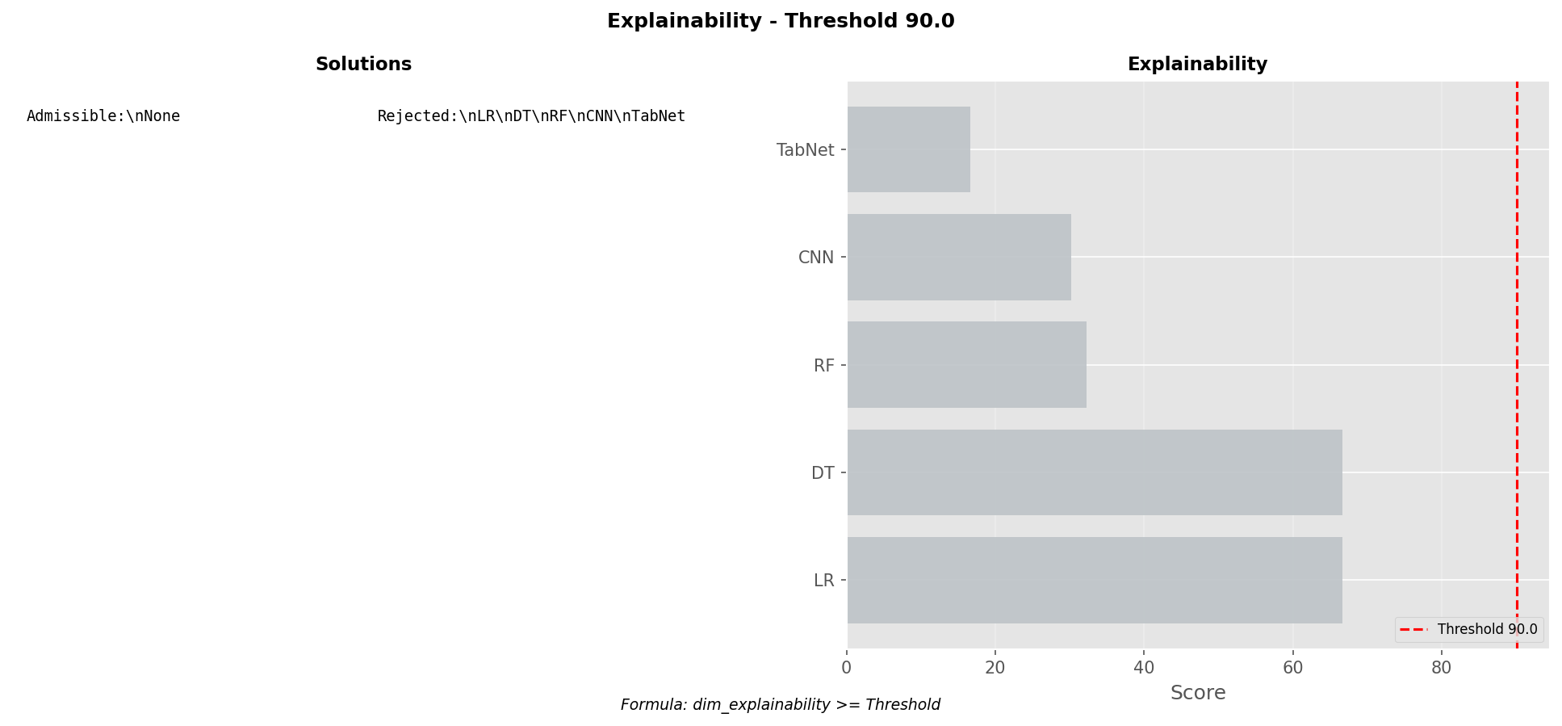

performance_resume.png

Chart generated by the pipeline.

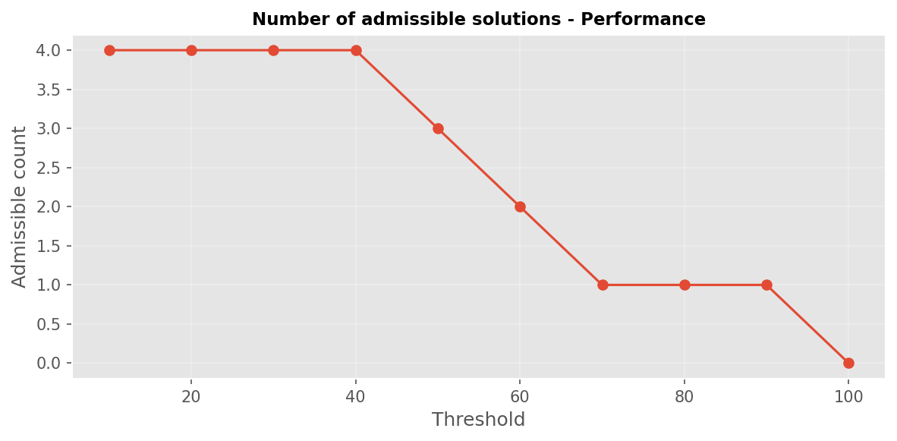

performance_threshold_10.png

Chart generated by the pipeline.

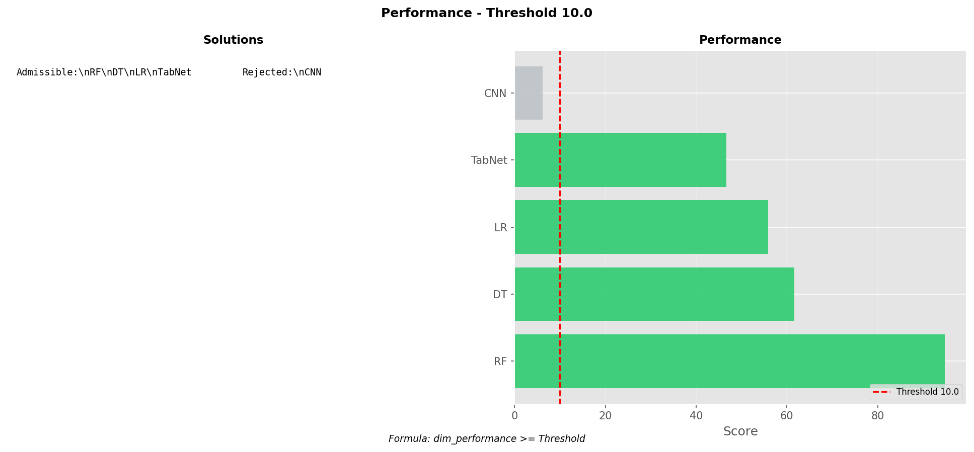

performance_threshold_100.png

Chart generated by the pipeline.

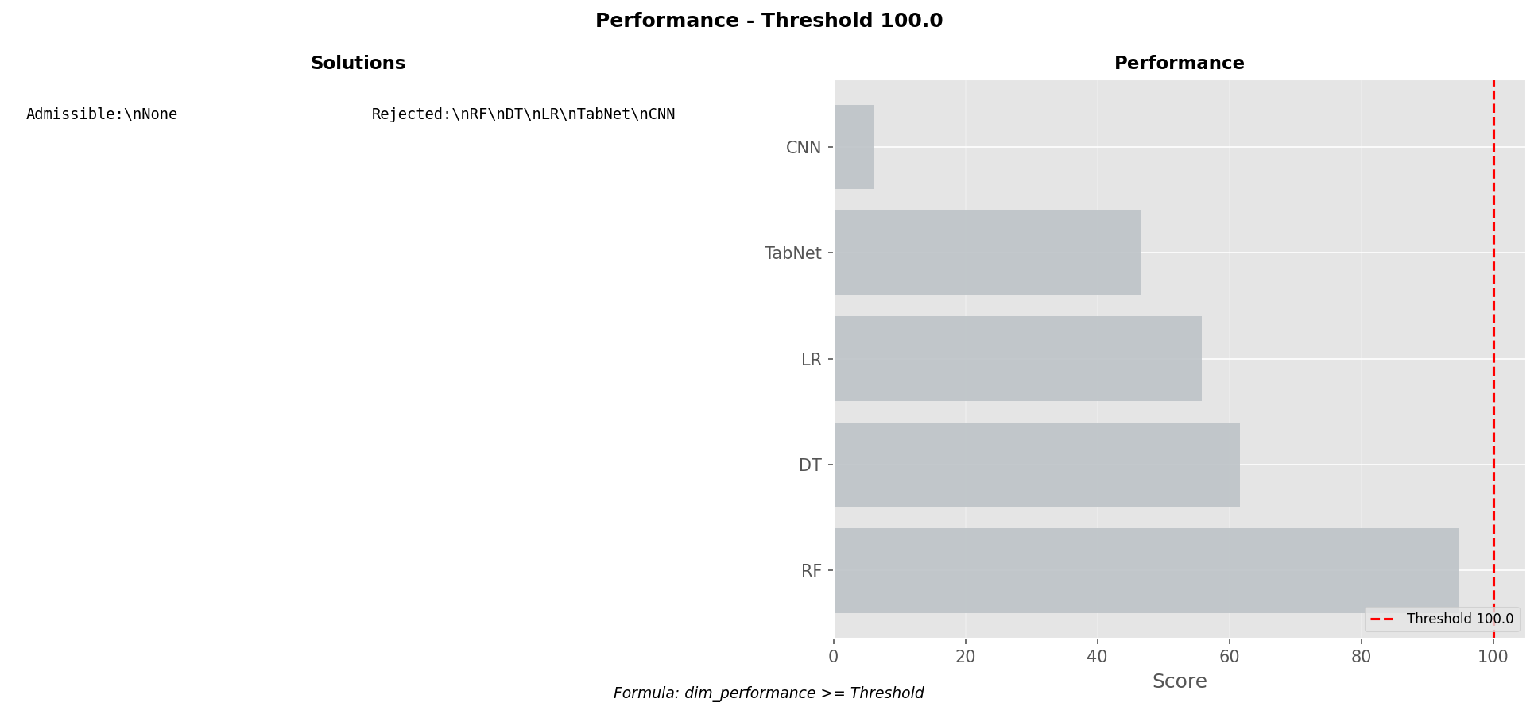

performance_threshold_20.png

Chart generated by the pipeline.

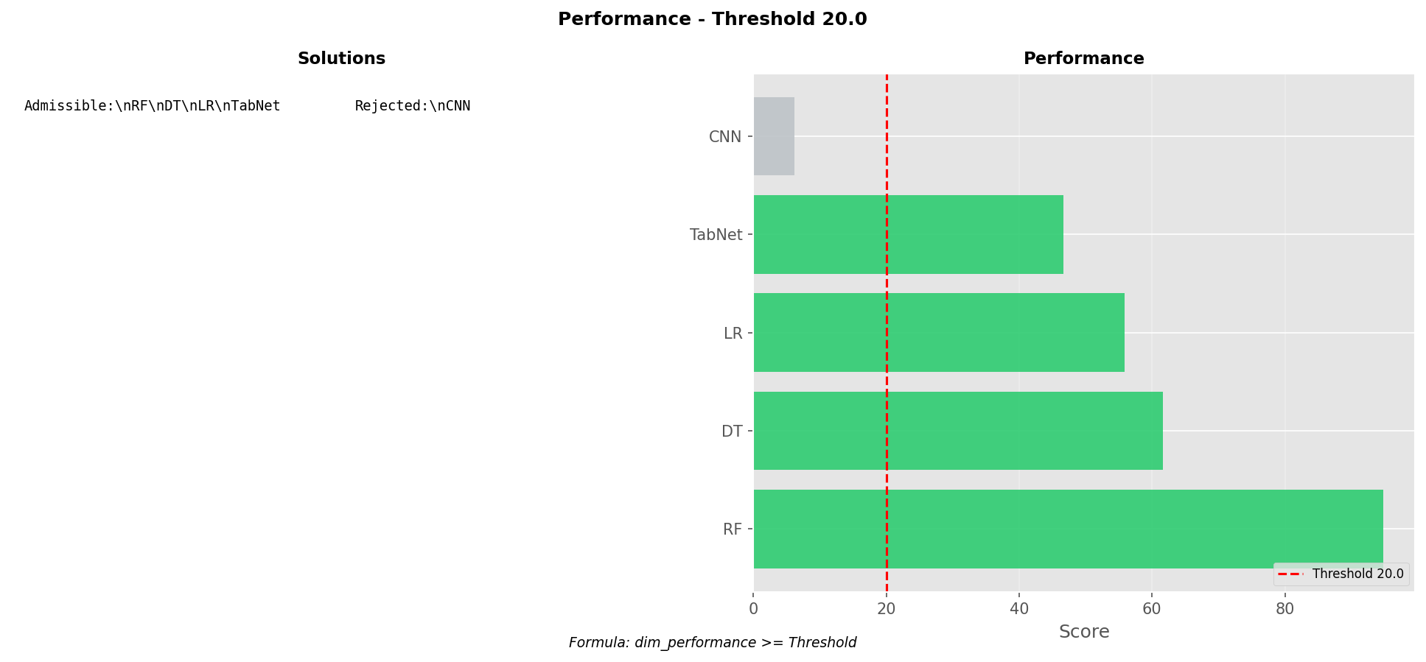

performance_threshold_30.png

Chart generated by the pipeline.

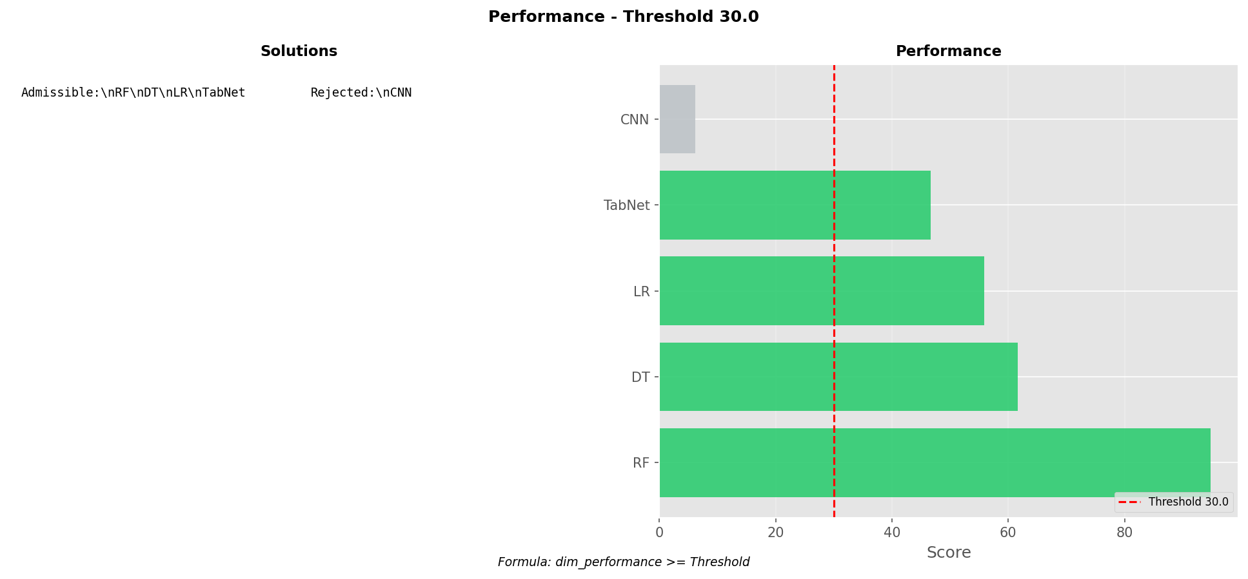

performance_threshold_40.png

Chart generated by the pipeline.

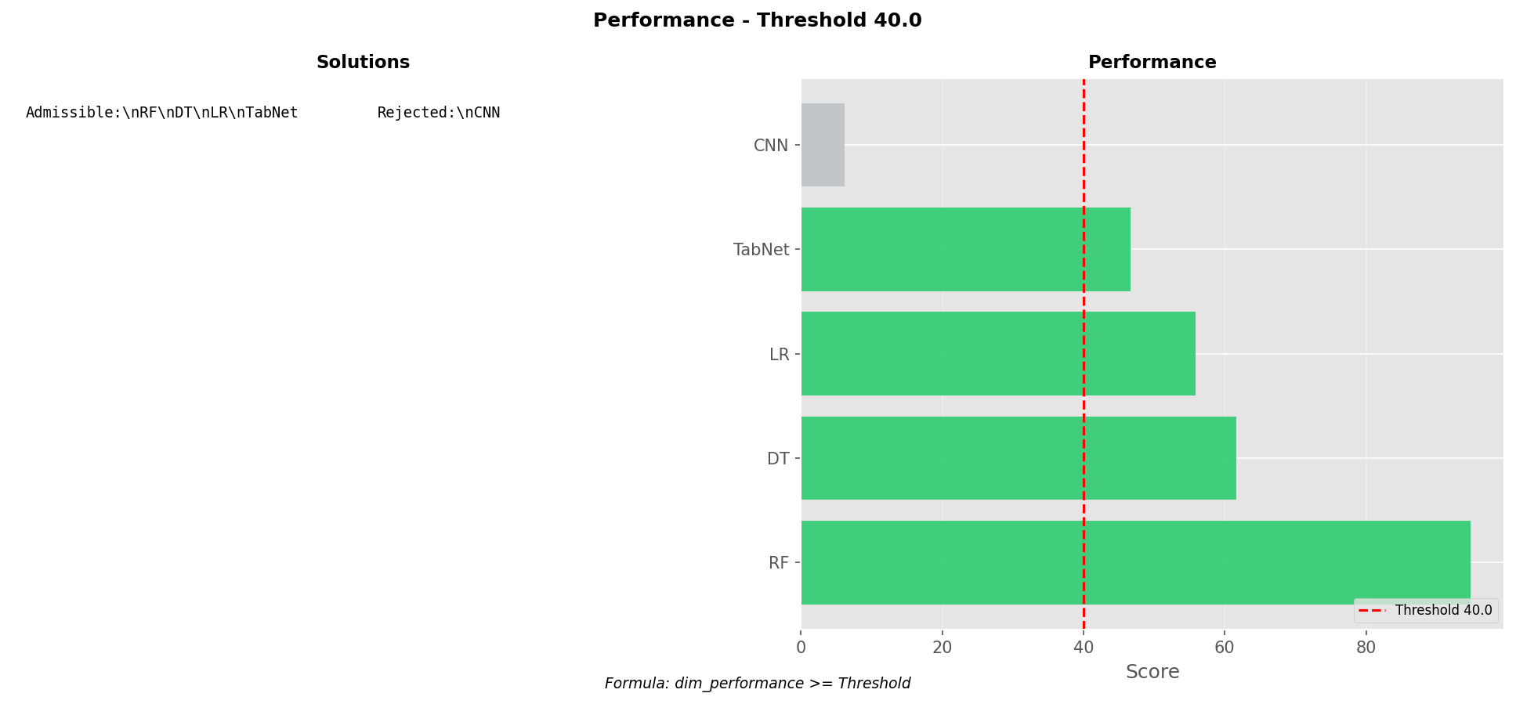

performance_threshold_50.png

Chart generated by the pipeline.

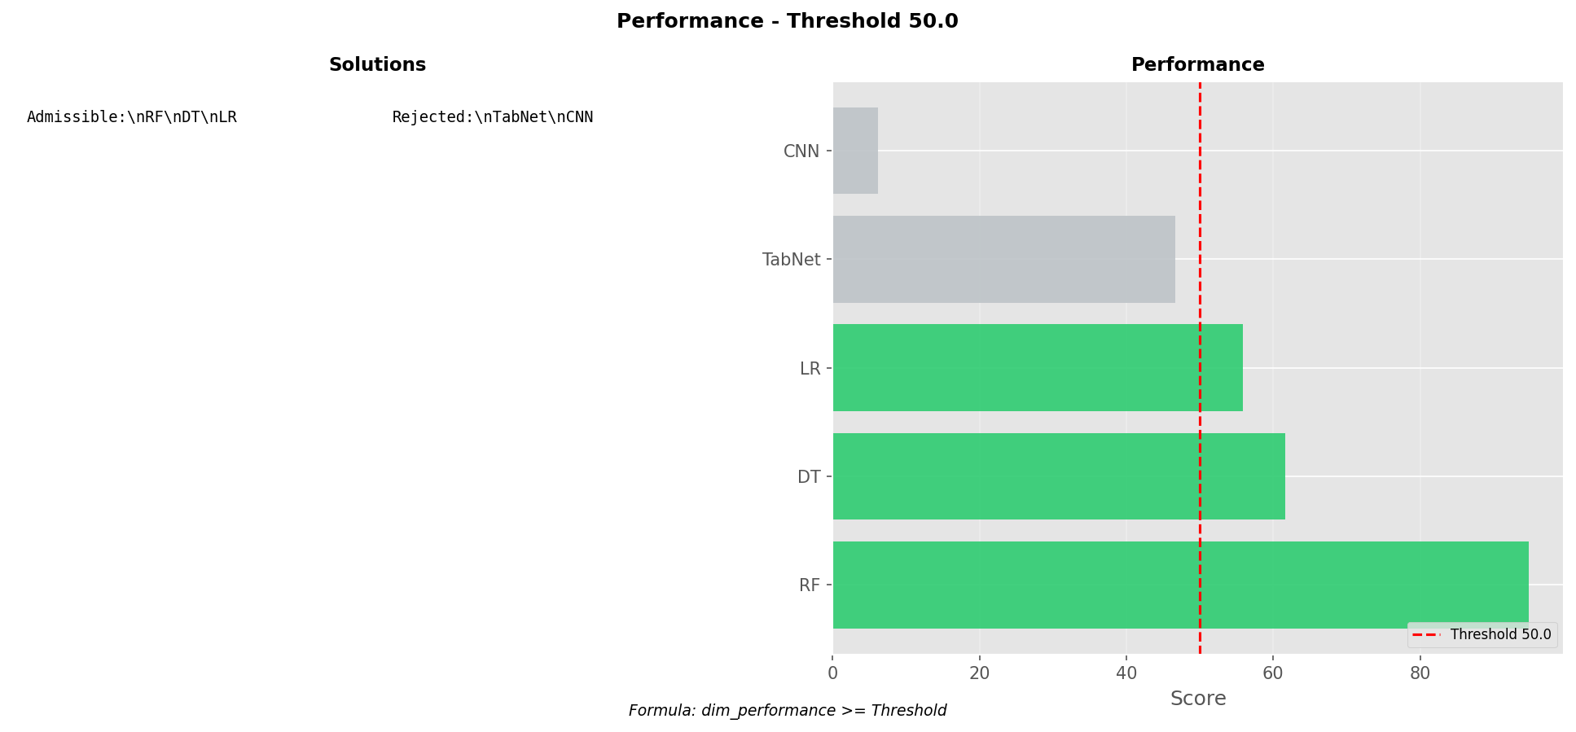

performance_threshold_60.png

Chart generated by the pipeline.

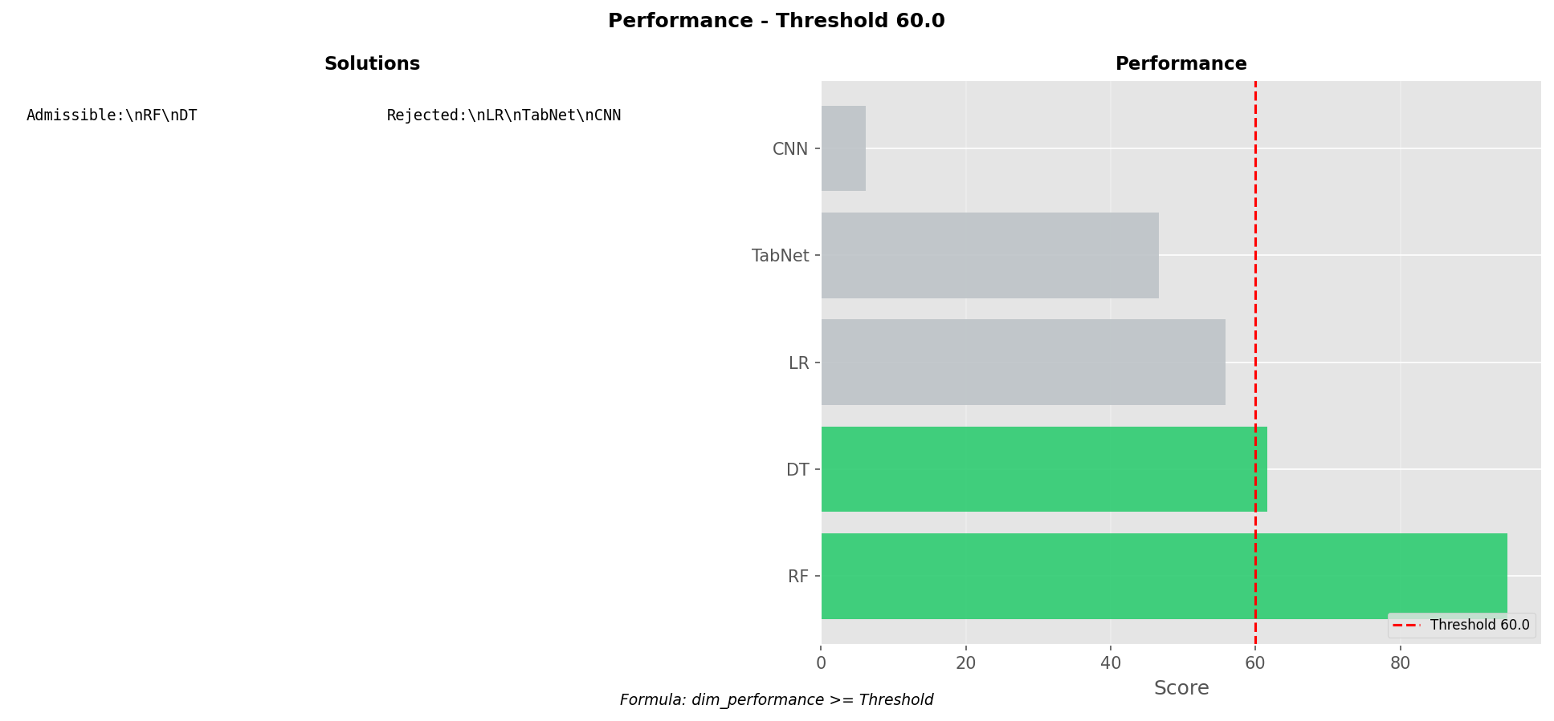

performance_threshold_70.png

Chart generated by the pipeline.

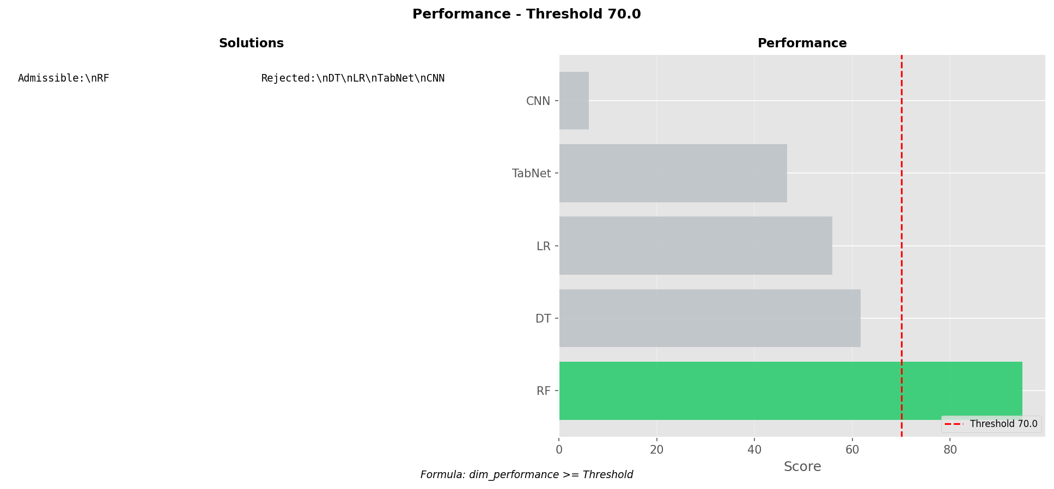

performance_threshold_80.png

Chart generated by the pipeline.

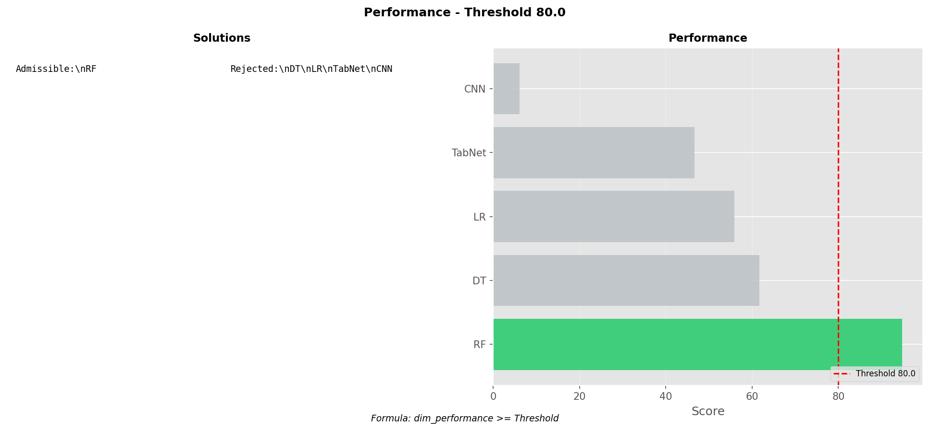

performance_threshold_90.png

Chart generated by the pipeline.

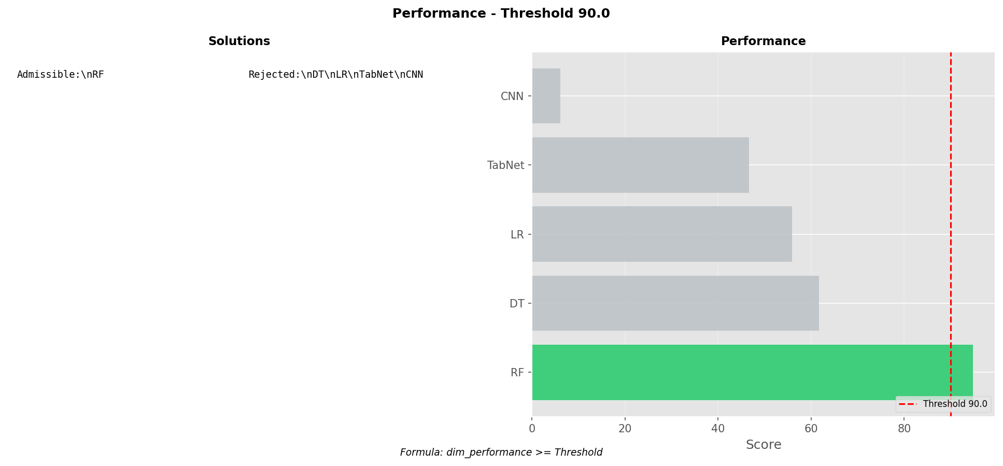

# TOPSIS visual report

Includes KS validation, feature importance, decision matrices, and final ranking.

01_ks_validation.png

KS statistics per feature against the theoretical threshold.

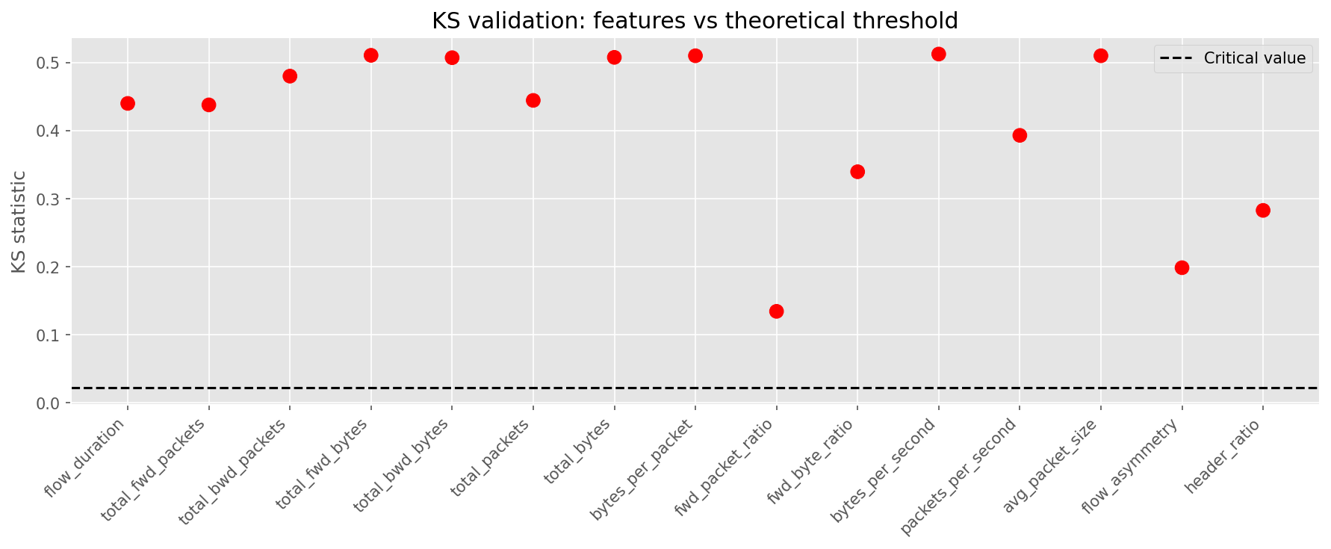

02_feature_importance.png

Feature ranking by relevance to the target label.

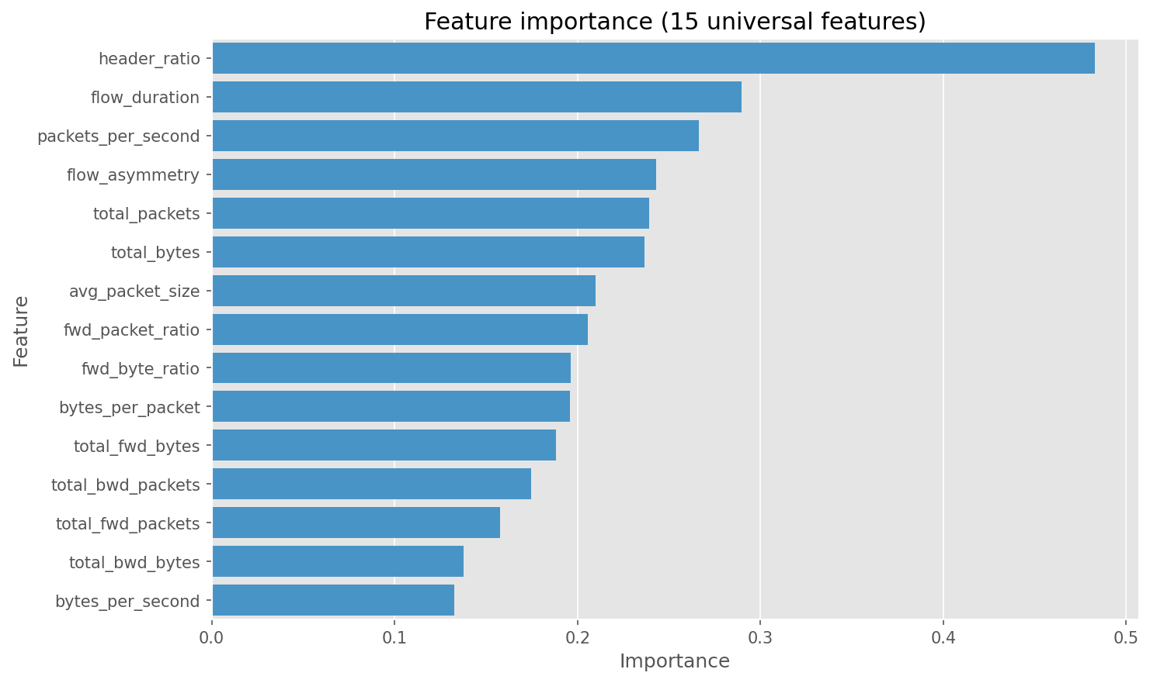

03_data_split_pie.png

Chart generated by the pipeline.

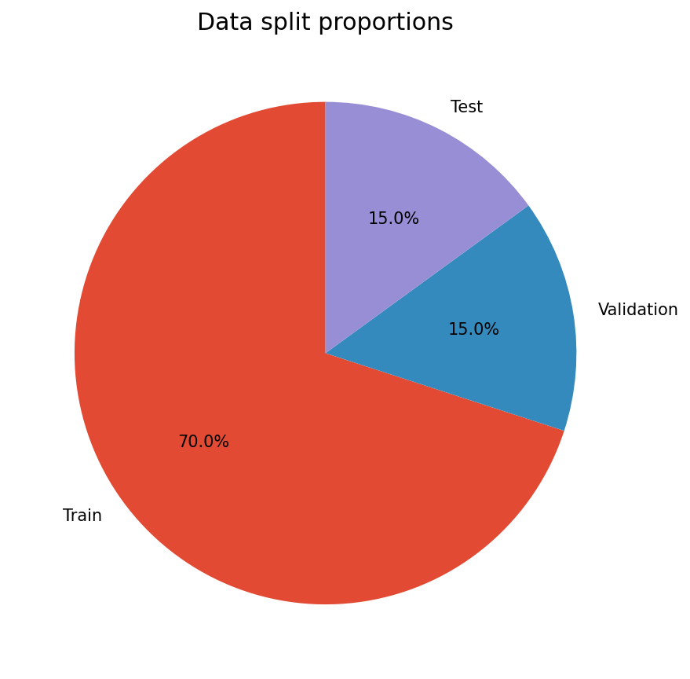

04_raw_matrix_heatmap.png

Raw decision matrix heatmap (before normalization).

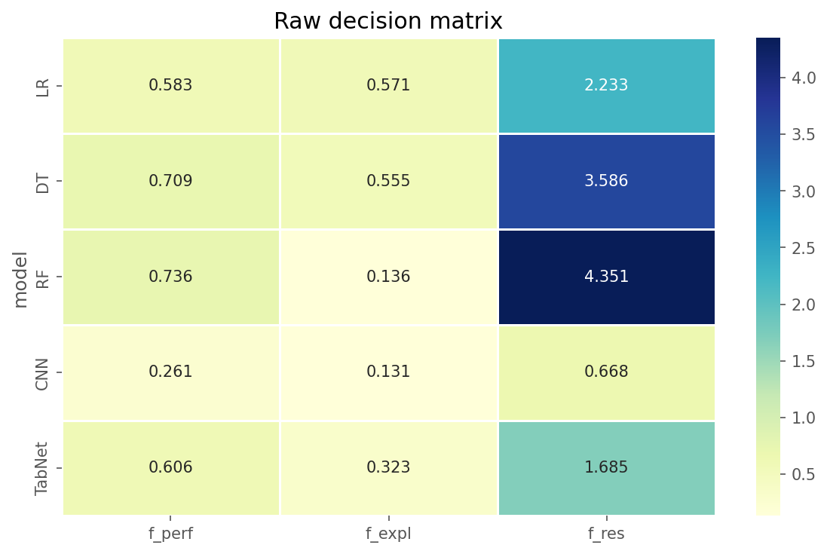

05_normalized_matrix_heatmap.png

Normalized decision matrix heatmap.

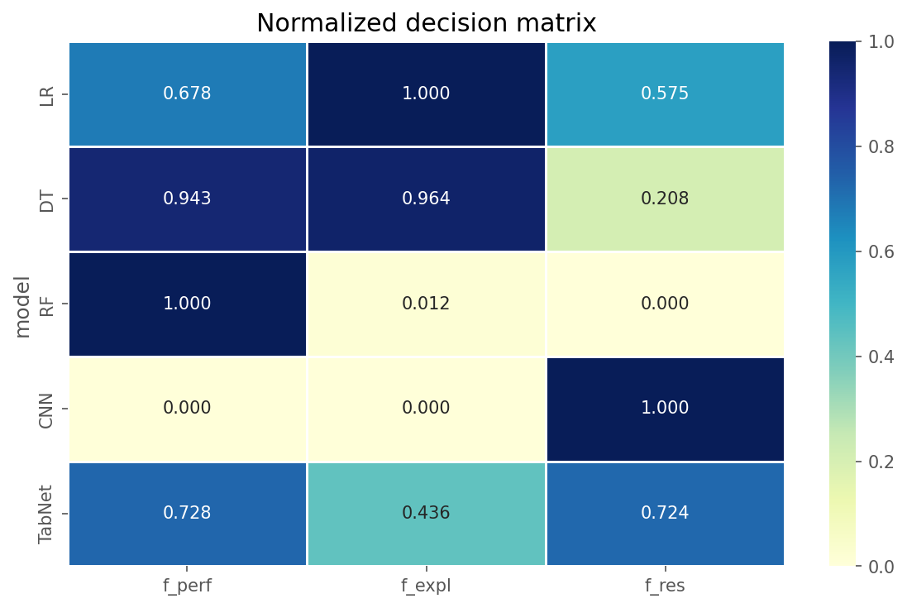

06_ahp_weights_donut.png

AHP weights used for TOPSIS.

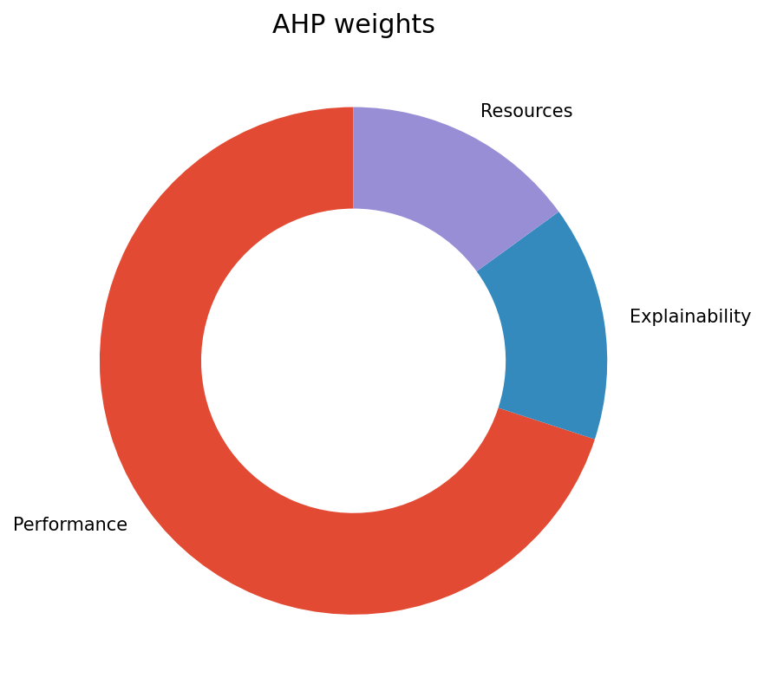

07_topsis_closeness.png

TOPSIS closeness coefficients for each alternative.

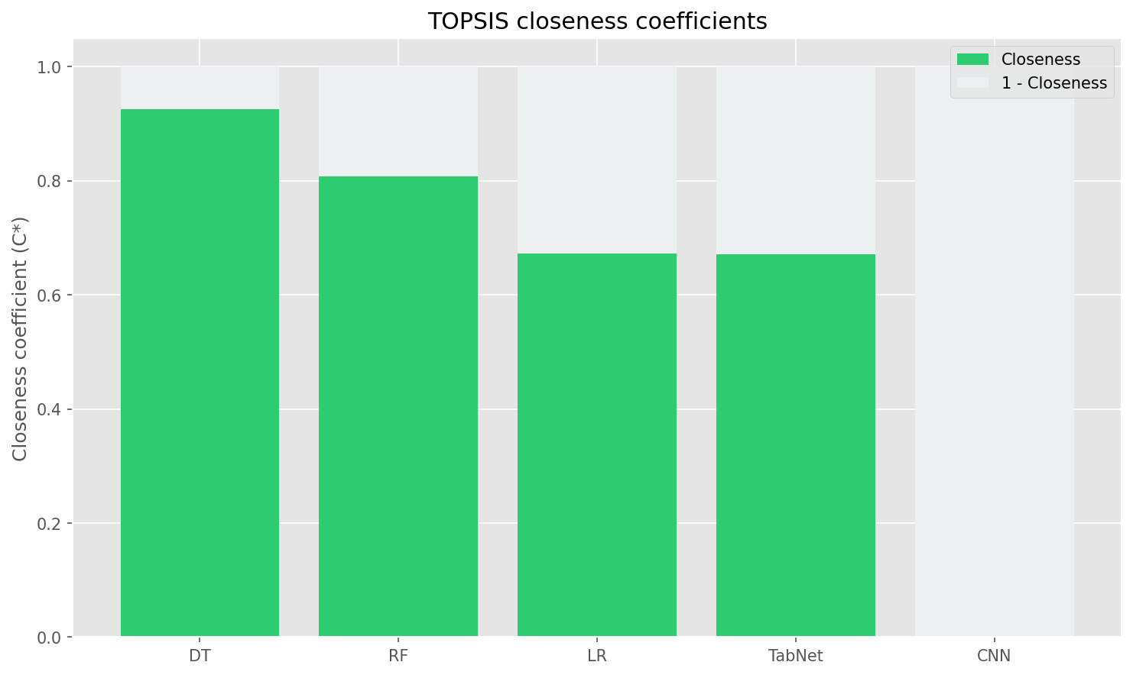

08_top3_radar.png

Radar comparison of top alternatives.

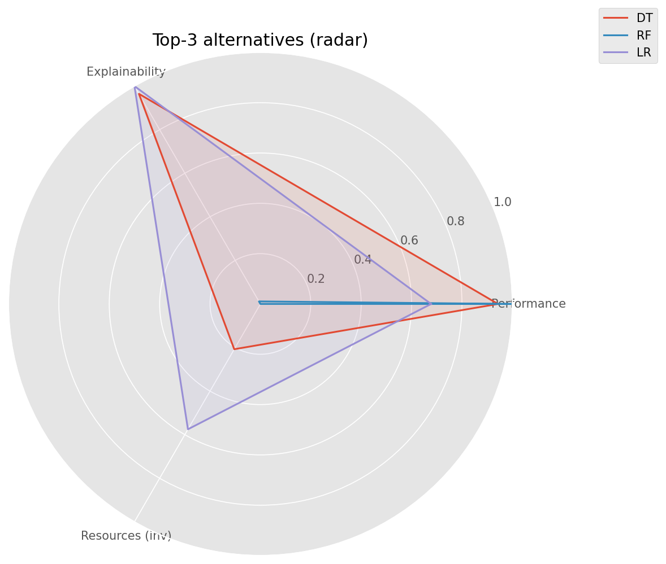

09_pipeline_overview.png

Pipeline flow diagram for MCDA steps.

